**School of Hairdressing and Applied Therapies**

**Level 1 Hairdressing and Beauty Therapy**

**Unit UV10417- Providing Basic Pedicure Treatments**

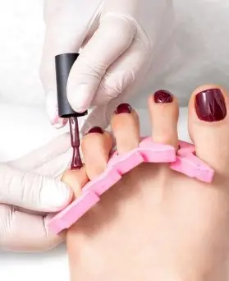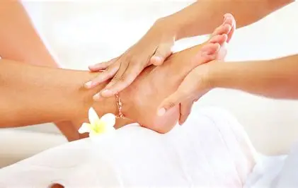

|  |  |
| --- | --- |
| **Question** | **√ or X** |
| 1. |  |
| 2. |  |
| 3. |  |
| 4. |  |
| 5. |  |
| 6. |  |

**Student Name:**

**Tutor Feedback/Feedforward:**

Literacy Alert:

**Completion Date:**

1. Outline salon’s requirement for preparation of yourself, the client and work area when carrying out pedicure treatments.
2. State the importance of carrying out a visual study of the feet and nails to identify factors that will influence the treatment.
3. How should you cut and file the toenails, and why?
4. Draw below how the toenail would appear if cut correctly, too short and ingrowing

Correctly shaped Too short Ingrowing



1. State possible contra-actions and how to respond.
2. State the homecare/aftercare advice you would offer the client.