

**School of Hairdressing and Applied Therapies**

**Introduction to the Hair & Beauty Sector**

**UV10343**

**Evidence workbook**

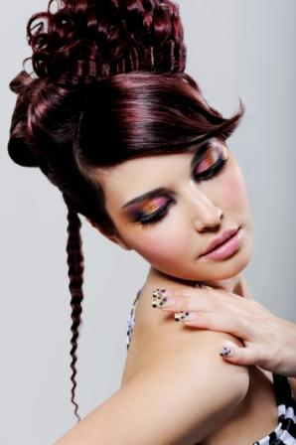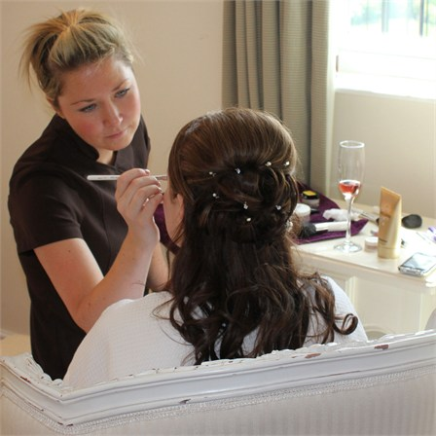

|  |  |  |
| --- | --- | --- |
| **Question** | **√ or X** | **Competent/Not yet**  **competent** |
| **Q1a** |  |  |
| **Q1b** |  |  |
| **Q1c** |  |  |
| **Q1d** |  |  |
| **Q2a** |  |  |
| **Q2b** |  |  |
| **Q2c** |  |  |

***Student Name:***

***Tutor Signature & Feedback/Feedforward:***

**Literacy Alert:**

**Outcome 1**

**Know the career opportunities and working patterns within the hair and beauty sector**

## 1.a. Identify the occupational roles in the hair and beauty sector and give a brief description of each.

1.b. Outline working patterns in the hair and beauty sector.

1.c. Identify the main career opportunities available in the hair and beauty sector and related industries.

1.d. List examples of sources of information on training and career opportunities in the sector.

**Outcome 2**

**Know the main hairdressing services and beauty treatments**

2.a. Identify different types of salons and the types of clients they attract.

2.b. Outline the main hairdressing services offered by salons.

2.c. Outline the main beauty treatments offered by salons.

Please use the grid below to correct any spelling mistakes identified within this workbook

|  |  |
| --- | --- |
| Spelling mistake | Spelling correction |

Please use the grid below to correct any grammar issues identified within this workbook

|  |  |
| --- | --- |
| Grammar mistake | Grammar correction |