

**School of Hairdressing and Applied Therapies**

**Level 1 Introduction to Hairdressing and Beauty Therapy**

**Unit UV30333 – Nail Art Application Workbook**

[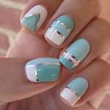](https://www.google.co.uk/url?q=http://nailartsdesign.com/nail-arts-daily-day-3/&sa=U&ei=9iYHU92QKdCVhQff2oCAAw&ved=0CC4Q9QEwADgU&usg=AFQjCNFRp92OarIweg-3dimA7OHGJA4T)[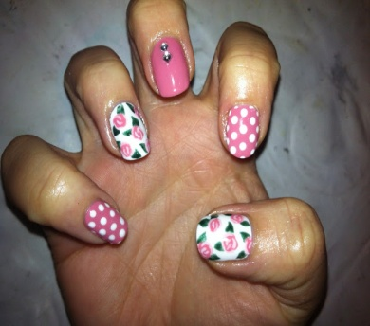](http://1.bp.blogspot.com/-b2mQKJOE3Es/UX0n8ERxc1I/AAAAAAAACHA/Z-XDwCGsiJU/s1600/CND+Shellac+Cath+Kidston+nail+art+with+Rosebud+and+Cream+Puff+1.j)[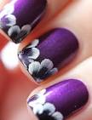](https://www.google.co.uk/url?q=http://someportal.com/freehand-nail-art-designs/&sa=U&ei=WCgHU9PiEMSthQeT04G4BA&ved=0CEQQ9QEwCziEAg&usg=AFQjCNH0ehjewJqXh6GuTVSwvmkWjDHt)

|  |  |
| --- | --- |
| **Question** | **√ or X** |
| **1.** |  |
| **2.** |  |
| **3.** |  |
| **4.** |  |
| **Literacy alert:** | |

**Evidence Workbook**

**Name:**

**Tutor feedback/feedforward:**

1. State the factors that could influence the choice of basic nail art techniques.
2. State the importance of the preparation procedures for basic nail art techniques.
3. State all the products and basic techniques used in nail art.
4. Design a 2D image of your choice. Include researched images and a written description of the tools and products needed to create the design.

|  |
| --- |
| Include:-  Select 4 nail art images from the internet that you like and could use in your design.  Add why you like each image.  My design –   * List products and tools you need to create your design. * Write a step-by-step procedure of how to apply your nail art design. |