

**School of Hairdressing and Applied Therapies**

**Level 1 Diploma in the introduction to the Hair and Beauty sector**

**UV30335 Skin Care Workbook**

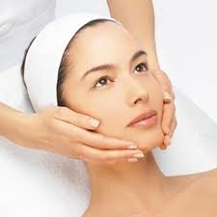

|  |  |
| --- | --- |
| **Question** | **√ or X** |
| **Q1** |  |
| **Q2** |  |
| **Q3** |  |

**Student Name:**

**Tutor signature & feedback/feedforward:**

**Literacy Alert:**

1. **State the correct procedure for client preparation.**
2. **State and describe the main characteristics of each skin type.**
3. **Why is it important to give a skin analysis before beginning treatment?**