

POSITIVE RELATIONSHIPS
“The challenges facing family
life in today’s society”

HOMELESSNESS

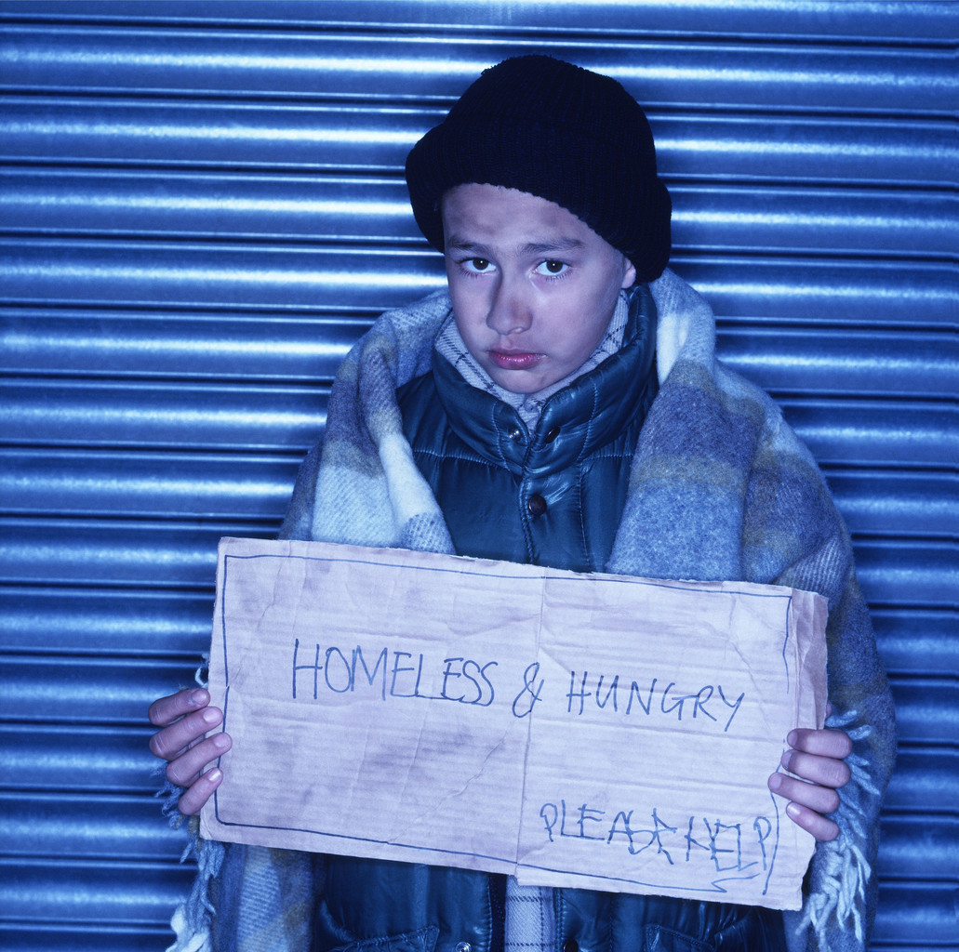

Name: ________________________
Personal Tutor: _________________
What is homelessness?
Homelessness means not having a home. Even if you have a roof over your head you can still be homeless. This is because you may not have any rights to stay where you live or your home might be unsuitable for you.

What situations mean you are homeless?
You don’t have to be sleeping on the streets to be classed as homeless. You might also be legally homeless if you are:
- temporarily staying with friends or family
- staying in a hostel or bed and breakfast
- living in very overcrowded conditions
- at risk of violence or abuse in your home
- living in poor conditions that affect your health
- living somewhere that you have no legal right to stay in (e.g. a squat)
- living somewhere that you can’t afford to pay for without depriving yourself of basic essentials
- forced to live apart from your family or someone you would normally live with, because your accommodation isn’t suitable

Who is affected?
Homelessness affects a wide variety of people. Some groups of people are more vulnerable to homelessness because they have fewer rights, particular needs or are less able to cope by themselves. These include:
- young people leaving home for the first time
- old people
- people with children
- people with physical or mental health problems
- people on benefits or low incomes
- people leaving care
- ex-prisoners
- asylum seekers and refugees
How do people become homeless?
You could become homeless for many different reasons. These could include:
- being evicted by your landlord
- losing your job
- health problems
- relationship problems
- a disaster such as fire or flooding
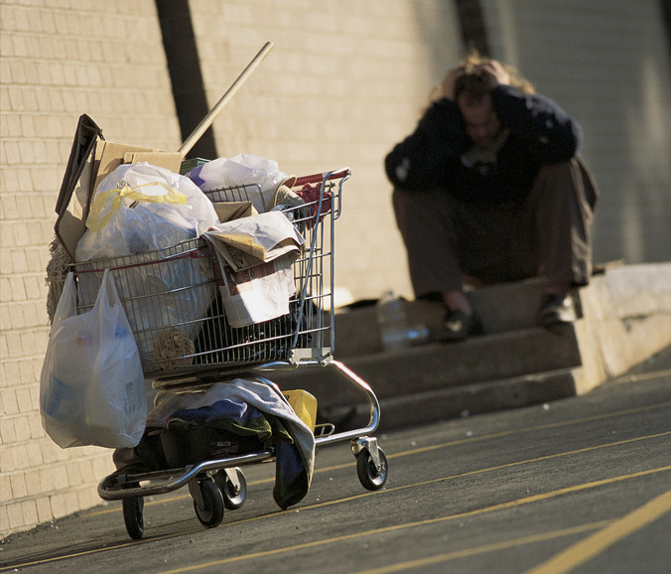

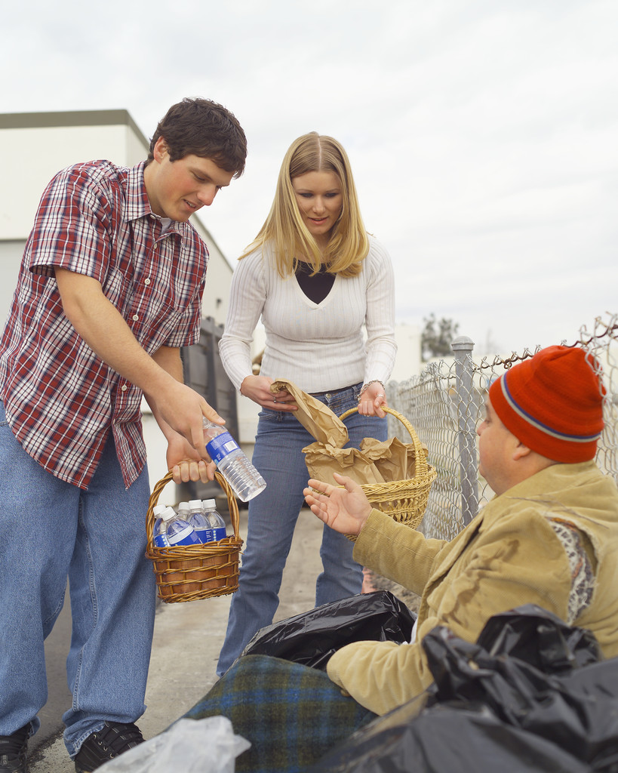

CASE STUDY: Ricky’s Story

When I was nine I was taken into care because my dad was drunk a lot of the time and used to beat us up. My mum couldn’t look after me and my four brothers and sisters because she was always so down and they had no money. My dad used to hit her sometimes too when he was drunk. He couldn’t hold down a job so we never had any money. My mum tried her best but she just got further and further into debt. When my dad found out how much we owed he lost it and stormed off to the pub as usual. He was so drunk when he came back that we all hid in the shed outside – except mum. He said he was going to kill her and set fire to the house. I think the neighbours must have called the police and I don’t remember much else about that night. I tried to hang on to my mum but they took me and my brothers and sisters into care, for our own good they said.

I was so worried about my mum that I bit and kicked everyone who came near me. I was taken to a foster family but I didn’t want to be there. I wanted to be with my mum and I didn’t know where my brothers and sisters were. Every time they put me in a new foster home I went mad so I wouldn’t have to stay. I was really worried about missing school. I didn’t go to school for months and I knew I’d never be able to catch up. I missed my mates a lot and didn’t want to make new friends. I thought they were all laughing at me. In the end they decided to send me to Bronswick Lodge, a home for other kids like me.

I didn’t like it there either but at least I had a room of my own and I got to see my mum sometimes. She said one day we’d be back together but I knew it wasn’t true.

They kept trying me out with different foster parents but it never worked out. Yeah, I was a pain, I know, but I just didn’t fit in and I

hated moving all the time. I went to three different schools in less than two years. I never made any real friends; I just hung out with all the troublemakers, and skived off whenever I could. I got thrown out of one school for having a go at the maths teacher. He was a bully just like my dad and I wasn’t going to have that again.

One day they sent me to a new foster family where there was just me and no other kids. I didn’t want to go at first but my mum said I should give it a go this time. I thought it had to be better than the care home which was OK but it’s not like a family to me. I don’t really know why but I felt a lot better in my new foster home straight away. I had a really nice room all to myself and they said I could put posters on the walls. My new foster mum was really cool. She didn’t stand any rubbish from me but she always seemed to have time to talk to me, she listened to me and she didn’t pretend to be better than my real mum. She helped me write to my mum and I was allowed to ring her up and see her sometimes. My foster dad was cool too. He knew a lot of stuff and helped me to sort out my schoolwork and bought me a computer to do my homework on. He told me I was clever. Nobody had ever said that to me before, and that was good for me, I reckon. I just don’t want to end up a waster like my dad.

It was hard to make friends at my new school. The other kids really got to me sometimes and I still have problems with some of the male teachers. But I’m doing OK and have to choose my GCSE options soon. I fancy doing graphic design and drama. I still miss my mum and my brothers and sisters, but I’m gradually getting my head sorted out. My mum’s got a new boyfriend now but I don’t like him very much, he reminds me too much of my dad. I hope I can stay here with my new mum and dad for a while. We’ve talked about adoption but I don’t know. I would only do it if I could stay in touch with my mum.
Ricky’s Story:

TASK 1
Name: _______________________________________

Read Ricky’s story before you do this worksheet.

- Using the following sheet write some entries for a diary Ricky may have kept during this really difficult time in his life

To help you get started try to imagine how Ricky felt about the following things:

- living in another new home in a strange town
- having to make new friends and moving away from his old friends
- going to yet another new school where he didn’t know anyone
- living with adults and other children he didn’t know
- being alone
- keeping up with school work
- being shouted at
- living without his birth family

Ricky’s Story:
Name: _______________________________________
Saturday, 12th May:
____________________________________________________________________________________________________
__________________________________________________
__________________________________________________
__________________________________________________

Wednesday, 16th May:
__________________________________________________
__________________________________________________
__________________________________________________
__________________________________________________
__________________________________________________

25th December (Christmas Day)
__________________________________________________
__________________________________________________
__________________________________________________
__________________________________________________
__________________________________________________
TASK 2
How Ricky felt:
Look at the table below. It shows some key stages in Ricky’s life. Using the table, write in the feelings that Ricky might have felt at these stages. (Please see list of feelings below.)

Ricky is aged 9 and his dad is being violent | Ricky is taken to his first foster family | He moves to Bronswick Lodge, the care home | He is moved from one set of foster parents to the next | Ricky settles with a foster family with no other kids | At his new school he begins to think about GCSEs

Feelings:
aggressive, depressed, angry, happy, optimistic, lonely,
lazy, confident, confused, alienated, determined, disorientated, embarrassed, frustrated, homesick, proud, restless, sad, scared, unconfident, unsettled, worried, bored.
TASK 3
Life can be hard
For children involved in fostering and adoption, life can be difficult. Some children who have experienced serious traumas in their birth families can suffer with emotional and social problems. Settling down at school and finding new friends, for example, is very difficult for young people who are moved around a lot from home to home. Sometimes these emotional problems lead to more problems such as difficulty with behaviour. Not everyone who is looked after through adoption or fostering ends up with these problems. Many do, but there are also many others for whom the experience was positive and ended happily.
* * * * * * *

What sort of things do you think might be more difficult for young people who have been fostered or live in a care home? Can you think of anything that might be better?

Use the following sheet to note your thoughts.

Things that might be more difficult:

_________________________________________________
_________________________________________________
_________________________________________________
_________________________________________________
_________________________________________________
_________________________________________________

Things that might be better:
_________________________________________________
_________________________________________________
_________________________________________________
_________________________________________________
_________________________________________________
_________________________________________________
_________________________________________________

