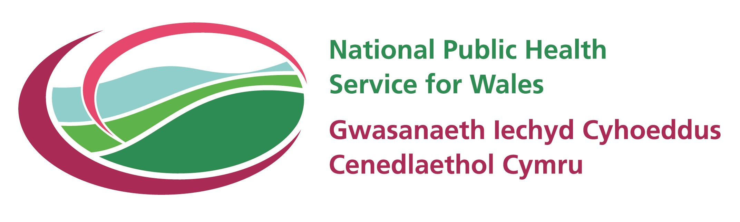

Health Needs Assessment 2006

Substance Misuse

Author
Anna Childs, Health Information Analysis Team (HIAT)
Professional input
Stuart Bartley National Public Health Service for Wales (NPHS)
Acknowledgements
The author wishes to thank the following for their valuable contributions:
  - Nathan Lester, Gareth Davies, Tracy Price, Hugo Cosh, Margaret Webber, Martin Heaven, and Lisa Williams (HIAT)
  - Rosemary Allgieier, Marilyn Meecham, Anne Hinchcliffe (Pharmaceuticial Public Health, NPHS)
  - Elizabeth Walsh and Tony Couch, Health Solutions Wales
  - Tim Powell, Substance Misuse Advisory Regional Team
  - Isabel Pucas, Library and Knowledge Management Services, NPHS

Copyright © 2006 National Public Health Service for Wales
Typographical Copyright © 2006 National Public Health Service for Wales
All rights reserved.
Any unauthorised copying without prior permission will constitute an infringement of copyright.

CONTENTS

1 Introduction 4
1.1 Geographies used in this report 5
1.2 Data sources 6
1.3 Rates 14
1.3.1 Crude rate 14
1.3.2 Age standardised rate 14
1.4 Confidence intervals and statistical significance 16
2 Setting the Scene 17
2.1 General data issues 17
3 Alcohol 18
3.1 Patterns of alcohol misuse 18
3.1.1 Welsh Health Survey 18
3.1.2 Health Behaviour in School aged Children Survey 20
3.2 Referrals for treatment for alcohol misuse 22
3.2.1 Welsh National Database for Substance Misuse 22
3.3 Hospital activity 25
3.4 Mortality 29
4 Drug Misuse 32
4.1 Patterns of drug misuse 32
4.1.1 British crime survey 32
4.1.2 Health Behaviour in School aged Children Survey 34
4.2 Referrals for drug misuse 35
4.2.1 Welsh National Database for Substance Misuse 35
4.3 Comparative Analysis System for Prescribing Audit 38
4.4 Hospital activity 39
4.5 Mortality 43
5 National drugs and alcohol helpline 45
6 References 46
Appendix 48
Introduction 48
Alcohol 50
Drug misuse 60

Introduction

This report is one of a series designed to support the health needs assessment to be undertaken by local health partnerships as part of the process of developing their Health, Social Care and Well-being Strategies. This report presents survey data showing patterns of substance misuse in Wales. Information is shown for Wales and, where appropriate, the 22 LHBs. Also included are data showing referral to treatment agencies for substance misuse and data relating to methadone and buprenorphine prescribing, hospital activity and mortality.
The problem use of alcohol and/or illicit or prescription drugs carries many serious health risks. However, the illicit nature means it is very difficult to ascertain the true extent of substance misuse. It should be noted that the client group is by definition unstable and not always willing or able to provide accurate demographic information. Additionally, household and school based surveys are unlikely to reach for example, those problematic drug users whose lives are so busy that they are hardly ever at home.
Definitions for Alcohol and Drug related hospital admissions and deaths used within this report are included in the appendix. The Office for National Statistics (ONS) has recently revised the list of ICD codes used for defining alcohol related deaths, to those based on those causes regarded as most directly due to alcohol consumption (ONS, 2006). This revised list was used for hospital admission and mortality analysis included within this report. These may differ from those published previously by the NPHS.
The definition of drug related deaths used within this report are those specified by the European Monitoring Centre for Drugs and Drug Addiction (EMCDDA). The EMCDDA definition gives a fewer number of deaths than the broader ONS definition (ERPHO, 2004). The specific ICD-10 codes used to extract mortality data for this report are shown in the appendix, and was applied to hospital admissions data using ‘any mention of’ and mortality data using the underlying cause of death only.

Geographies used in this report
Many analyses in this paper are presented at local health board (LHB) level. LHBs are coterminous with unitary authorities. The map below identifies the boundaries of the 22 LHB areas:
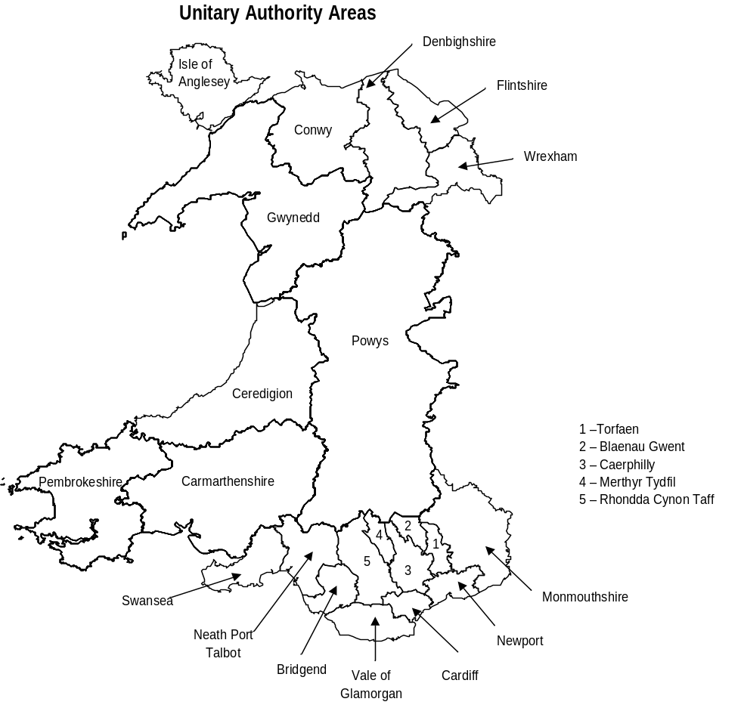

Crown copyright material is reproduced with the permission of the Controller of HMSO and the Queen’s Printer for Scotland

Data sources
This report includes indicators from key data sources, major issues that must be considered when interpreting data relating to substance misuse are detailed below:-

- Welsh Health Survey
The new Welsh Health Survey provides a rich source of information about the health of people living in Wales, the way they use health services, and the factors that can affect their health. It replaces the former Welsh Health Surveys undertaken in 1995 and 1998 and the former Health in Wales surveys undertaken every two to three years between 1985 and 1996.
The new Welsh Health Survey is based on a representative sample of adults aged (16 and over) and over living in private households in Wales. At each household contacted, all adults are eligible for inclusion in the survey. A small amount of information is also collected about children (under 16s) from parents or guardians. Fieldwork for the survey began in October 2003, and was planned to run initially for a continuous two-year period until September 2005; the survey has since been extended and is planned to run until at least 2008. Data included within this report are taken from the results of the second year of the survey (2004/05) published in August 2006 (NAfW, 2006a). Local authority data is also included where appropriate based on data combined from the first two years of the survey (NAfW, 2006b). This replaces provisional local authority results from the first year of the survey (2003/04), published in July 2005 (NAfW, 2005). New results from the survey will be made available on the National Assembly for Wales website at http://new.wales.gov.uk/topics/statistics/theme/health-survey/?lang=en
It is important to note that the results from the new Welsh Health Survey are not comparable with those from previous surveys because of differences in both questionnaire and survey design. Additionally the survey excludes people living in institutions. When considering results from the survey it is important to note that people living in institutions are likely to be, on average in poorer health than those living in private households.
During the first two years’ of the survey a household interview was obtained with 74% of eligible households in the sample. Self-completion questionnaires were obtained for 84% of adults in participating households with around 32,300 adults participating fully in the survey. Response rates for the first and second year of the survey and for individual LHBs are available from the respective Welsh Health Survey reports. (NAfW, 2006a; NAfW, 2006b; NAfW, 2005).

- Health Behaviour in School aged Children
The Health Behaviour in School-aged Children (HBSC) study is an international research study conducted in collaboration with the World Health Organisation Regional Office for Europe, and is administered in Wales by the Health Promotion Division of the Welsh Assembly Government. The study is school based and in Wales involves pupils from school years 7 (age 11-12), 9 (age 13-14) and 11 (age 15-16). Data are collected via a self-completion questionnaire which is administered under exam conditions. Pupils who are absent due to sickness or for other reasons are not followed up. General information about the international HBSC study is available from www.hbsc.org. The latest international report (using 2001/02 data) is available from the site which presents data at an all-Wales level alongside findings from 30+ other countries (WHO 2004). The Health Promotion Division of the Welsh Assembly Government have additionally produced a series of briefing reports using 2001/02 data which can be downloaded from:
http://www.cmo.wales.gov.uk/content/work/schools/hbsc-e.htm#reports

- British Crime Survey
The British Crime Survey (BCS) is a large nationally representative survey of adults living in private households in England and Wales. In addition to asking respondents about their experiences of crime, the BCS also asks about a number of other crime related topics. Since 1996 the BCS has included a comparable self-completion module on questions on illicit drug use. From 1996, those aged under 16 were not eligible for interview, while those aged 60 or over were not asked to complete the drugs component (based on low prevalence rates for the use of prohibited drugs in the over 60s) (Roe, 2005).
Results relating to drug misuse are reported for 2004/05 and are based on the 28,509 respondents who completed the drugs module of the BCS and an extra 2,653 16 to 24 year olds who were also interviewed as part of the 2004/05 youth boost. The response rate for the core BCS sample was 75% and 74% for the 16-24 year old youth boost (Roe, 2005).
It is important to note that as a household survey, the BCS does not cover some small groups, this is potentially important given that they may have relatively high rates of drug use: notably the homeless, and those living in certain institutions such as prisons or student halls of residence. It is also important to note that a household survey is unlikely to reach those problematic drug users whose lives are so busy or chaotic that they are hardly ever at home.
Data relating to Drug Misuse are reported annually from the British Crime Survey (Walker et al, 2006). Data relating to 2004/05 is currently available and is included in this report. It is important to note that drug misuse data from the latest BCS (2005/06) will be available in October 2006 and can be accessed from the Home Office website at
http://www.homeoffice.gov.uk/rds/bcs1.html [accessed 15th August 2006].

- Comparative Analysis System for Prescribing Audit (CASPA)
This report contains data relating to methadone and buprenorphine prescribing by GPs in Wales between April 2004 and March 2006. It is important to note that the data are based on prescriptions for dispensing in the community sector, in community pharmacies. Prescribing through secondary care providers, voluntary sector agencies and prisons are therefore excluded. Prescribing to Welsh patients by English GPs is also excluded. The source of the data is the Comparative Analysis System for Prescribing Audit (CASPA).

Methadone and buprenorphine are prescribed as substitute medication for the treatment of problem opioid misuse, to prevent or minimise the onset of withdrawal symptoms. Methadone and buprenorphine are both used as oral medicines suitable for maintenance therapy. The choice of opioid substitute will depend on individual patient treatment needs, although methadone is generally more often used compared to buprenorphine, as yet. Treatment often continues with maintenance prescriptions but some patients will be able to reduce or stop substitute therapy (detoxification) when appropriate.

The data are presented as items per 1,000 prescribing units for Welsh LHBs. Items refers to the number of individual items on a prescription. Prescribing units (PU) are a weighting measure used to standardise the number of prescription items. Patients under 65 years of age and temporary residents are treated as a single PU, whilst patients aged 65 years and over are counted as three PUs.

Prescribing data are assigned to LHBs based on the address of the GP practice rather than the address of the patient. If a GP practice with branch practices crosses more than one LHB, all prescriptions from all branches are assigned to the LHB where the main branch is sited.

- Welsh National Database for Substance Misuse
The Welsh National Database for Substance Misuse (WNDSM) is managed by Health Solutions Wales on behalf of the Welsh Assembly Government and contains data relating to people referred for drug and alcohol problems to treatment agencies within Wales since April 1st 2005. Prior to the establishment of the WNDSM, data collection relating to drug and alcohol misuse referrals was incomplete, with low compliance and a lack of standardised data definitions. The new system attempts to address some of these problems.
This report presents data from the first complete year of the database (April 1st 2005 to March 31st 2006) (Health Solutions Wales, 2006a). The data are based on a frozen file taken on 19th June. The system is however dynamic, this means that the figures quoted in this report could change as more data becomes available. However, such changes are unlikely to affect the observed patterns.
Within this report, data is presented for 2005-06 by age, sex and main drug of use. Data is additionally presented for Community Safety Partnership (CSP) areas, these are co-terminous with local authority and Local Health Board boundaries (see section 1.1). They were established under the 1998 Crime and Disorder Act, which placed a statutory responsibility on Chief Officers of police and of Local Authorities to work with other partners to formulate and implement a community safety strategy. This led to the formation of Crime and Disorder Reduction Partnerships or Community Safety Partnerships (CSPs). Under the 2002 Police Reform Act, the Fire Service and Local Health Boards were also included within the partnership, and CSP areas required to formulate and implement strategies for combating substance misuse alongside those for crime and disorder.
The system is based on ‘referrals’ not individuals. It is important to note that the data collection system is new and as a result there are a number of issues relating to the database that still need to be resolved therefore, the data are classified as ‘experimental’ and the results should be interpreted with caution. The client population is by definition unstable and not always willing or able to provide accurate demographic information; the information handlers at agency level have not always seen the supply of information to the centre as a high priority and the technical systems support at some agencies has been of a low standard. In addition, the comprehensiveness of the information supplied to Health Solutions Wales has been variable across agencies. In 1627 cases a referral was not recorded as leading to any contact whatsoever with an agency (these referrals are excluded from any analyses presented in this report).
Other data quality issues relating to the WNDSM data presented within this report include:-

  - The number of referrals may not include clients who were referred to treatment agencies before the WNDSM started in April 2005, and who are currently still in treatment.
  - Data for some CSP areas are artificially low due to technical difficulties.
  - Many clients categorised under ‘Alcohol’ may also be receiving treatment for drug misuse.
  - Where the Local Authority of the client is unknown the Local Authority of the agency is used.

All these considerations must be kept in mind when conclusions are drawn from the figures.

- Hospital activity data
The source of hospital activity data presented within this report is the Patient Episode Database for Wales (PEDW). PEDW is managed by Health Solutions Wales (HSW) and provides an electronic record of all inpatient and daycase activity for Welsh residents in NHS hospitals in England and Wales and for patients treated in Welsh Trusts (HSW, 2006b). Records within PEDW are based on finished episodes of care under a particular consultant in one health care provider (FCEs). Multiple FCEs may occur within one hospital provider spell (or stay in hospital).

Epidemiological analysis of PEDW data using either FCEs or provider spells as the currency have proved unreliable. This is because there is variation in the way provider spells and episodes are recorded across NHS trusts. For example, three identical pieces of care could possibly result in a different number of provider spells and FCEs depending upon where in the country the patient was treated. This can lead to double or treble counting of some patients. See the table below for a hypothetical example where the patient is admitted as an emergency and requires cardiac revascularisation.

 | 5th January | 6th January | 15th January
Patient A admitted to Trust X | Admitted under general medicine for assessment | Patient transferred to cardiology – 2nd FCE begins | Following operation and rehabilitation, patient is discharged
Patient B admitted to Trust Y | Admitted under general medicine for assessment | Patient is transferred to neighbouring trust with specialist cardiology services | Following operation and rehabilitation, patient is discharged

In the above scenario an analysis of provider spells would count patient A once, and patient B twice. An analysis of FCEs would count patient A twice and patient B twice. Real examples may be far more complex but the point is that although the diagnosis and treatment may be the same the resulting analysis may be different.

In addition to the problem of counting provider spells and FCEs, very often, people may be admitted to hospital more than once during a year for the same underlying illness. Once again for epidemiological analysis it is preferable to avoid counting such persons more than once.

In order to try to overcome these problems hospital activity data for Welsh residents presented within this report are based on ‘persons per year’ (rather than FCEs or spells) where the admission date is between 1st January 1999 and 31st December 2005. This methodology counts a patient once per calendar year, irrespective of how many separate admissions to hospital they may have had during that year. The methodology is still in its infancy and the results should therefore be treated with some caution. It is important to note that there are a number of limitations to the ‘patient per year’ methodology; for example a patient admitted for separate provider spells in December 2003 and January 2004 will be counted twice (once for 2003 and once for 2004) whilst a patient admitted for separate provider spells in January and February 2004 will only be counted once. It is also worth noting that the number of ‘patients per year’ admitted for different conditions will not add to the total for all cause ‘patients per year’. Despite these limitations, the patient per year methodology is believed to give a more meaningful rate than counting FCEs or provider spells.

The ‘patient per year’ analysis has been modified for the analysis of seasonal variation in conditions such as food poisoning and flu, for which it is conceivable that the same individual may be admitted for multiple unrelated spells on a fairly frequent basis. For these analyses, the algorithm used has been adjusted to allow the same individual to be counted once per calendar month.

It should be noted that data for 2005 has only recently been made available and as such, coding variations may exist between trusts that may affect the results.

This report presents data showing variations in hospitalisation rates between local authorities in Wales. In theory, different levels of need should account for different hospitalisation rates, however the interplay between healthcare supply, need and demand is complex and in practice, admission to hospital is dependent of a variety of factors including

- Distance from home
- Ability to cope if living alone
- Bed availability
- Surgeons’ propensities to operate rather than treat patients in an outpatient setting.

HSW monitors the quality of PEDW data, but does not provide any indication of the quality of service in terms of technical success, patient satisfaction and outcome (PIE, 2001). Whilst quality has improved in recent years variations in coding and completeness are still known to exist. Welsh Assembly Government has established a task and finish group to investigate variations in coding between trusts. It should be noted that PEDW is subject to many validity checks but these may not reveal all the variations in coding between trusts (PIE, 2001).

- Mortality data (annual district death extract)
This report presents data from the Annual District Death Extract (ADDE). The ADDE is supplied to the NPHS by the Office for National Statistics on an annual basis, and is based on details from the medical certificate of cause of death and other relevant particulars supplied by informants (usually relatives) to local Registrars. The process of death registration in England and Wales is very complex and governed by a variety of laws.
Information presented within this report relates to deaths registered between 1st January 1996 and 31st December 2004. Trend data are presented and additional breakdowns by age, sex, LHB of residence, are provided, as appropriate. For some indicators selected indicators are also presented at Middle Super Output Area (MSOA) level. Major issues that must be considered when interpreting mortality data are detailed below.
Most mortality statistics including those presented within this report are based on the ‘underlying cause of death’. This is generally the most useful single cause for public health purposes (Devis and Rooney, 1999), and is defined by the World Health Organisation as:
- the disease or injury that initiated the train of events directly leading to the death; or
- the circumstances of the accident or violence that produced the fatal injury.
Comparison of time trends of deaths is complicated by many changes to the system of collecting and classifying causes of deaths over the years. The main change affecting trend data presented in this report is the introduction, in January 2001, of the tenth revision of the International Classification of Diseases (ICD-10). ICD-10 replaces ICD-9 and is the most important revision to ICD in over 50 years.
There are significant differences between ICD-9 and ICD-10 that mean that data coded to ICD-10 is not directly comparable with data coded to ICD-9. The main changes are that some diseases and groups of conditions have moved between broad ICD chapters to reflect current ideas of aetiology and pathology. Several changes have also been made to the rules governing the selection of the underlying cause of death (there are now only 5 rules instead of 9). However, the changes in the application of Rule 3 have had the largest impact. In ICD-10 the list of conditions affected by Rule 3 is more clearly defined than in ICD-9 and is also broader in scope. Its impact is to reduce the number of deaths assigned to certain conditions such as pneumonia and to increase the number of deaths assigned to chronic debilitating diseases. In England and Wales about 20% of deaths mention pneumonia so the effect of the change in Rule 3 is large.
ONS has carried out a comprehensive study to analyse the results of the change in the classification. The results are presented as comparability ratios or the ratio of the number of deaths coded to a cause in ICD-10 to the number of deaths coded to the equivalent cause in ICD-9. These ratios can then be used to adjust comparisons at or near the time of change over. Further details are available from the ICD-10 for mortality website at:
http://www.statistics.gov.uk/about/classifications/icd10/default.asp.
It is important to note that comparability ratios have not been applied to trend data presented within this report.
Analysis by area of residence is based on the information supplied by the informant (usually a relative) to the Registrar. Although the effect is likely to be minimal it is important to note that since 1993 it has been up to the informant to decide which address to give if more than one is applicable. For example, a parent registering the death of a student in term time may give the parental home or the term time address of the student. Another example is where an informant provides a private home address rather than the address of a nursing home (or communal establishment) even where the death may have occurred in the communal establishment or when the deceased may have lived there for many months (ONS, 2005).
The underlying cause of death is based on the medical certificate of cause of death (MCCD), this is completed by the certifying doctor for about three quarters of deaths and by a coroner for the remainder. Most of the deaths certified by a coroner do not involve an inquest or any suspicion of violence; but are referred to the coroner because they were sudden and unexpected, or because there was no doctor in attendance during the deceased’s last illness (or because the attending doctor was not available to complete the MCCD). Numerous checks and validations are carried out to ensure the quality of mortality data. However, the data are used for many purposes which may not all be best served by the current system. It is important to note that with many thousands of doctors writing certificates, the differences in their training, habits, and knowledge mean that there will inevitably be variations in the quality of MCCDs (ONS, 2005).

Rates
Rates presented in these analyses are either crude or age standardised.

Crude rate
A crude rate is simply the total number of events divided by the total number at risk. For example, the infant mortality rate is a crude rate defined as the number of children who died before reaching one year of age who were resident in an LHB (during a specified time period) divided by the total number of live births to mothers who were resident in the same LHB (during the same specified time period). When taken over a single time period, whether that be a single or group of years, this is effectively a proportion and hence is a measure of the risk of an event occurring.
Crude rates are given more context by scaling them up to an appropriate population. In the example of infant deaths the crude rate is quoted as the number of infant deaths per 1000 live births. It is therefore possible to calculate the actual number of events in a given population if both the crude event rate and the population at risk are known.
Crude rates are primarily used when there is no need or justification for making any adjustment for potentially confounding factors, such as age. They may also be of use in calculating the expected volume of events in a known population.

Age standardised rate
An age standardised rate is a comparative statistic which uses the age specific crude rates of an area, for example an LHB, to produce a figure which represents the total number of events that would occur in a standard population if that standard populations age specific crude rates were the same as those of the LHB. For example, the European Age Standardised Rate (EASR) for deaths due to coronary heart disease in an LHB is the number of coronary heart disease deaths that would occur in the standard European population if the age specific crude rates of the European standard population were the same as those of the LHB.
This is not a proportion and is not a measure of the risk of an event occurring. It is a measure that allows for direct comparison between LHBs (or other geographical entities) as long as they have all been calculated on the basis of the same standard population.
The actual standard population does not matter greatly but rates standardised to different standard populations are in no way comparable. Throughout these analyses the standard European population has been used as this is widely used within Europe and therefore any such analyses here are directly comparable with those produced on an identical basis elsewhere. The standard European population itself is based on the proportion of the total population in the typical European country that fell into each five year age group at some point in time. It almost certainly no longer reflects the actual proportions in each age group but this is irrelevant as what is of the most importance is its consistent definition and use.
It is important to note that its outcomes can in no way indicate whether an LHB or other geographical entity is better or worse than Europe.
As the rates are thankfully often very small it is standard practice in these analyses to present them scaled up to rates per hundred thousand population. This can lead to two problems of misinterpretation.
- Firstly, it is obvious that many areas, particularly sub LHB level, have fewer than one hundred thousand residents. This is irrelevant as the scaling to one hundred thousand is primarily to avoid presenting rates for rare events, such as suicide, which may have to run to a number of decimal places to get any figure other than zero.
- Secondly, although the rates are quoted as per hundred thousand it is not possible to calculate the actual number of events in a given population if both the standardised event rate and the population at risk are known.
Standardised rates are primarily used when there is a need or justification for making an adjustment for potentially confounding factor of age. Such rates are then of use for drawing direct comparisons between areas such as LHBs.

Confidence intervals and statistical significance
Where applicable and possible to do so, 95 per cent confidence intervals have been calculated. Confidence intervals are indications of the natural variation that would be expected around a rate and they must be considered when assessing or interpreting a rate.
In the context of this report all rates are essentially estimates of the true population rate, whether they be calculated from survey data, such as the Welsh Health Survey, or from other data sources. As such the 95 per cent confidence interval represents a range which has a 95 per cent probability of including the true population rate.
The size of the confidence interval is dependent on the size of the population from which the events came and an assumption about the statistical distribution of the data. Generally speaking, rates based on small populations are likely to have wider confidence intervals. Conversely, rates based on large populations are likely to have narrower confidence intervals.
Confidence intervals cannot be used to assess the statistical significance of different areas, only an appropriate statistical test can do so. It is true that if a measure for Wales is outside the confidence interval for the LHB then an appropriate statistical test would always indicate a statistically significant difference. However the converse is not true, hence they cannot be used as a true test for statistical significance.

Setting the Scene

- Substance misuse in the Welsh context refers to the problem use of illicit or prescribed drugs and or alcohol.
- Within Wales the strategic leads from WAG now rests with the minister for Social Inclusion - not Health and Social Care. The Strategy for substance misuse was produced in 2001 and has been followed by an ongoing programme of good practice guidance on specific issue e.g. prescribing and needle exchange. The agenda has had a focus on crime and disorder
- From a public health perspective three of the major issues are:
- co-morbidity i.e. the co-existence of a mental health problem and problem substance misuse
- the impact of alcohol misuse on the physical health of the population in Wales.
- the maintenance and development of effective needle exchange schemes
Policy guidance produced by the NPHS on a) and c) above was produced in 2003 and NPHS good practice guidance will be available in 2007.

General data issues
- It is difficult to assess the exact levels of substance misuse both in the general population and in those with mental health problems. Data on incidence and prevalence of those with co-morbidity is not routinely available in Wales, though prevalence rates may be estimated from data collected separately on mental illness and substance misuse. Prevalence is thought to be rising .
- Treatment agencies routinely collect data on those in receipt of treatment but this does not identify co-morbid presentations.

Alcohol

The use of alcohol is embedded within British culture. However, for some people, social drinking can lead to heavier drinking, leading to excessive, hazardous or harmful alcohol consumption and sometimes dependence (collectively known as problem use of alcohol). Problem use of alcohol can cause serious social, psychological and health problems, affecting work, social and personal relationships. Health risks associated with heavy drinking include:

- liver disease (cirrhosis of the liver),
- alcohol-related anaemia and nutritional disease,
- chronic calcifying pancreatitis,
- heart muscle damage (cardiomyopathy),
- alcoholic dementia, and
- Psychiatric disorders.

Alcohol has recently been identified as the third highest risk to health in developed countries (Alcohol Concern, 2006).

Patterns of alcohol misuse

Welsh Health Survey
Data from the Welsh Health Survey shows that in response to a question asking about the average units consumed on a day of drinking alcohol, 40 per cent of adults reported that their alcohol consumption was above the recommended guidelines of no more than four units a day for men and no more than three units per day for women (see following figure). The data is standardised for age and sex.

Data supporting this chart can be found in table 1 of the appendix.
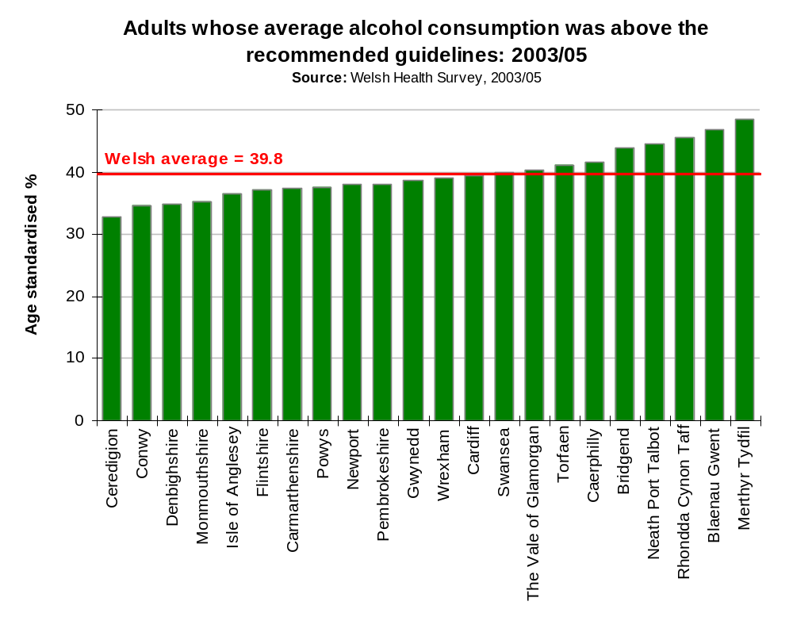
Binge drinking is becoming a big problem in the UK. Around 40 per cent of patients admitted to A&E are diagnosed with alcohol-related injuries or illnesses (Sussex Partnership NHS Trust, 2006). Binge drinking is defined as drinking eight or more units of alcohol in one session for men, and more than six units in one session for women.
Data from the Welsh Health Survey showing the standardised proportion of adults who reported binge drinking on at least one day in the past week, shows that 19 per cent of adults report binge drinking in the past week (figure below). The data are in response to a question about the most units drunk on any one day in the last seven days. Binge drinking means men drinking more than eight units in a day; women more than six units. Based on all adults (drinkers and non-drinkers). The number of adults both drinking above recommended levels (previous chart), and binge drinking (following chart) at LHB level (the chart above) show a similar pattern.

Data supporting the following chart can be found in table 2 of the appendix.

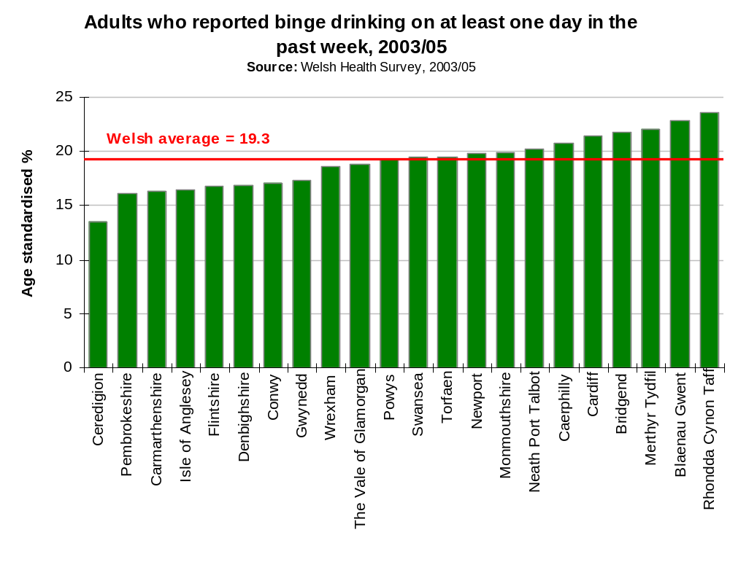

Health Behaviour in School aged Children Survey
Adverse health outcomes resulting from alcohol use are common among young people and many alcohol-related deaths occur relatively early in life. They also include intentional and unintentional injuries, both of which are related to patterns of drinking. The negative social consequences include missing school, falling behind in schoolwork, unplanned and unprotected sexual activity, arguments with friends, destructive behaviour and trouble with the police (WHO, 2004).
Data from the Health Behaviour in School Aged Children (HBSC) Survey included within this report show the percentage of young people who drink any alcoholic drink weekly. Weekly drinking is defined as reportedly consuming alcohol once a week or more.
The following chart shows that seven per cent of 11-year old girls and 12 per cent of 11-year old boys in Wales reported drinking any alcohol on a weekly basis.
Data supporting this chart can be found in table 3 of the appendix.
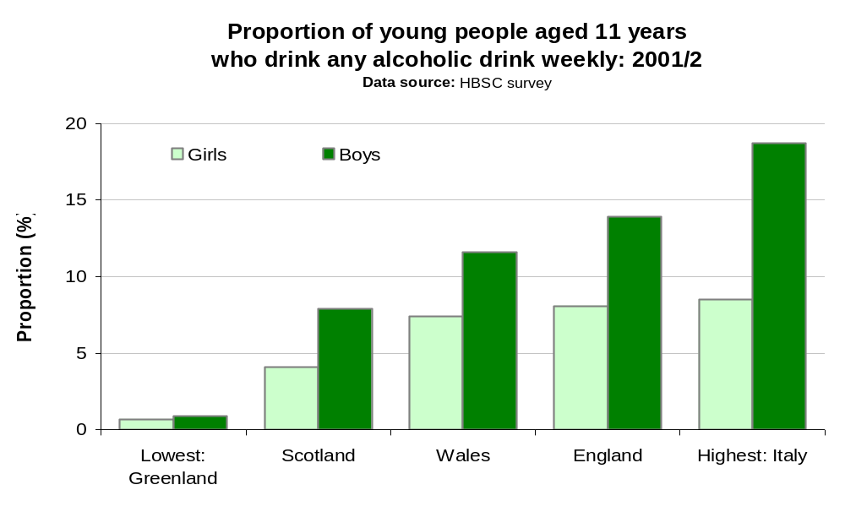
For 13-year olds nearly a quarter of girls and a third of boys in Wales reported drinking any alcoholic drink weekly. Comparative data are included for England and Scotland. The figure below (and appendix table 4) shows that the Welsh figure is almost as high as that for England, which has the highest reported proportion of 13 year olds drinking weekly of all the countries participating in the survey.
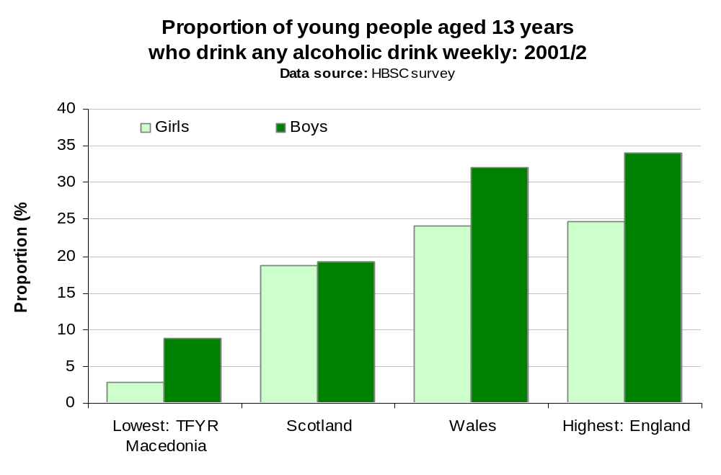
Data for 15-year olds shows that Wales has the highest proportion of young people in this age group reporting to drink on a weekly basis, of all the countries participating in the HBSC survey. Over 50 per cent of girls and almost 60 per cent of boys reported drinking alcohol on a weekly basis. Data supporting this chart can be found in table 5 of the appendix.
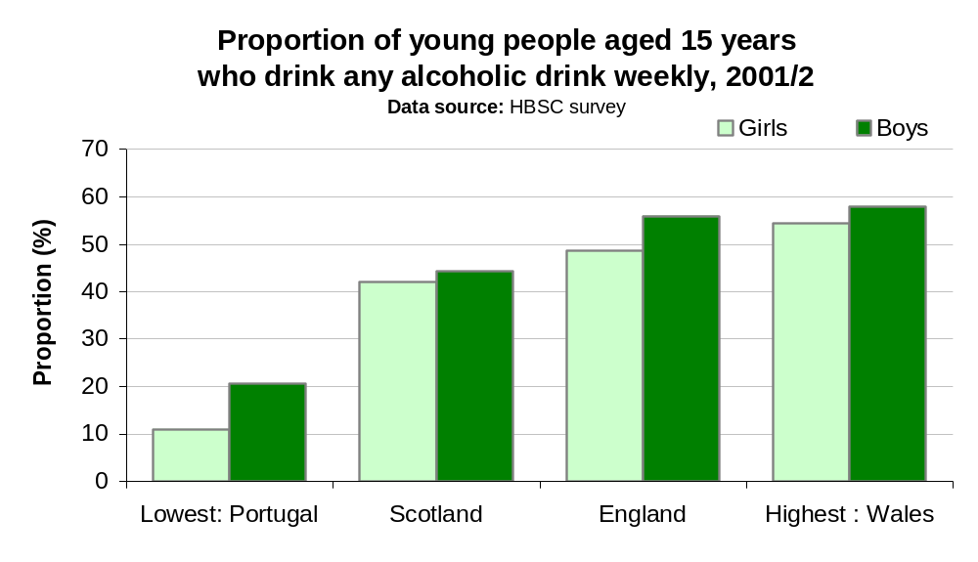

Referrals for treatment for alcohol misuse

Welsh National Database for Substance Misuse
The Welsh National Database for Substance Misuse contains details relating to people referred for drug and alcohol problems to treatment agencies within Wales since 1st April 2005. Data are presented within this report for the first full year of the database (1st April 2005 to 31st March 2006). The data are classified as experimental and the results should be interpreted with caution; further details are provided in section 1.2.
The following figure shows the age and sex distribution of referrals for alcohol misuse to the WNDSM, for 2005/06. The table shows that 32 per cent of referrals for men and 27 per cent of referrals for women were for people aged 30 years of age and under. The number of referrals can be seen to be greatest in the 30-39 and 40-49 age groups. The number of referrals for alcohol misuse for men was 1.9 times higher the number of referrals for women.

Data supporting this chart can be found in table 6 of the appendix.
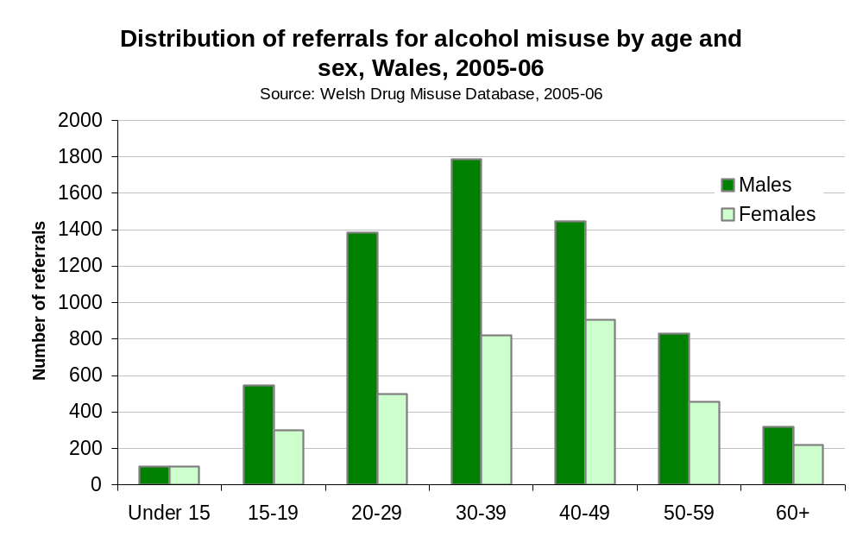
The following table presents data for Community Safety Partnership (CSP) Areas. Information about CSPs is provided in section 1.2. It is important to note that in addition to the data quality issues highlighted in section 1.2 the interpretation of data at this level is complicated by the proportion of cases referred to treatment agencies for unspecified problems. For 2005/6 this averages 15 per cent, but ranges from one per cent to 47 per cent at LHB level. Whilst these data are helpful at LHB level it is difficult to make comparisons between LHBs, particularly given the different levels of service provision across Wales.
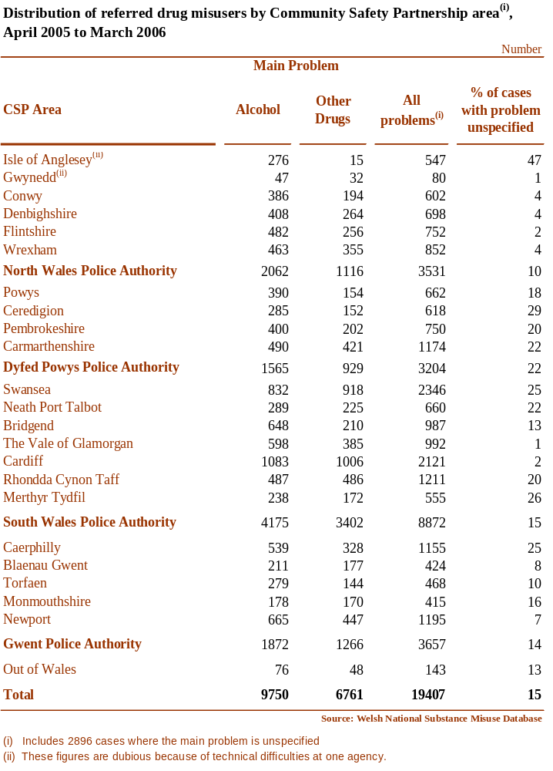

Hospital activity
Data are presented within this section of the report for ‘patients per year’ (further details are provided in section 1.2). Every record in PEDW has a space for up to 14 diagnoses and 12 procedures (severity is not measured). Over the years, the most important (principle) diagnosis and procedure has not always been coded in the first position; despite national standards rules and conventions for the coding of data. Therefore analysis included within this report is based on any mention of the diagnosis (or procedure) in question. It is important to note that this will often produce a different result from one based on the first or principle diagnosis.

Details of the ICD-10 codes used for the hospital activity and mortality analysis within this report are shown in the appendix.

The following figure shows age and sex specific crude rates for people admitted to hospital with alcohol related conditions. For all age groups, admissions are higher for men compared with women. Admissions peak for men in the 45-54 age group and for women in the 35-44 age group.

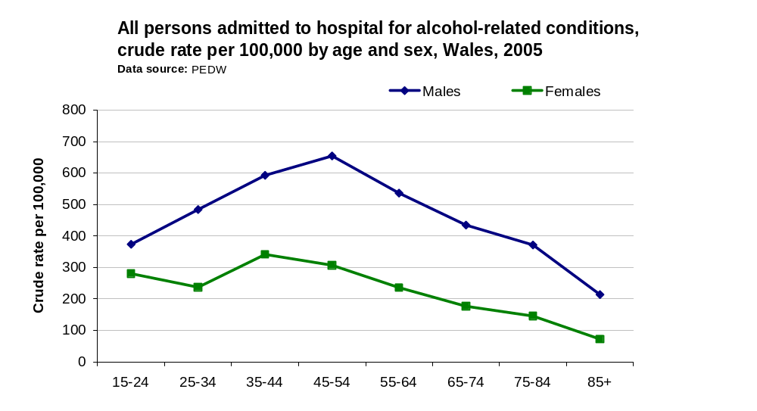

Data supporting this chart can be found in table 7 of the appendix

The following figures show hospital admissions for alcohol related conditions at LHB level. The data are age standardised to take account of the differences in age structures within different LHBs. The all-Wales EASR of 309 per 100,000 population for alcohol related hospital admissions can be seen to range at LHB level from 200 to 490 per 100,000 population. (Data supporting this chart can be found in table 8 of the appendix).

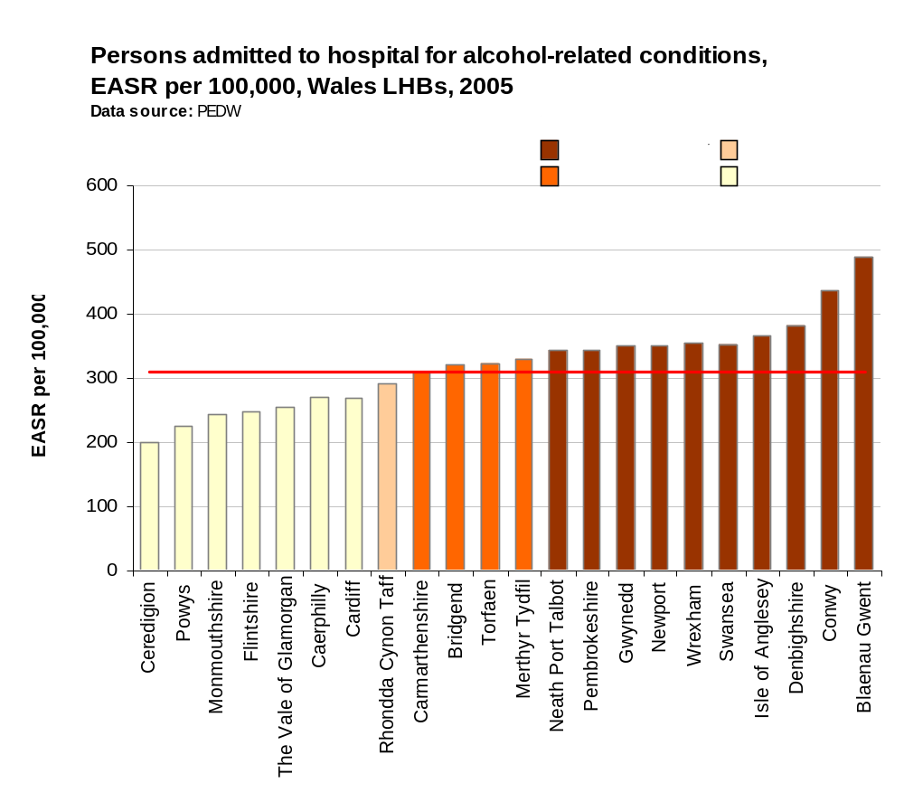
This data is presented separately for men and women in the following figures. The all-Wales EASR of 405.4 for men is almost double the rate for women (218.2 per 100,000 population).

Data supporting this chart can be found in tables 9 and 10 of the appendix.

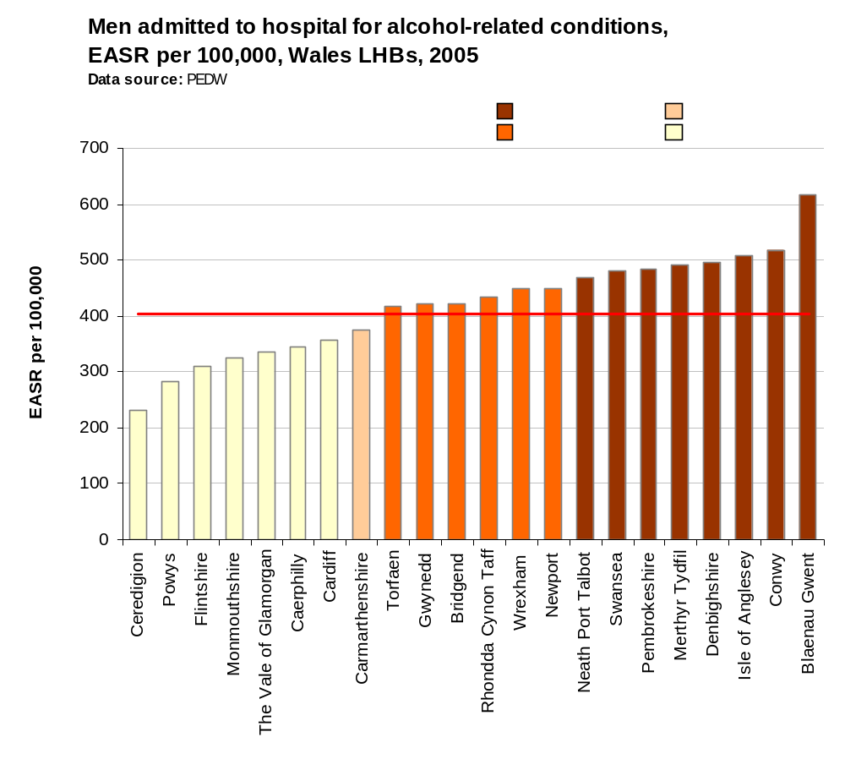

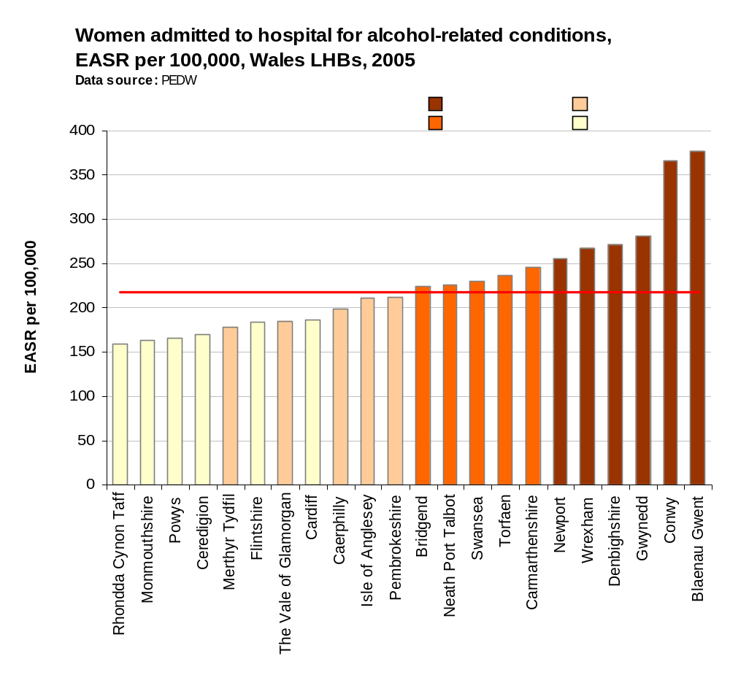

Trend data for hospital admission for alcohol related conditions are shown in the following chart. For both men and women an increase in the number of people admitted for alcohol related conditions can be seen. Data supporting this chart can be found in table 11 of the appendix.
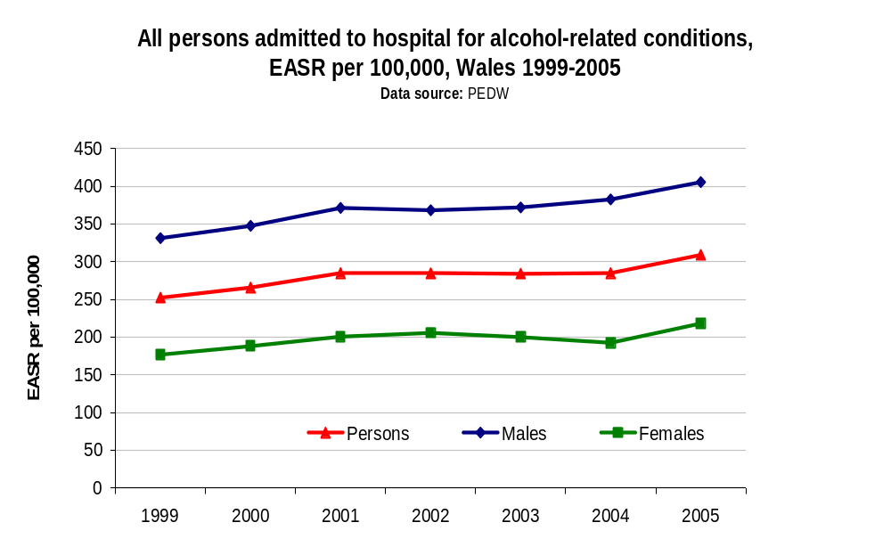

Mortality
This section presents alcohol related mortality data, using the recently revised definition of alcohol related deaths, based on those causes regarded as most directly due to alcohol consumption (ONS, 2006). It is important to note that this definition differs from that used previously in analyses undertaken by the NPHS for Wales.
The following figure shows an age and sex breakdown for the average annual number of deaths resulting from alcohol related conditions for Wales. Between 2002 and 2004 there were on average 398 deaths resulting from alcohol related conditions. The number of deaths can be seen to peak for both men and women, in the 50-54 age group.
Data supporting this chart can be found in table 12 of the appendix.
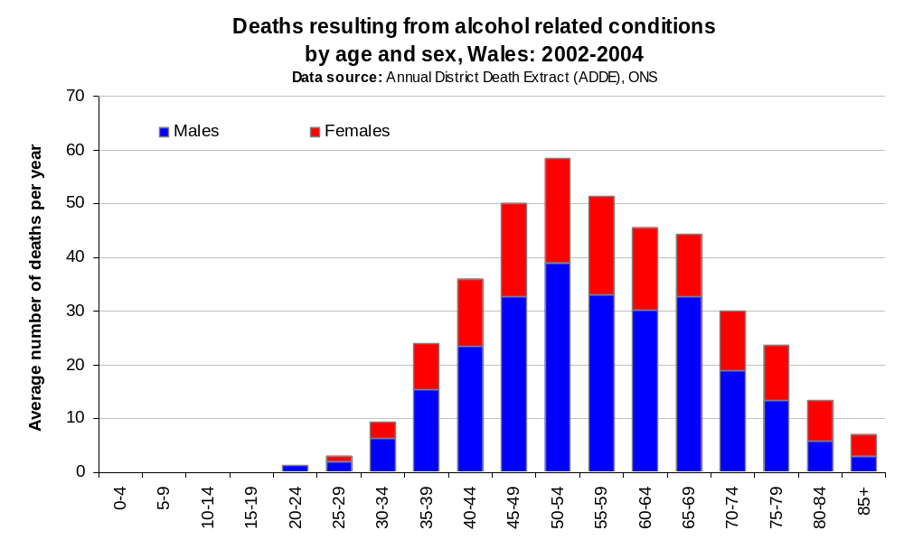

The following figure (and appendix table 13) presents data showing three-year rolling average EASMRs for alcohol related mortality between 1996 and 2004. The all-Wales EASMR can be seen to increase from 10.2 per 100,000 population in 1996-1998 to 14.0 per 100,000 population in 2002-2004.
It is however, important to note that caution needs to be applied when comparing deaths coded using ICD-9 (pre 2001) and ICD-10 (2001 onwards). Further details on the effect on alcohol related deaths is available from the following link
http://www.statistics.gov.uk/downloads/theme_health/Defining_alcohol-related_deaths.pdf#search=%22%22ONS%20-%20Defining%20alcohol-related%20deaths%22%22 [accessed 14th September 2006].
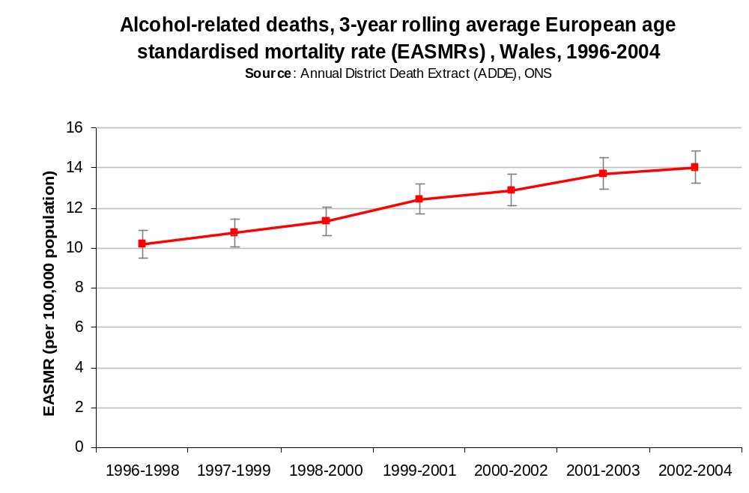

Drug Misuse

The UK has a higher prevalence of drug misuse than any other country in Europe (Morgan et al, 2006). This is important because the problem use of illicit or prescription drugs carries many serious health risks, often because they are not controlled or supervised by medical professionals. Street drugs are often mixed with many other substances, which can be more harmful than the drugs themselves.
As well as having immediate health risks, some drugs can cause physical or psychological dependency, with the result that larger amounts are needed to get the same effect often leading to long-term damage to the body. Heavy or long-term use of some illegal drugs may cause the user to overdose, which may cause permanent damage to the body and can be fatal.

Patterns of drug misuse

British crime survey
The British crime survey (BCS) provides an important source of information both about levels of crime and public attitudes to crime. Since 1996 the survey has included a number of questions about illicit drug use.
This section of the report presents the latest available BCS data relating to drug misuse from the 2004/05 British crime survey.
It is important to note that drug misuse data from the latest BCS (2005/06) will be available in October 2006 and can be accessed from the Home Office website at http://www.homeoffice.gov.uk/rds/bcs1.html [accessed 15th August 2006].
The following figures show the proportion of both adults and young adults reporting to use any drug in the last year by Government office region. Drug use ‘in the last year’ is deemed to be the best indicator to measure trends in recent drug use (Roe, 2005).
The figures show that 11 per cent of adults (aged 16-59 years of age) and almost a third (30.1 per cent) of young adults (aged 16-24 years of age) in Wales reported using drugs in the last year. The figure for young people for Wales, with the exception of the South East is higher than the proportion reported for other government office regions in England and Wales.
Data supporting these figures can be found in table 14 of the appendix.

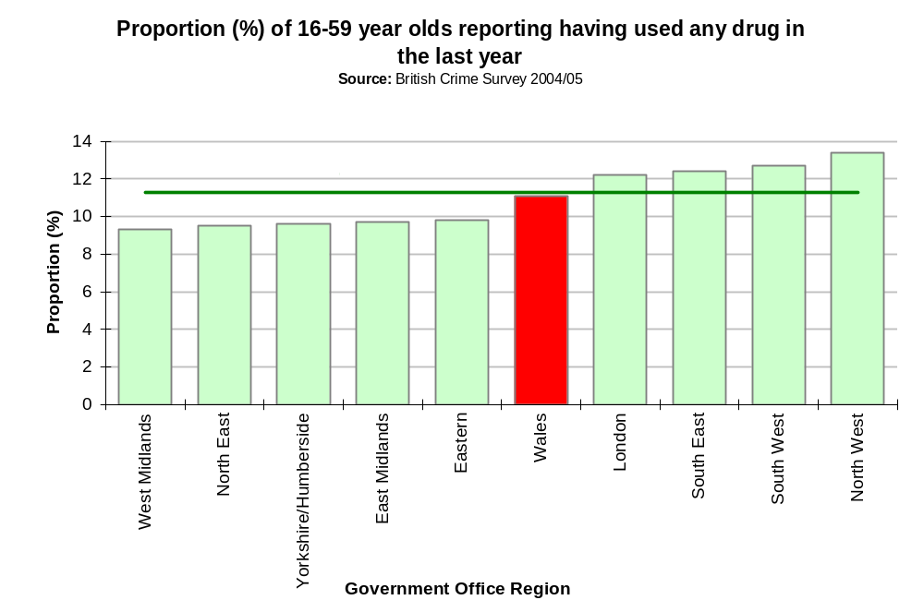

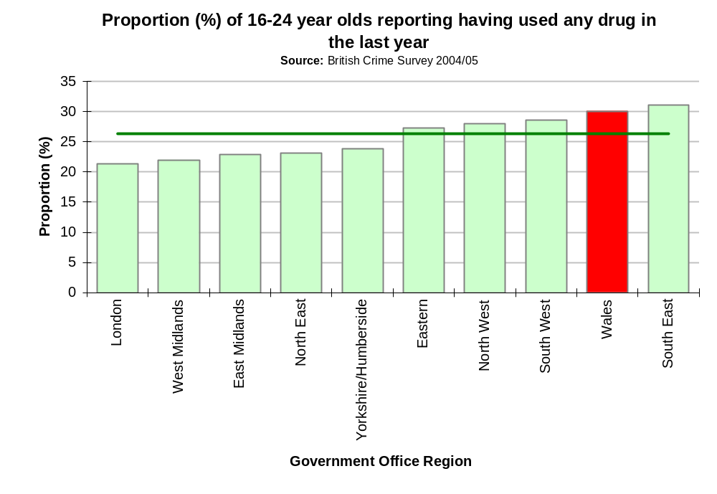

Health Behaviour in School aged Children Survey
The Health behaviour in school aged children (HBSC) survey asked young people (15 year olds only) about cannabis use. This section of the report presents data from the HBSC survey on both the use and the frequency of cannabis use during the last year.
The following chart presents data showing the proportion of young people using cannabis in the previous year. Use is more common among boys than girls (see also appendix table 15).
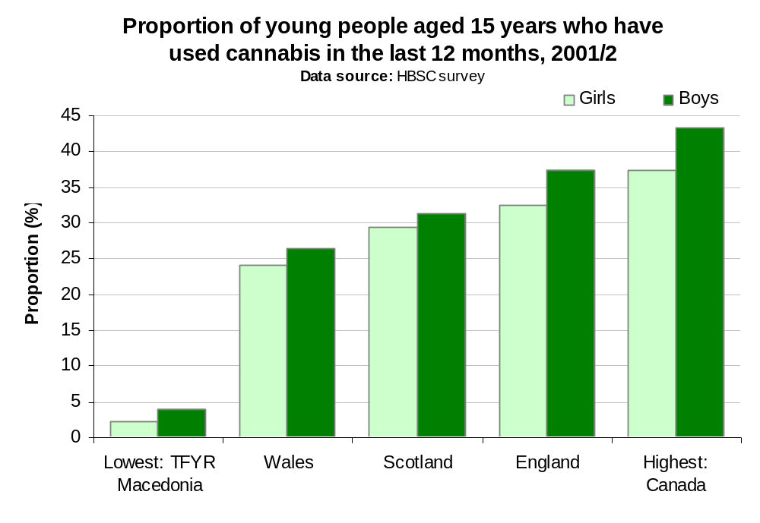
While research suggests that the recreational use of cannabis may not harm social functioning, heavy use may be an indicator of problem behaviour, both internalised and externalised, such as depression, risk taking and deviance. Although most users in all countries and regions belong to the experimental or recreational groups and seem to be able to control their cannabis use, the HBSC sample comprises relatively young age groups. The small numbers reporting heavy use (see below for definitions) at this stage of their lives may well be at risk of adverse health and social consequences and should be the focus of targeted interventions (WHO, 2004, p87).
The following chart presents information showing the frequency of cannabis use among 15 year olds (further details are available in appendix table 16). The proportion of regular users and, to a greater extent, heavy users is lower in Wales than in England or Scotland.
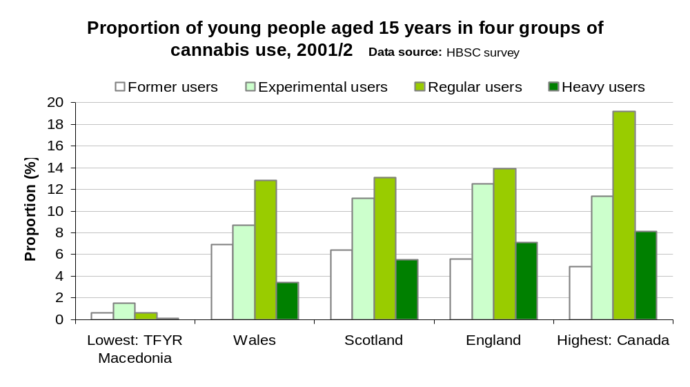

Referrals for drug misuse

Welsh National Database for Substance Misuse
The Welsh National Database for Substance Misuse (WNDSM) contains details relating to people referred for drug and alcohol problems to treatment agencies within Wales since 1st April 2005. Data are presented within this report for the first full year of the database (1st April 2005 to 31st March 2006). The data are classified as experimental and the results should be interpreted with caution (further details are available in section 1.2).
The following figure shows the age and sex distribution of referrals for drug misuse to the WNDSM, for 2005/06. The table shows that 58 per cent of referrals for men and 61 per cent of referrals for women were for people aged less than 30 years. The median age on referral is 27. The number of referrals can be seen to be greatest in the 20-29 and 30-39 age groups. The number of referrals for drug misuse for men was almost two and a half times higher than the number of referrals for women.
Data supporting this chart can be found in table 17 of the appendix.
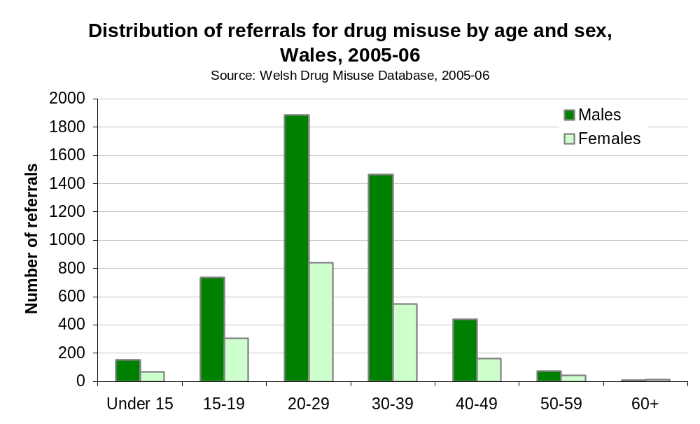

The following table shows the distribution of referrals to the WNDSM by main problem drug.
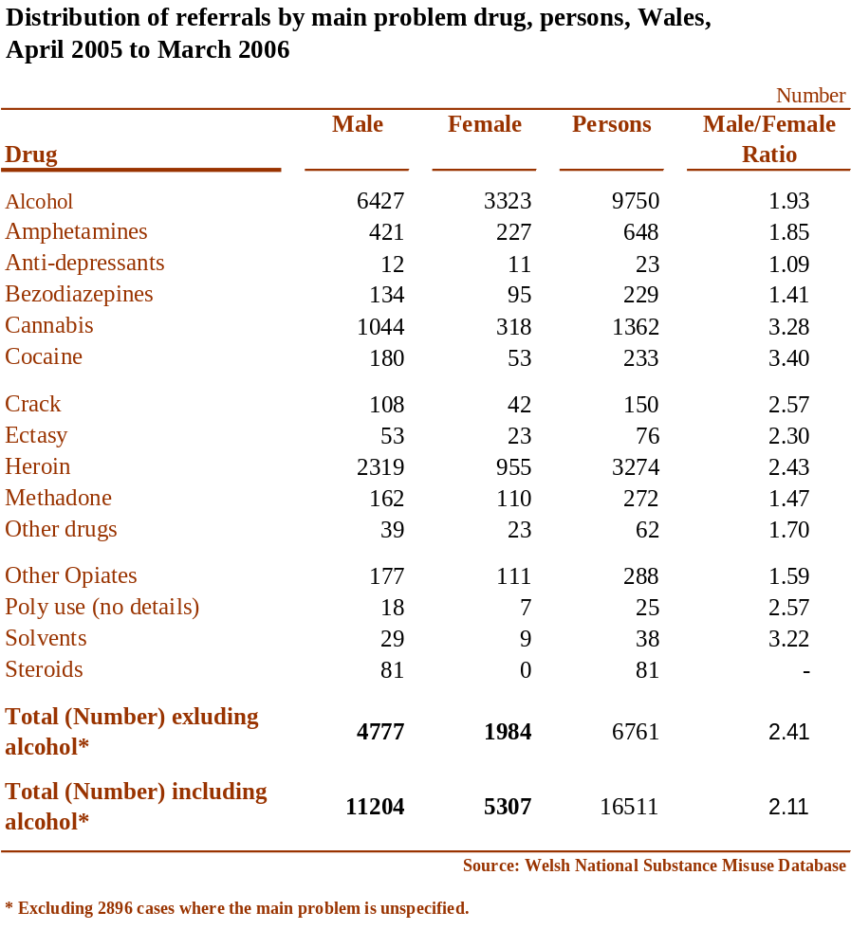
Section 3.2.1 presents WNDSM data for Community Safety Partnership Areas (CSPs). At CSP level the number of referrals for drug misuse shows wide variation. However, it is important to consider this variation in the context of both the data quality issues highlighted in section 1.2 and the variation in the proportion of cases where the problem is unspecified. As for alcohol referrals these data are helpful at LHB level but it is difficult to make comparisons between LHBs, particularly given the different levels of service provision across Wales.

Comparative Analysis System for Prescribing Audit
The chart below shows prescribing for methadone and buprenorphine between April 2004 and March 2006. The data are from the Comparative Analysis System for Prescribing Audit (CASPA), and are expressed as items per 1,000 Prescribing units (further details about this data source are given in section 1.2). The data shows some degree of variation in prescribing at LHB level. A number of factors are likely to affect the levels of prescribing and may include e.g. availability of GP shared-care schemes for opioid substitute therapy, availability of community pharmacies for supervised ingestion services, prevalence of opioid misuse, prevalence of injecting drug use and availability of home detoxification services.
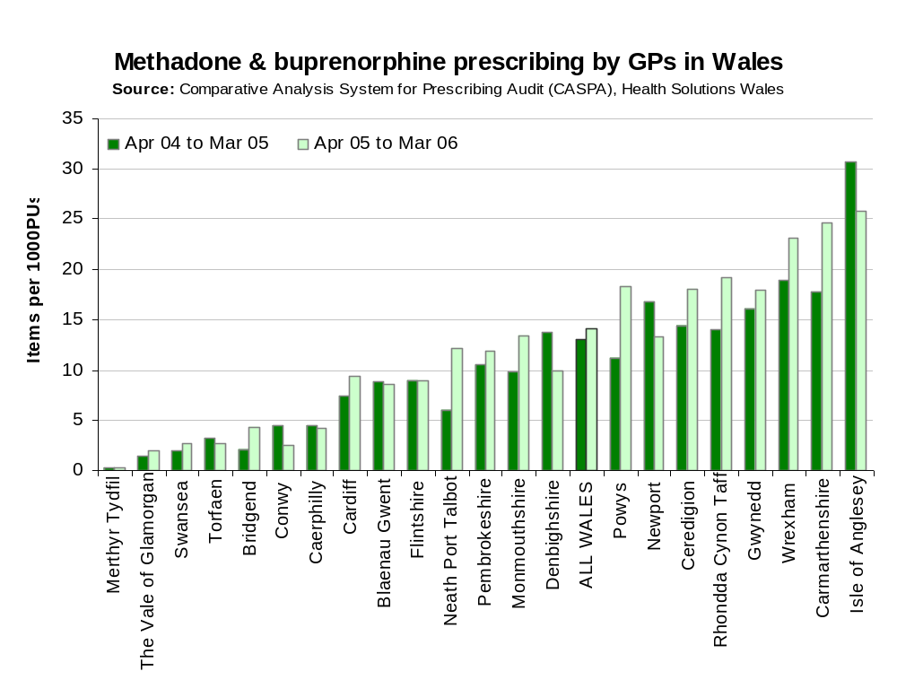

Further details are available in table 18 of the appendix.

Hospital activity

Data are presented within this report based on inpatients (involving an overnight stay) and daycases. A daycase is defined as a patient admitted electively to a bed during the course of a day with the intention of receiving care or treatment which can be completed in a few hours so that they do not need to remain in hospital overnight and who then return home as scheduled (HSW, 2006c).

Every record in PEDW has a space for up to 14 diagnoses and 12 procedures (severity is not measured). Over the years, the most important (principle) diagnosis and procedure has not always been coded in the first position; despite national standards rules and conventions for the coding of data. Therefore analysis included within this report is based on any mention of the diagnosis (or procedure) in question. It is important to note that this will often produce a different result from one based on the first or principle diagnosis.
The definition of drug related hospital admissions used within this report are those specified by the European Monitoring Centre for Drugs and Drug Addiction (EMCDDA) The EMCDDA definition gives fewer hospital admissions than the broader ONS definition. The patient based analysis used to extract hospital activity is based on the codes outlined in the appendix. The codes included cover accidents and suicides involving drug poisoning as well as poisoning due to drug abuse and dependence but not other adverse effects of drugs. The range of substances includes legal and illegal drugs, prescriptions drugs and over-the-counter medications.
The following figure presents drug related hospital admissions by age and sex for 2005. Admissions can be seen to peak in the younger age groups. Data supporting this chart can be found in table 19 of the appendix.
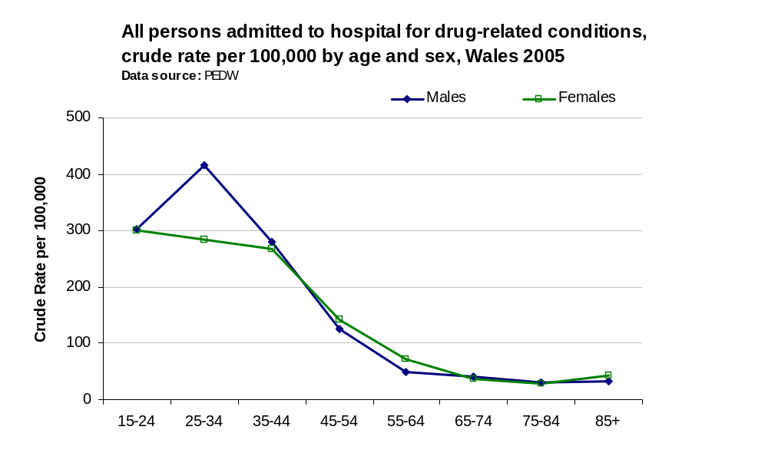

The following figures show hospital admissions for drug related conditions at LHB level. The data are age standardised to take account of the differences in age structures within different LHBs. The all Wales EASR of 166 per 100,000 population, can be seen to range at LHB level from 81 to 229 per 100,000 population. (Data supporting this chart can be found in table 20 of the appendix).

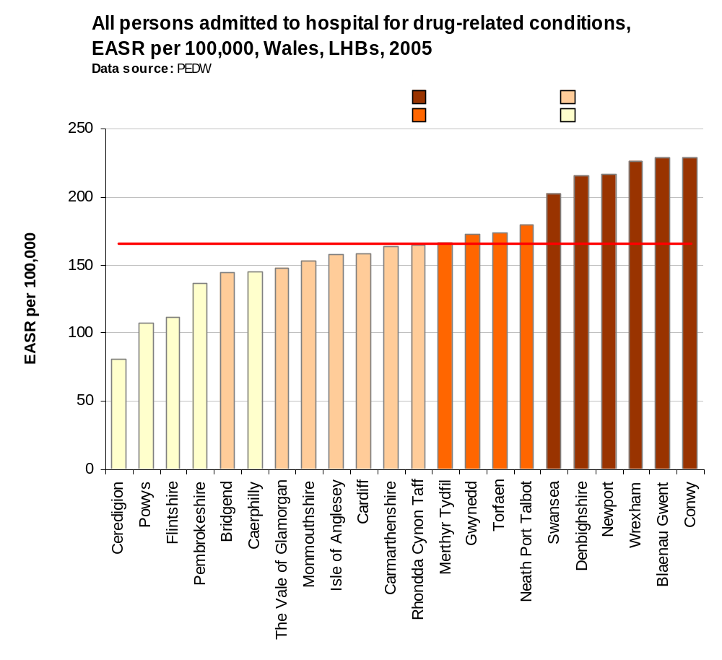
The all-Wales drug related hospital admission EASR for men, of 172.6 per 100,000 population compares with the rate for women of 159.6. Compared to Wales, Wrexham, Conwy and Newport can be seen to have significantly higher EASRs for drug related hospital admission for women. EASRs for drug related hospital admission for men show that additionally Blaenau Gwent, Denbighshire, Swansea and Neath Port Talbot have significantly higher drug related hospital admission EASRs compared to Wales.
Data supporting the following charts can be found in tables 21 and 22 of the appendix.
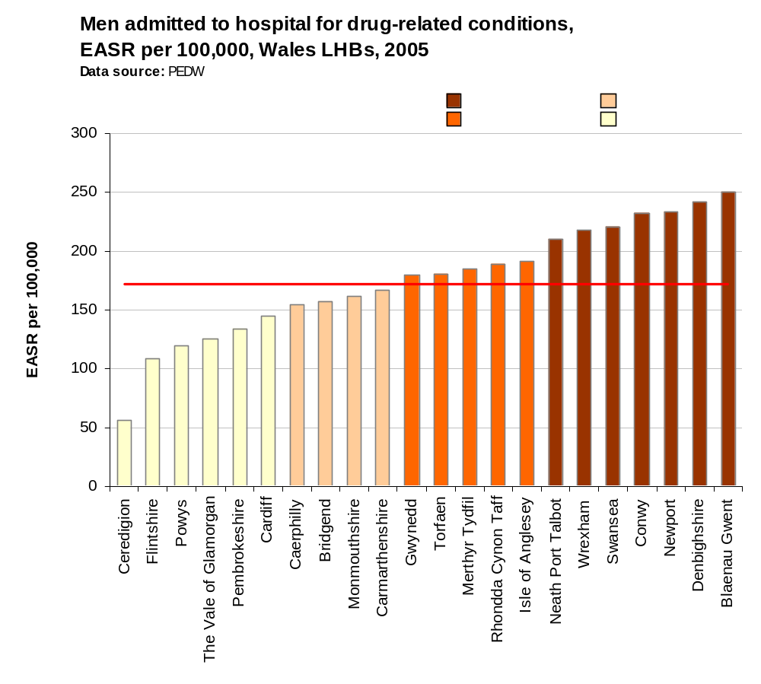
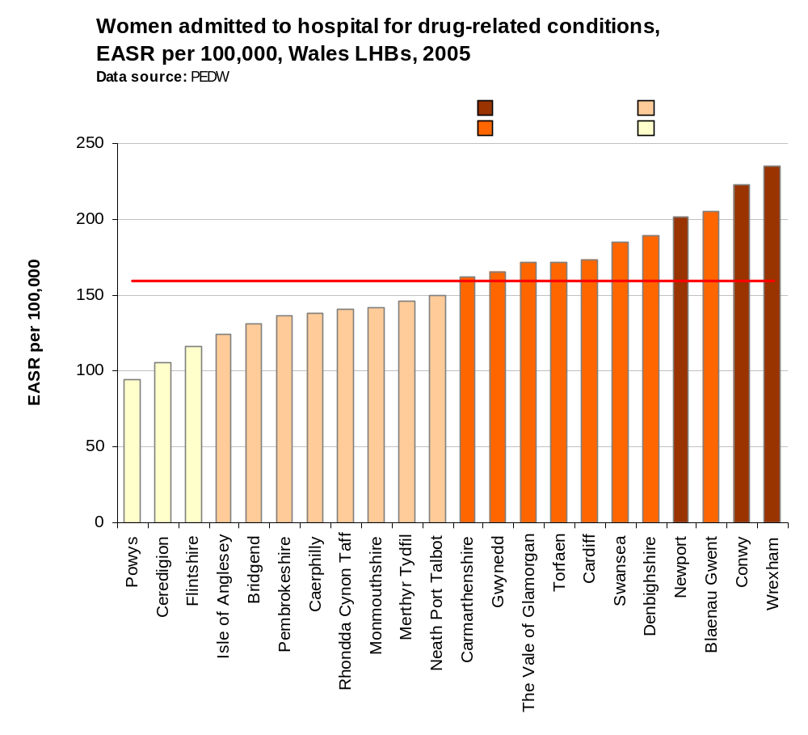
The following figure (and appendix table 23) shows trend data for EASRs for drug related hospital admissions. The number of drug related hospital admissions can be seen to have decreased between 1999 and 2005 for both, males, females and persons.

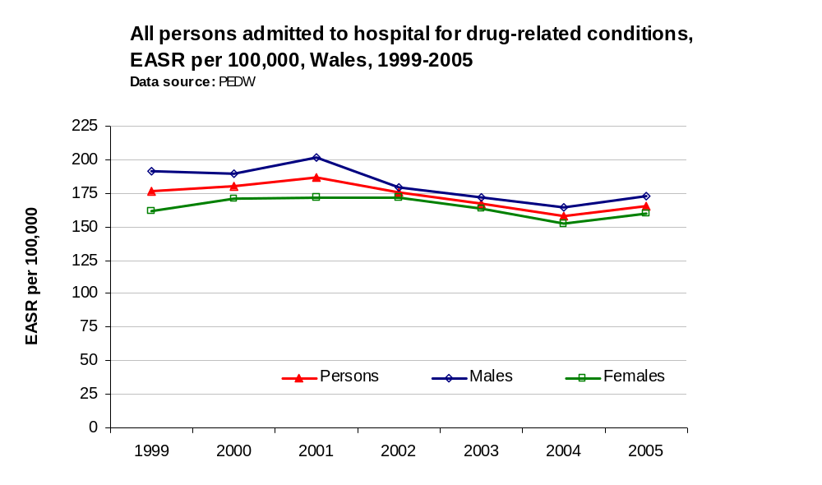

Mortality
Data relating to drug related mortality are shown below. The definition of drug related deaths used within this report are those specified by the European Monitoring Centre for Drugs and Drug Addiction (EMCDDA) The EMCDDA definition gives a fewer number of deaths than the broader ONS definition. The specific ICD-10 codes used to extract mortality data for this report are shown in the appendix. This definition was applied to mortality data using the underlying cause of death only. The codes included cover accidents and suicides involving drug poisoning as well as poisoning due to drug abuse and dependence but not other adverse effects of drugs. The range of substances includes legal and illegal drugs, prescriptions drugs and over-the-counter medications.
The following figure shows an age and sex breakdown for the average annual number of deaths resulting from drug related conditions at the all-Wales level. Between 2002 and 2004 there were on average 112 deaths resulting from drug related conditions (appendix table 24). Overall for every woman who died from drug related conditions three men died. The number of deaths can be seen to peak in the 20-34 year olds
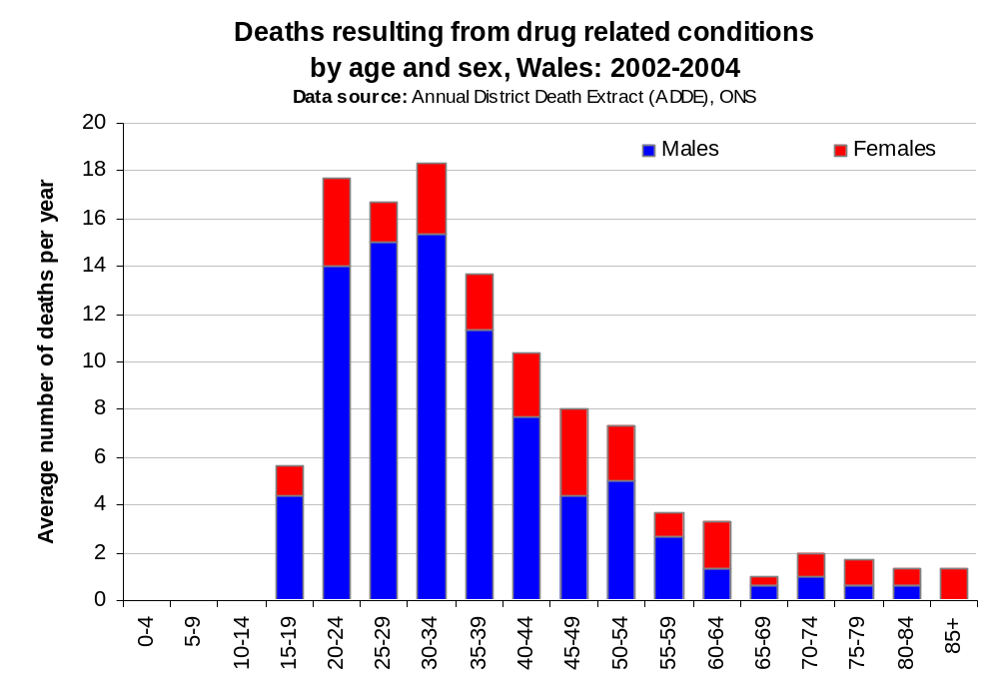

National drugs and alcohol helpline
Wales’ first free and bilingual drugs and alcohol helpline became fully operational on 1st September 2006 (Welsh Assembly Government, 2006).
DAN 24/7 is a national confidential service providing advice to drugs and alcohol users and anyone wanting information on substance misuse 24 hours a day, 7 days a week.
The helpline number is 0800 6 33 55 88. All calls from land lines are free, although some mobile phone networks may charge.

References

Alcohol Concern. (2006) Health impacts of alcohol. Factsheet. London: Alcohol Concern. Available http://www.alcoholconcern.org.uk/files/20060320_121128_Health%20effects%20pullout%20version%203%20March%202006.pdf [Accessed 18th Oct 2006].
Devis, T. and Rooney, C. (1999) Death certification and the epidemiologist. Health Statistics Quarterly 01, pp.21-33. Available http://www.statistics.gov.uk/downloads/theme_health/HSQ1Book.pdf [Accessed 20th Sept 2006]
Eastern Region Public Health Observatory (ERPHO). (2004) Drug misuse in the East of England. Available http://www.erpho.org.uk/Download/Public/10524/1/Drugs_report_final.pdf [Accessed17th Oct 2006]
Health Solutions Wales (2006a). Tackling substance misuse in Wales. Performance management framework: The Welsh National Database for Substance Misuse – First annual report 2006-06. Cardiff: HSW. [Experimental Statistics]
Health Solutions Wales (2006b) What is PEDW. Available http://howis.wales.nhs.uk/page.cfm?pid=28 [intranet] [Accessed 12th Sept 2006]
Health Solutions Wales (2006c) NHS Wales Data Dictionary Version 2.12. Available http://datadict.hsw.wales.nhs.uk/Current/htm/hh_start.htm [intranet] [Accessed 8th Sept 2006]
Morgan, O., Griffiths, C., Toson, B., Rooney, C., Majeed, A., and Hickman, M. (2006) Trends in deaths related to drug misuse in England and Wales, 1993-2004. Health Statistics Quarterly 31, pp.23-27. Available http://www.statistics.gov.uk/downloads/theme_health/HSQ31.pdf [Accessed 18th Oct 2006]
National Assembly for Wales (2005) Welsh Health Survey 2003/04. Cardiff: NAfW. Available http://new.wales.gov.uk/topics/statistics/publications/publication-archive/health-survey2003-04/?lang=en [Accessed 13th Sept 2006]
National Assembly for Wales (2006a) Welsh Health Survey 2004/05. Cardiff: NAfW. Available http://new.wales.gov.uk/topics/statistics/publications/health-survey2004-05/?lang=en [Accessed 13th Sept 2006]
National Assembly for Wales (2006b) Welsh Health Survey 2003/05: Local Authority Report. Cardiff: NAfW. Available http://new.wales.gov.uk/topics/statistics/headlines/health-2006/hdw20060906/?lang=en [Accessed 13th Sept 2006]
Office for National Statistics (2006) ONS - Defining alcohol-related deaths. Summary of responses to discussion paper. London: ONS. Available http://www.statistics.gov.uk/downloads/theme_health/Summary_responses.pdf [Accessed 14th Sept 2006]
Office National Statistics (2005) Mortality statistics: general review of the registrar general on deaths in England and Wales, 2003. Series DH1 no.36. London: ONS. Available http://www.statistics.gov.uk/downloads/theme_health/Dh1_36_2003/DH1_2003.pdf [Accessed 20th Sept 2006]
Public Health Information and Epidemiology Group (2001). A review of hospital utilisation in Wales: Local authority comparisons. Available http://howis.wales.nhs.uk/microsite/home.cfm?ORGID=330 [intranet] [Accessed 4th Sept 2006]
Roe, S., 2005. Home Office Statistical Bulletin. Drug misuse declared: findings from the 2004/05 British Crime Survey. London: Home Office. Available from: http://www.homeoffice.gov.uk/rds/pdfs05/hosb1605.pdf [Accessed 17 Aug 2006]
Sussex Partnership NHS Trust (2006) What is alcohol misuse. Available http://www.sussexpartnership.nhs.uk/index.cfm?page=22517 [Accessed 12th Sept 2006]
Walker, A., Kershaw, C. and Nicholas, S. (2006) Crime in England and Wales 2005/2006. Webpage. Available http://www.homeoffice.gov.uk/rds/crimeew0506.html [Accessed 17 Aug 2006]
Welsh Assembly Government (2006) New national drugs and alcohol helpline. Press release Available http://new.wales.gov.uk/news/presreleasearchive/010906helpline?lang=en [Accessed 18th Oct 2006]
World Health Organization (2004) Young peoples health in context. Health Behaviour in School-aged Children (HBSC) study: international report from the 2001/2002 survey. Denmark: WHO. Available http://www.euro.who.int/document/e82923_part_1.pdf [Accessed 15th June 2006]

Appendix

Introduction

ICD Codes used for hospital admission and mortality analysis within this report.

Alcohol
Codes as per new (2006) guidance from ONS. It should also be noted that there are difficulties associated with comparing mortality data before and after 2001 due to the change from ICD-9 to ICD-10 coding further details are available from:- http://www.statistics.gov.uk/downloads/theme_health/Defining_alcohol-related_deaths.pdf#search=%22%22ONS%20-%20Defining%20alcohol-related%20deaths%22%22
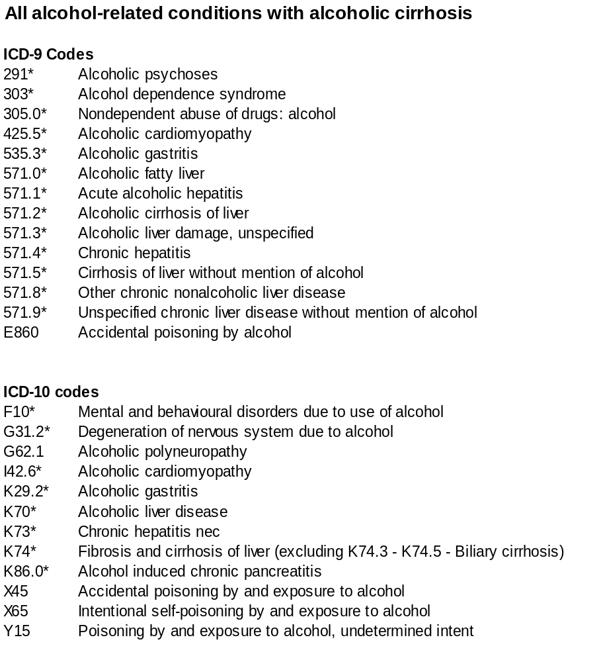

Drug misuse
The range of substances includes legal and illegal drugs, prescriptions drugs and over-the-counter medications.
ICD-10 Codes
F11-F12, F14-F16, Mental and behavioural disorders due to drug use (excluding
F19 alcohol and tobacco)
X41-X42^ Accidental poisoning by drugs, medicaments and biological
substances (excludes analgesics)
X61-X62^ Intentional self-poisoning by drugs, medicaments and biological
substances.
Y11-Y12^ Poisoning by drugs, medicaments and biological substances,
undetermined intent.
N.B. The above codes may also include any fourth-character figure.

^ EMCDDA recommend that these ICD-10 codes should be used in conjunction with T codes T40.0-9 and T43.6. It should be noted that these T codes have not been used in the analysis included in this report.

Alcohol

Table 1

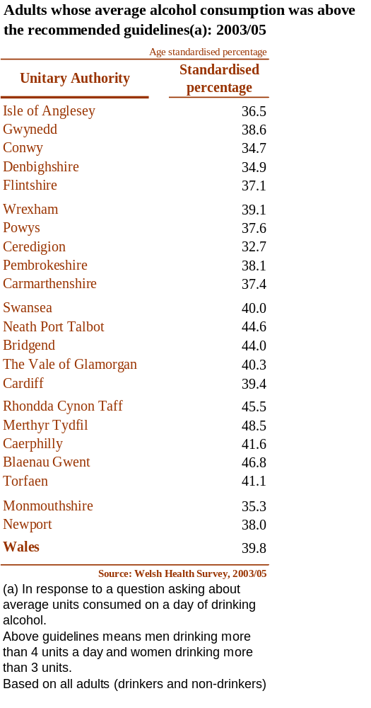

Table 2
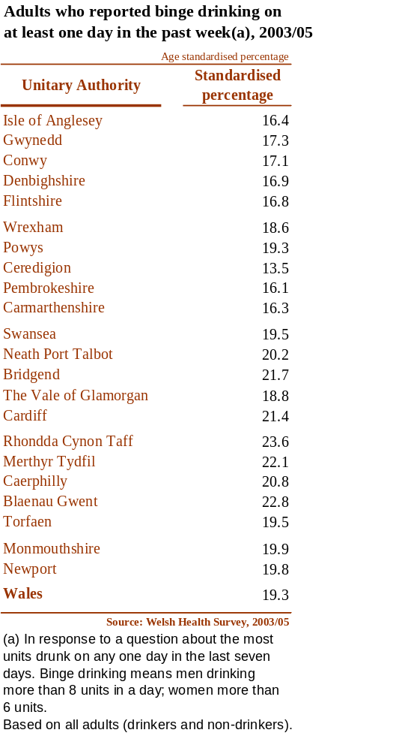

Table 3
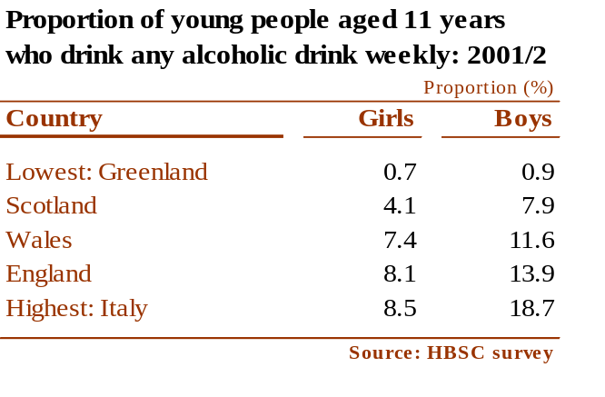

Table 4
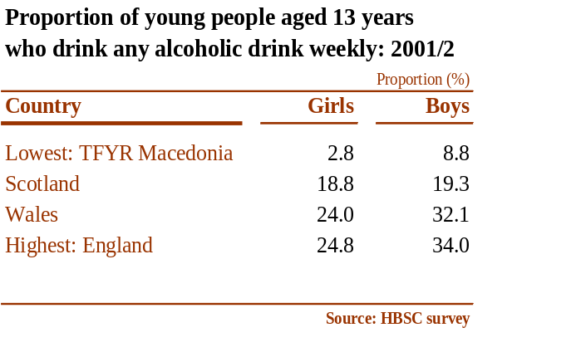

Table 5

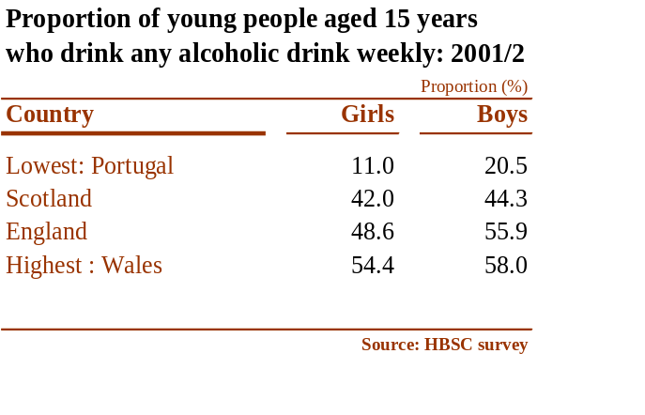

Table 6
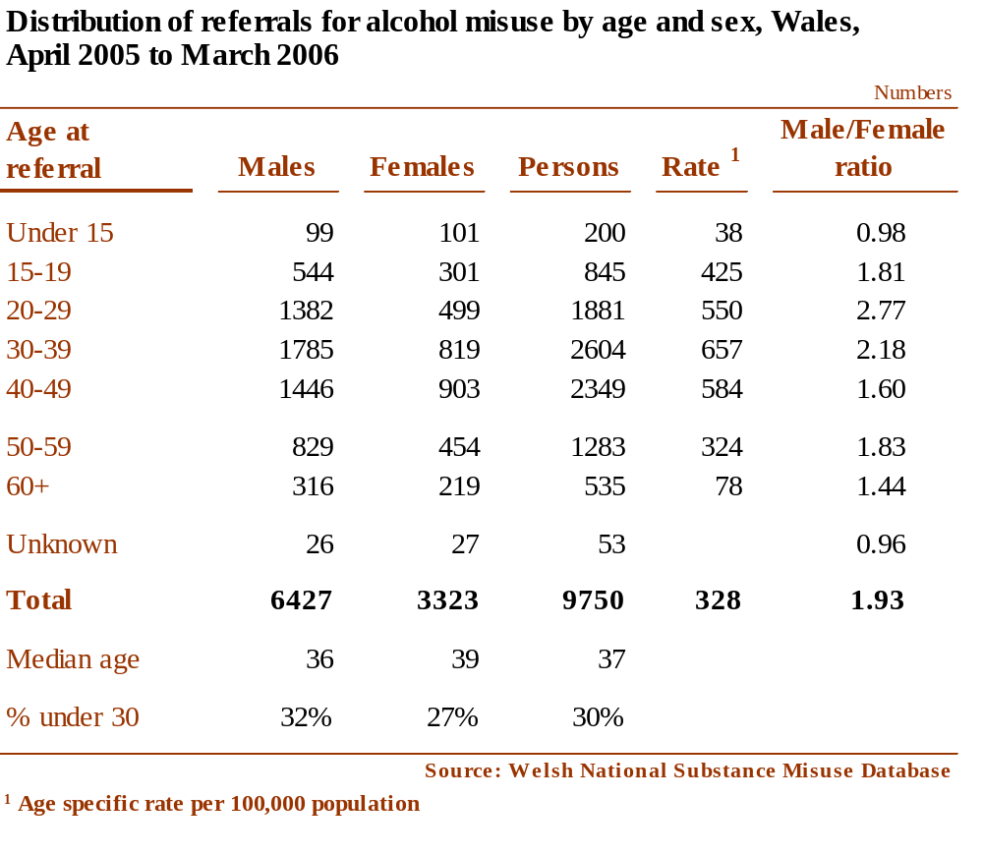

Table 7
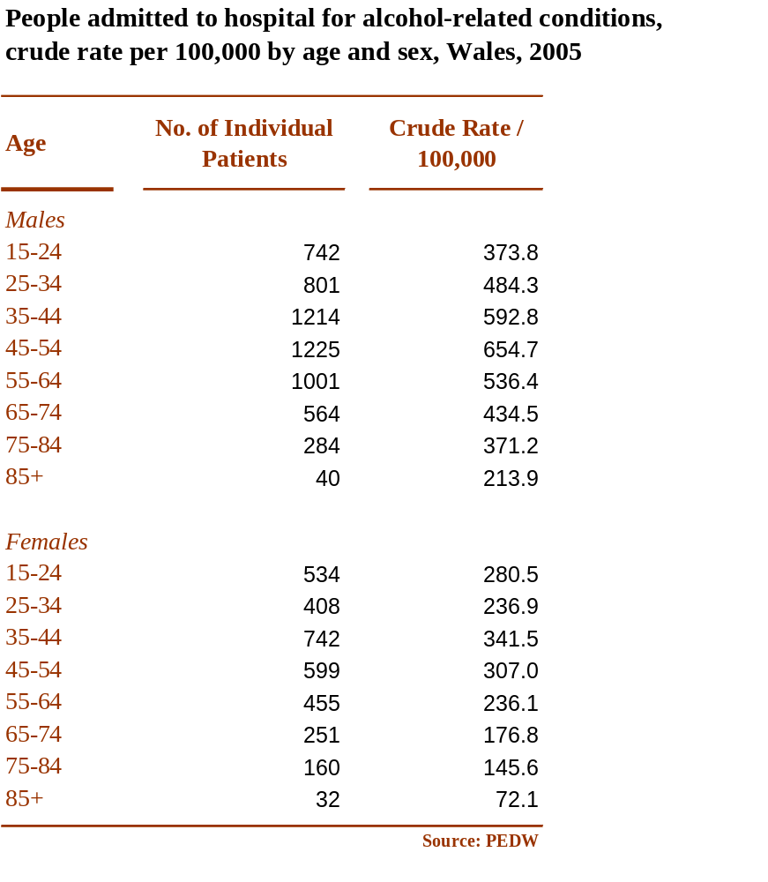

Table 8
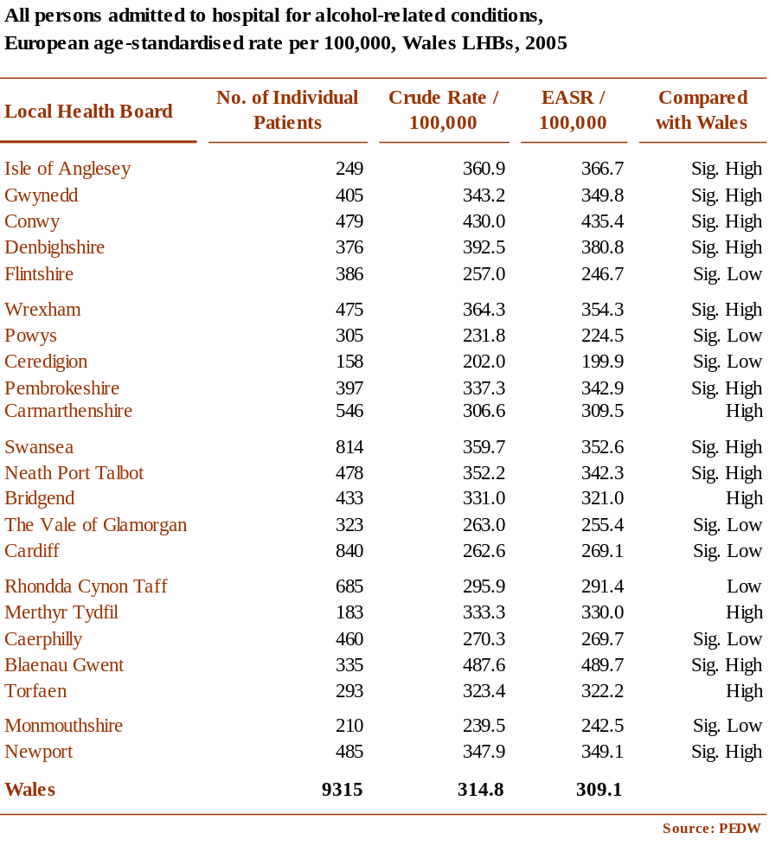

Table 9
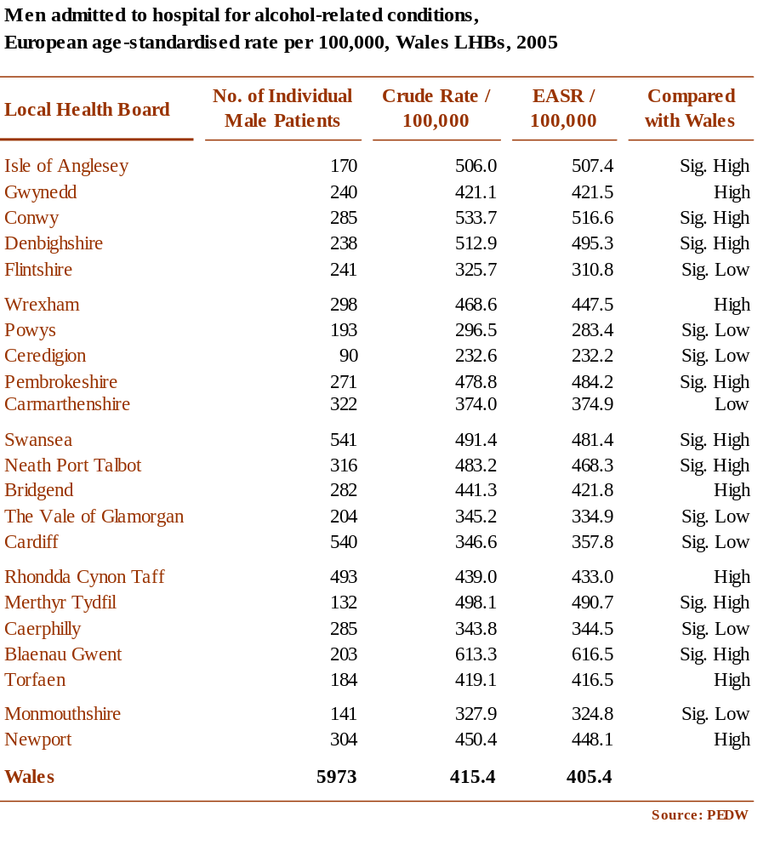

Table 10
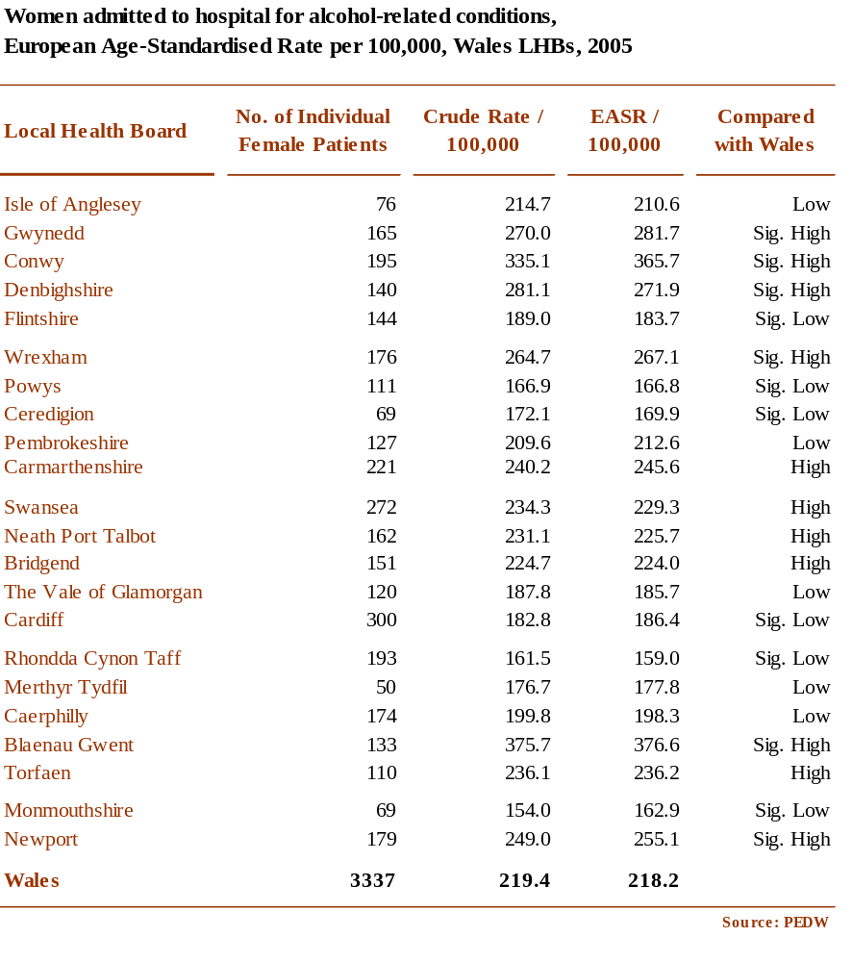

Table 11
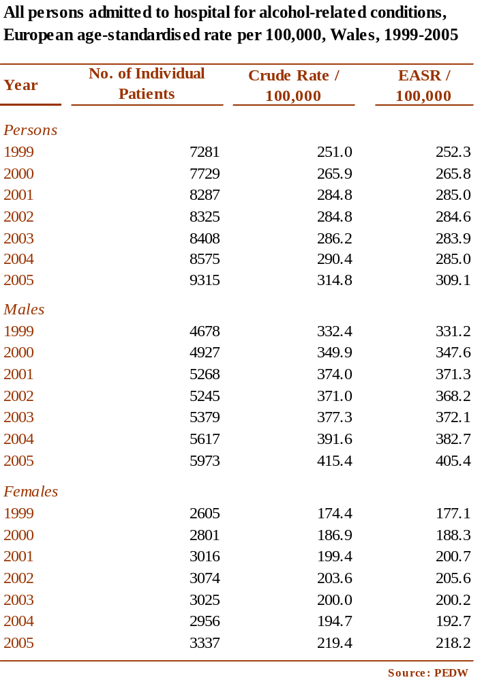

Table 12

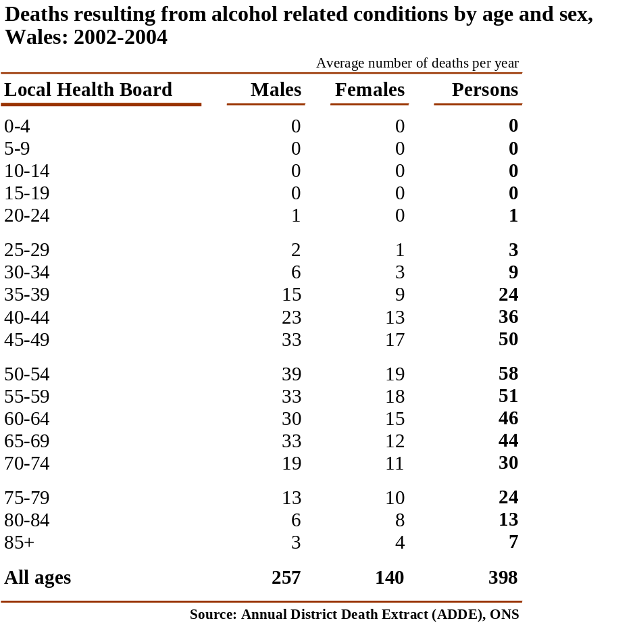

Table 13
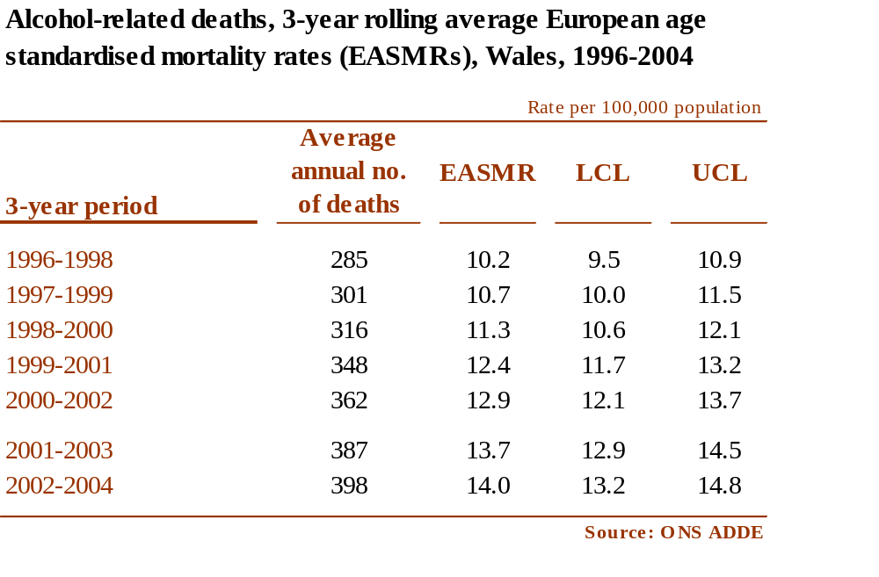

Drug misuse

Table 14
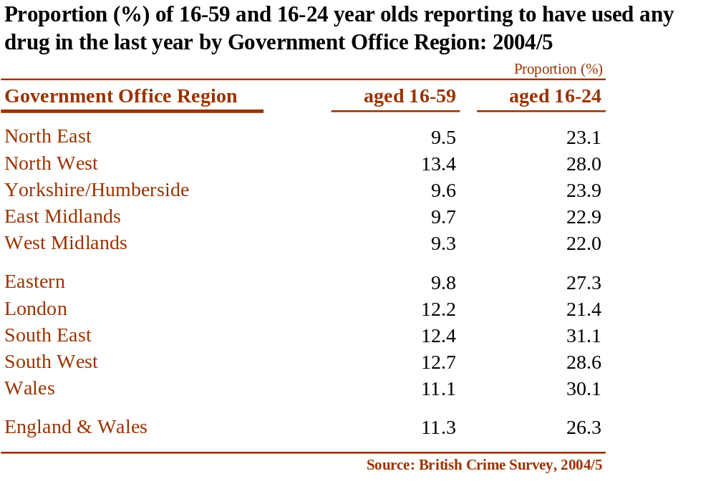

Table 15
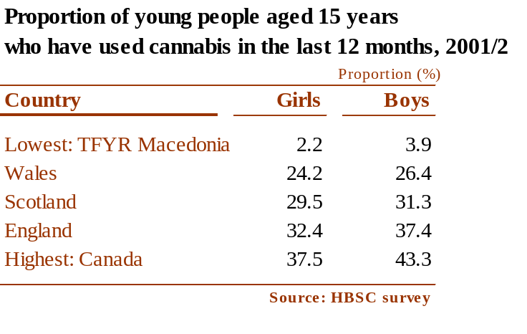

Table 16
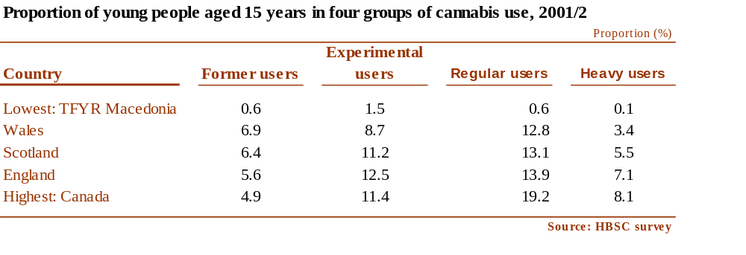

Table 17
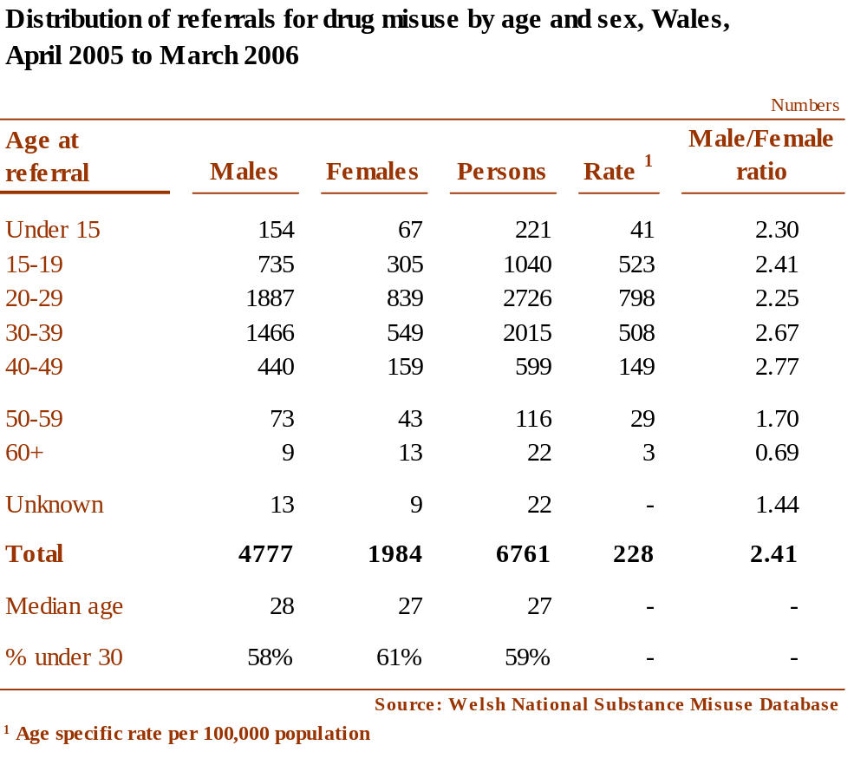

Table 18

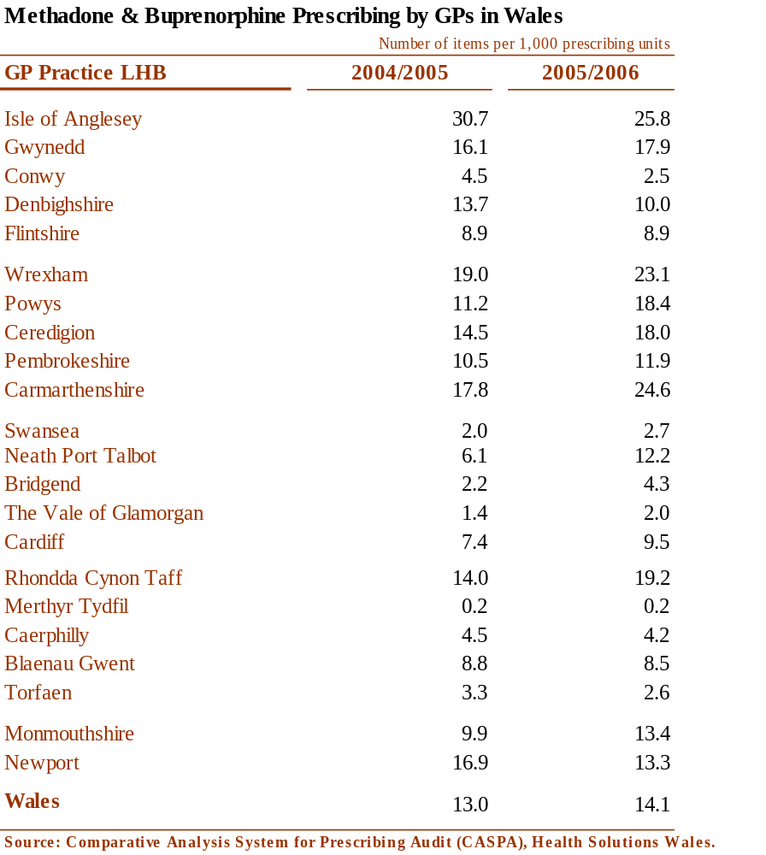

Table 19
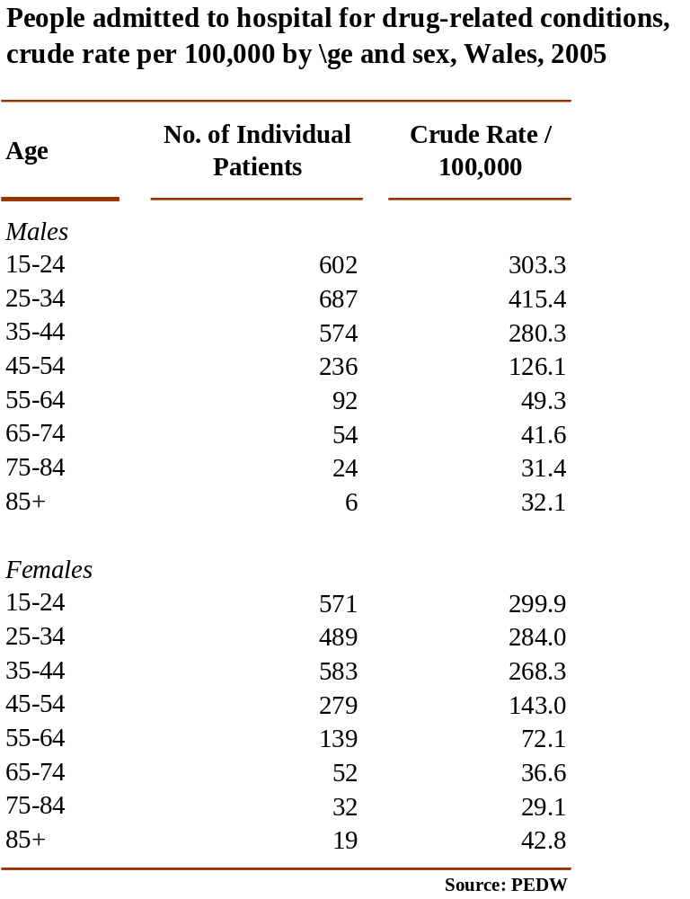

Table 20
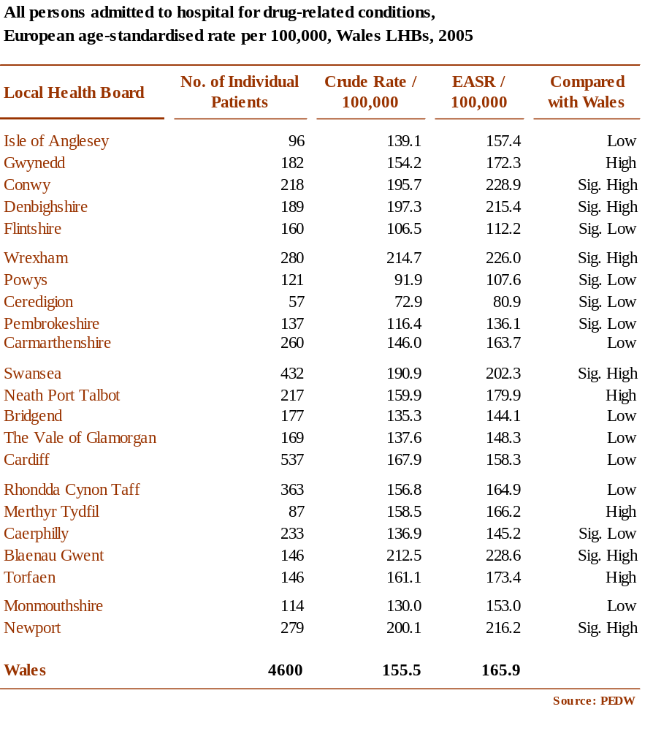

Table 21
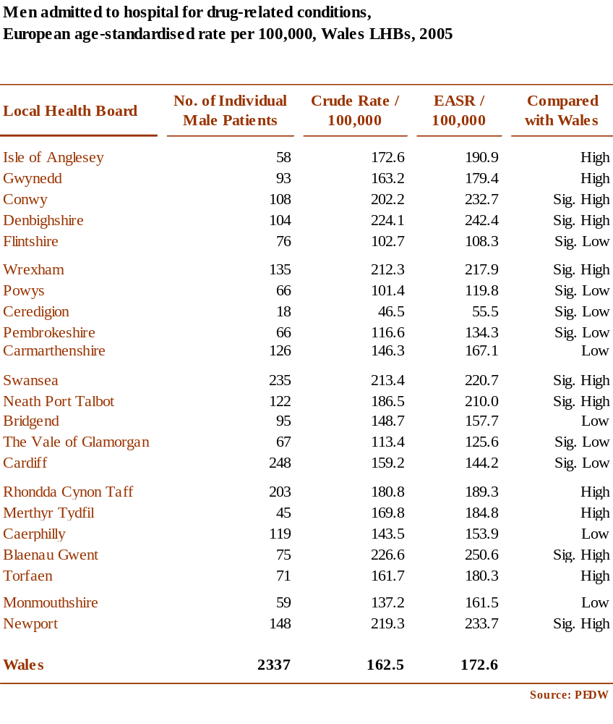

Table 22
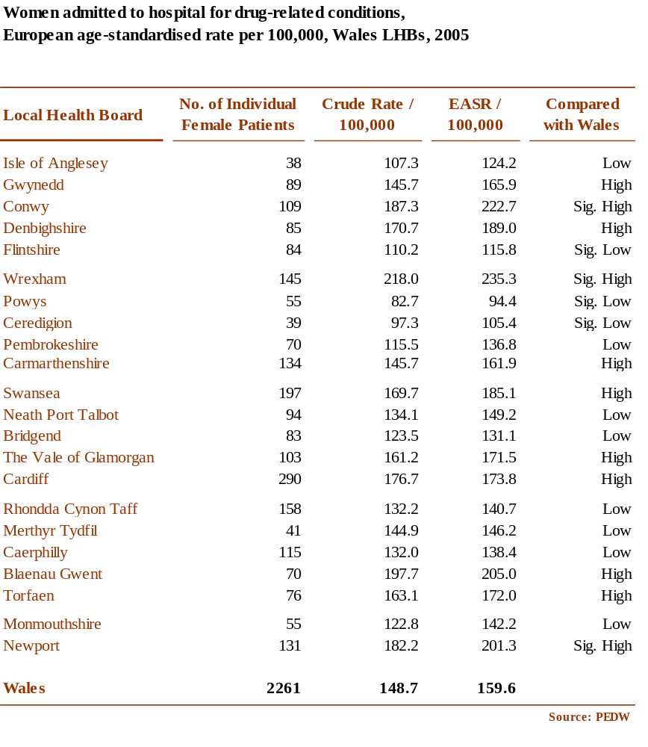

Table 23
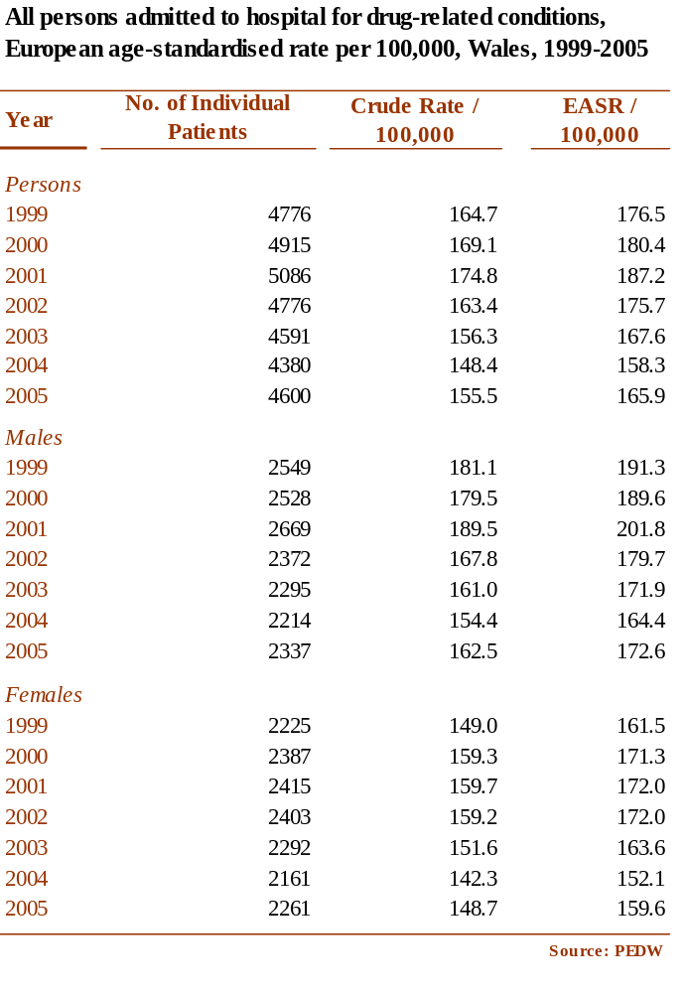

Table 24


