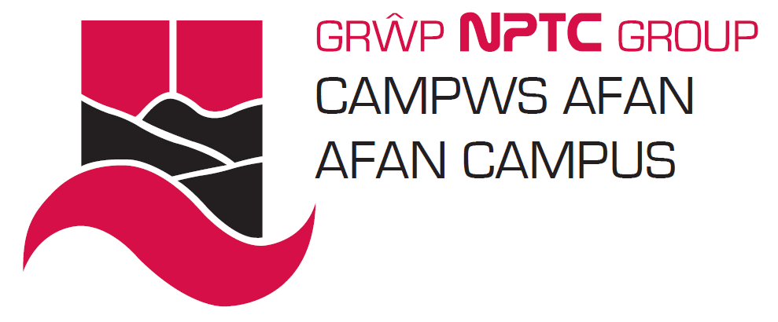

School of Hairdressing and Applied Therapies

NVQ Level 2 Diploma In Beauty Therapy

Universal Evidence Work Book
for the Following Units

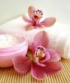

- B4
- B5
- B6
- B8
- N2
- N3

Student Name:

Tutor Signature & Comments
Q | √ or X | Competent √ Not yet competent
Q1.
Q2.
Q3.
Q4.
Q5.
Q6.
Q7.
Q8.
Q9.
Q10.
Q11.
Q12.
Q13.
Q14.
Q15.
Q16.
Q17.
Q18.
Q19.
Q20.
Q21.
Q22.
Q23.
Q24.
Q25
Literacy Alert:

Date of competence:

Q1.Explain your responsibilities under relevant Health and safety legislation, standards and guidance. (Refer to Health and safety policies, COSHH, RIDDOR, Risk assessments etc)

Q2. Explain why minors should not be given treatments without informed and signed parental or guardian consent. State the age at which an individual is classed as a minor and how this differs nationally.

Q3. Explain the importance of not discriminating against clients with illnesses and disabilities and why.

Q4.Describe your responsibilities and reasons for maintaining personal hygiene protection and appearance according to accepted industry and organisational requirements.

Q5. Describe the necessary environmental conditions for treatments, including lighting, heating, ventilation and general comfort and why these are important.

Q6.State the differences between sterilising and disinfecting.

Q7. Explain the importance of the correct storage of client records in relation to the Data Protection act.
Why is it necessary to gain clients signatures on record cards?

Q8. Explain the importance of and reasons for disinfecting hands and how to do this effectively.

Q9. Explain how to avoid potential discomfort and injury and the risks of poor positioning of clients.

Q10. Describe how to maintain equipment and materials in a clean and hygienic condition. Compare methods of sterilisation used in the salon.

Q11. Explain how to minimise and dispose of waste from treatments.

Q12. Describe the condition in which the work area should be left ready and why this is important.

Q13. Describe why it is important to maintain standards of hygiene and the principles of avoiding cross infection.
Q14. Describe contact dermatitis and how to avoid developing it while carrying out treatments.

Q15. Explain the type of personal protective equipment that should be available and used by yourself and why reasons.

Q16. Explain how to use effective consultation techniques when communicating with clients from different cultural and religious backgrounds, ages and disabilities and genders for treatments.

Q17. Describe how to give effective advice and recommendations.
Q18. Describe the questioning and listening skills needed in order to find out information.

Q19. Explain how to give effective advice and recommendations to clients.

Q20. Describe how to interpret negative and positive body language.

Q21a. Explain the importance of questioning clients to establish any contra-indications and to question the client on known contra-indications.

b. Explain why it is important to record client responses to questioning regarding contra-indications/relevant information and the legal significance of recording client responses.

Q22. Explain why it is important to encourage and allow time for clients to ask questions.

Q23. Explain why it is important to maintain client’s modesty and privacy.

Q24. State the content of the current Code of Practice for Waxing Services and the importance of following its provision.

Q25. Describe your own responsibilities under relevant health and safety legislation and Industry Code of Practice for Nail Services.

