New GHS (Global Harmonisation System) Pictograms
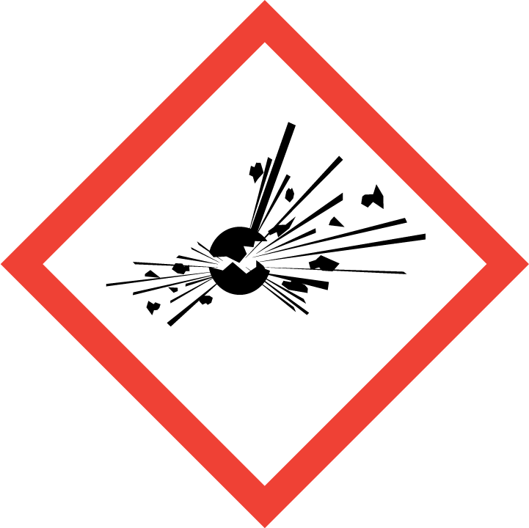 | 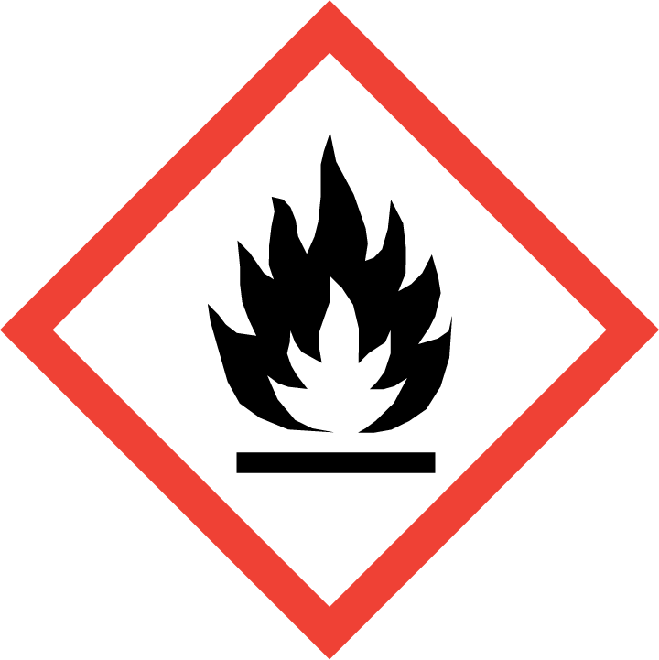 | 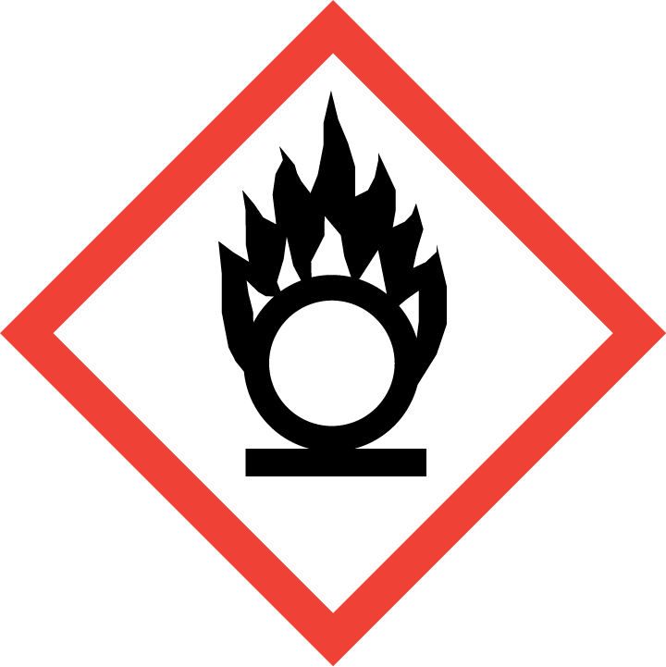
GHS01 Explosive | GHS02 Flammable | GHS03 Oxidising
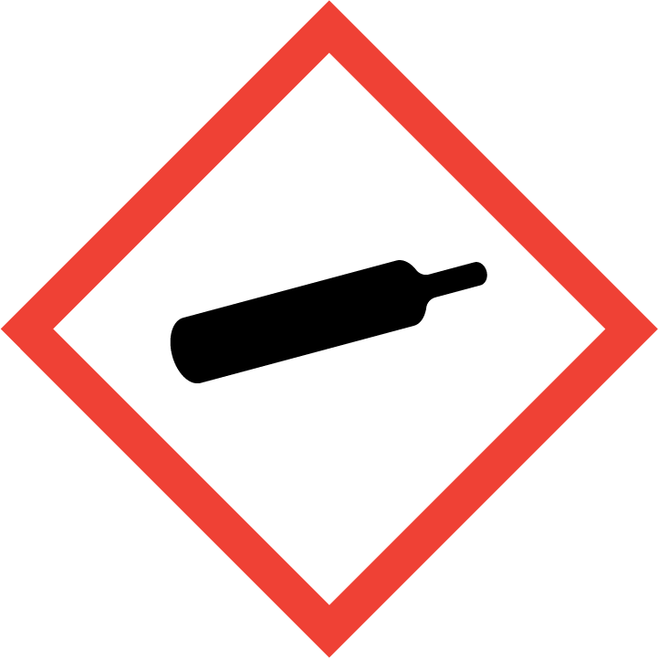 | 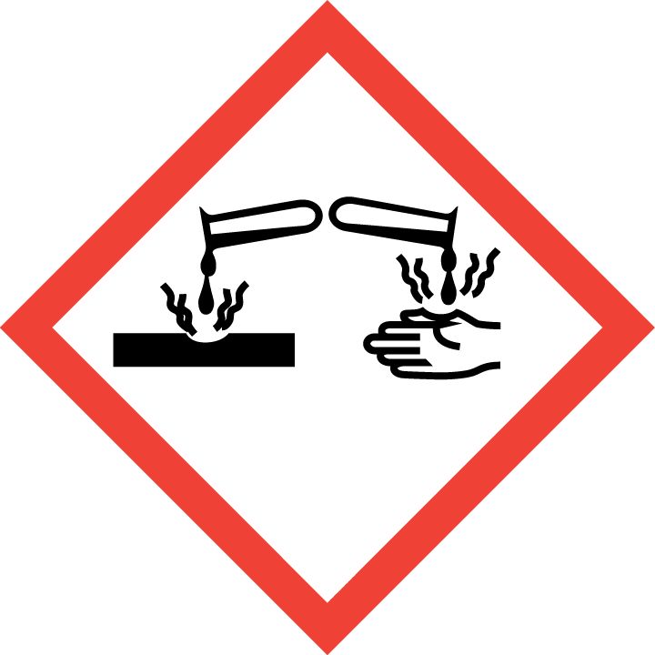 | 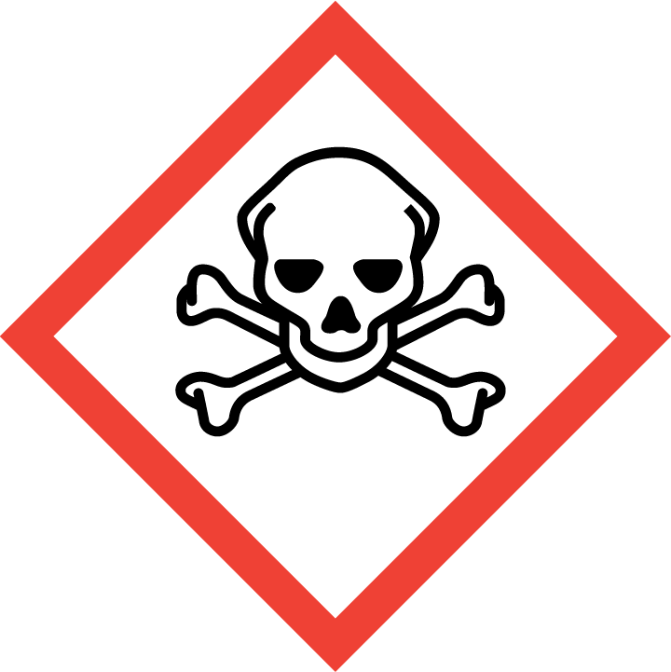
GHS04 Compressed Gas | GHS05 Skin Corrosion | GHS06 Acute Toxicity
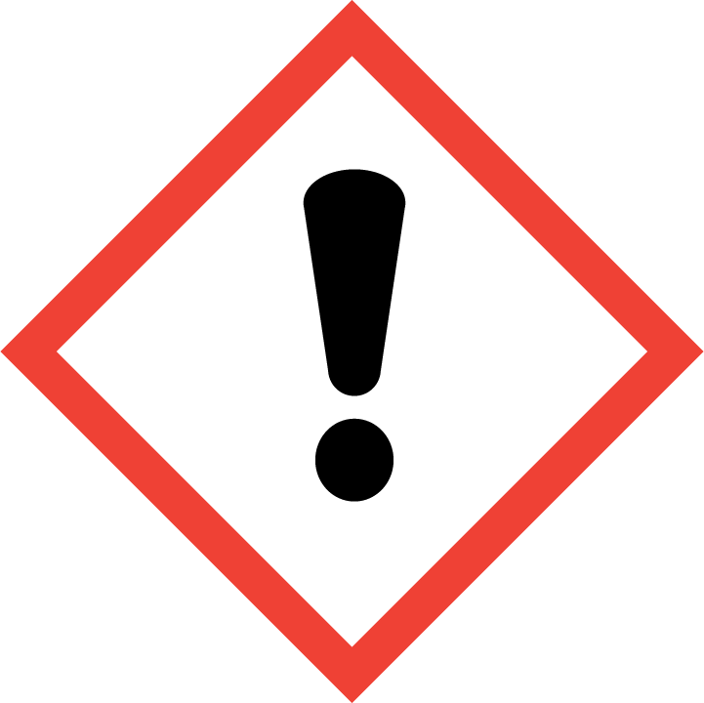 | 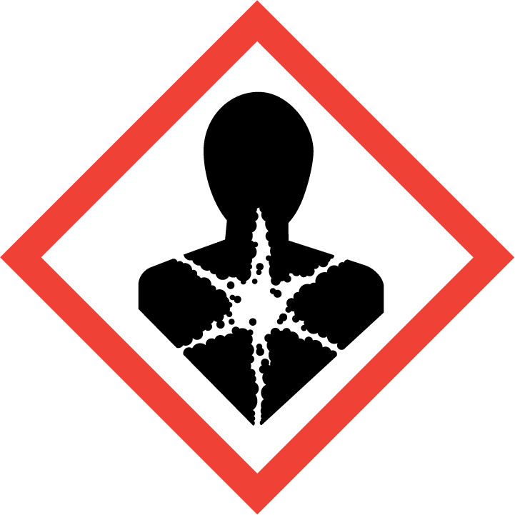 | 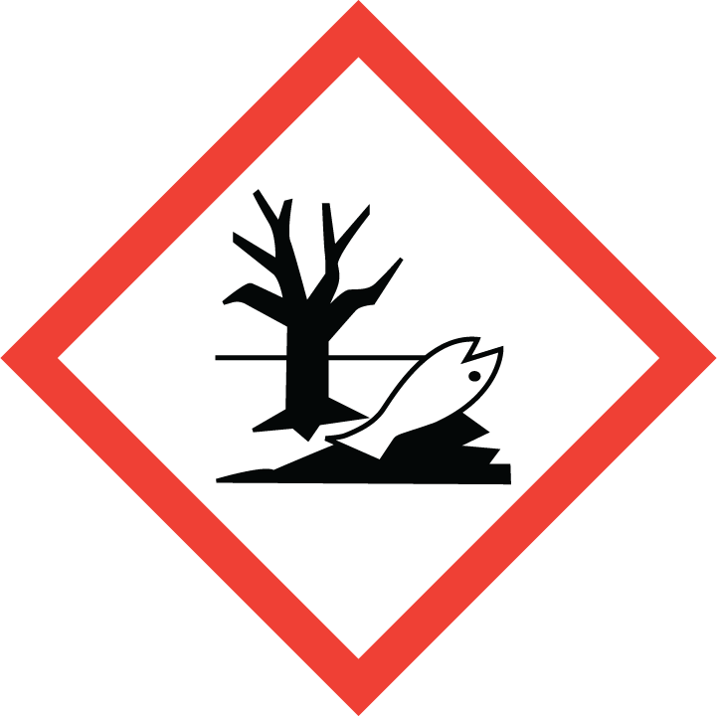
GHS07 Skin Irritation | GHS08 Health Hazard | GHS09 Environment Hazard

The above pictograms will be accompanied by a new signal word which describes the level of the risk.
The two new signal words are:-
DANGER or WARNING

Danger being of higher severity than Warning. The signal word will be accompanied by a list of H and P codes, these codes replace the old R and S codes.
The example below shows conc. Nitric Acid from the Scientific & Chemical catalogue….

The following pages list the H and P codes.
List of hazard statements H

H200 Unstable explosive
H201 Explosive; mass explosion hazard
H202 Explosive; severe projection hazard
H203 Explosive; fire, blast or projection hazard
H204 Fire or projection hazard
H205 May mass explode in fire
H220 Extremely flammable gas
H221 Flammable gas
H222 Extremely flammable aerosol
H223 Flammable aerosol
H224 Extremely flammable liquid and vapour
H225 Highly flammable liquid and vapour
H226 Flammable liquid and vapour
H227 Combustible liquid
H228 Flammable solid
H240 Heating may cause an explosion
H241 Heating may cause a fire or explosion
H242 Heating may cause a fire
H250 Catches fire spontaneously if exposed to air
H251 Self-heating; may catch fire
H252 Self-heating in large quantities; may catch fire
H260 In contact with water releases flammable gases which may ignite spontaneously
H261 In contact with water releases flammable gas
H270 May cause or intensify fire; oxidizer
H271 May cause fire or explosion; strong oxidizer
H272 May intensify fire; oxidizer
H280 Contains gas under pressure; may explode if heated
H281 Contains refrigerated gas; may cause cryogenic burns or injury
H290 May be corrosive to metals
H300 Fatal if swallowed
H301 Toxic if swallowed
H302 Harmful if swallowed
H303 May be harmful if swallowed
H304 May be fatal if swallowed and enters airways
H305 May be harmful if swallowed and enters airways
H310 Fatal in contact with skin
H311 Toxic in contact with skin
H312 Harmful in contact with skin
H313 May be harmful in contact with skin
H314 Causes severe skin burns and eye damage
H315 Causes skin irritation
H316 Causes mild skin irritation
H317 May cause an allergic skin reaction
H318 Causes serious eye damage
H319 Causes serious eye irritation
H320 Causes eye irritation
H330 Fatal if inhaled
H331 Toxic if inhaled
H332 Harmful if inhaled
H333 May be harmful if inhaled
H334 May cause allergy or asthma symptoms or breathing difficulties if inhaled
H335 May cause respiratory irritation
H336 May cause drowsiness or dizziness
H340 May cause genetic defects
(State route of exposure if it is conclusively proven that no other routes of exposure cause the hazard)
H341 Suspected of causing genetic defects
(State route of exposure if it is conclusively proven that no other routes of exposure cause the hazard)
H350 May cause cancer
(State route of exposure if it is conclusively proven that no other routes of exposure cause the hazard)
H351 Suspected of causing cancer
(State route of exposure if it is conclusively proven that no other routes of exposure cause the hazard)
H360 May damage fertility or the unborn child
(State specific effect if known)
(State route of exposure if it is conclusively proven that no other routes of exposure cause the hazard)
H361 Suspected of damaging fertility or the unborn child
(State specific effect if known)
(State route of exposure if it is conclusively proven that no other routes of exposure cause the hazard)
H362 May cause harm to breast-fed children
H370 Causes damage to organs
(Or state all organs affected, if known)
(State route of exposure if it is conclusively proven that no other routes of exposure cause the hazard)
H371 May cause damage to organs
(Or state all organs affected, if known)
(State route of exposure if it is conclusively proven that no other routes of exposure cause the hazard)
H372 Causes damage to organs (state all organs affected, if known) through prolonged or repeated exposure (state route of exposure if it is conclusively proven that no other routes of exposure cause the hazard)
H373 May cause damage to organs (state all organs affected, if known) through prolonged or repeated exposure (state route of exposure if it is conclusively proven that no other routes of exposure cause the hazard)
H400 Very toxic to aquatic life
H401 Toxic to aquatic life
H402 Harmful to aquatic life
H410 Very toxic to aquatic life with long lasting effects
H411 Toxic to aquatic life with long lasting effects
H412 Harmful to aquatic life with long lasting effects
H413 May cause long lasting harmful effects to aquatic life

List of precautionary statements

P101 If medical advice is needed, have product container or label at hand.
P102 Keep out of reach of children.
P103 Read label before use.
P201 Obtain special instructions before use.
P202 Do not handle until all safety precautions have been read and understood.
P210 Keep away from heat/sparks/open flames/hot surfaces. – No smoking.
P211 Do not spray on an open flame or other ignition source.
P220 Keep/Store away from clothing/.../combustible materials.
P221 Take any precaution to avoid mixing with combustibles/...
P222 Do not allow contact with air.
P223 Keep away from any possible contact with water, because of violent reaction and possible flash fire.
P230 Keep wetted with ...
P231 Handle under inert gas.
P232 Protect from moisture.
P233 Keep container tightly closed.
P234 Keep only in original container.
P235 Keep cool.
P240 Ground/bond container and receiving equipment.
P241 Use explosion-proof electrical/ventilating/lighting/.../equipment.
P242 Use only non-sparking tools.
P243 Take precautionary measures against static discharge.
P244 Keep reduction valves free from grease and oil.
P250 Do not subject to grinding/shock/…/friction.
P251 Pressurized container: Do not pierce or burn, even after use.
P260 Do not breathe dust/fume/gas/mist/vapours/spray.
P261 Avoid breathing dust/fume/gas/mist/vapours/spray.
P262 Do not get in eyes, on skin, or on clothing.
P263 Avoid contact during pregnancy/while nursing.
P264 Wash ... thoroughly after handling.
P270 Do not eat, drink or smoke when using this product.
P271 Use only outdoors or in a well-ventilated area.
P272 Contaminated work clothing should not be allowed out of the workplace.
P273 Avoid release to the environment.
P280 Wear protective gloves/protective clothing/eye protection/face protection.
P281 Use personal protective equipment as required.
P282 Wear cold insulating gloves/face shield/eye protection.
P283 Wear fire/flame resistant/retardant clothing.
P284 Wear respiratory protection.
P285 In case of inadequate ventilation wear respiratory protection.
P231+P232 Handle under inert gas. Protect from moisture.
P235+P410 Keep cool. Protect from sunlight.
P301 IF SWALLOWED:
P302 IF ON SKIN:
P303 IF ON SKIN (or hair):
P304 IF INHALED:
P305 IF IN EYES:
P306 IF ON CLOTHING:
P307 IF exposed:
P308 IF exposed or concerned:
P309 IF exposed or if you feel unwell:
P310 Immediately call a POISON CENTER or doctor/physician.
P311 Call a POISON CENTER or doctor/physician.
P312 Call a POISON CENTER or doctor/physician if you feel unwell.
P313 Get medical advice/attention.
P314 Get medical advice/attention if you feel unwell.
P315 Get immediate medical advice/attention.
P320 Specific treatment is urgent (see ... on this label).
P321 Specific treatment (see ... on this label).
P322 Specific measures (see ... on this label).
P330 Rinse mouth.
P331 Do NOT induce vomiting.
P332 If skin irritation occurs:
P333 If skin irritation or rash occurs:
P334 Immerse in cool water/wrap in wet bandages.
P335 Brush off loose particles from skin.
P336 Thaw frosted parts with lukewarm water. Do not rub affected area.
P337 If eye irritation persists:
P338 Remove contact lenses, if present and easy to do. Continue rinsing.
P340 Remove victim to fresh air and keep at rest in a position comfortable for breathing.
P341 If breathing is difficult, remove victim to fresh air and keep at rest in a position comfortable for breathing.
P342 If experiencing respiratory symptoms:
P350 Gently wash with plenty of soap and water.
P351 Rinse cautiously with water for several minutes.
P352 Wash with plenty of soap and water.
P353 Rinse skin with water/shower.
P360 Rinse immediately contaminated clothing and Oxidizing liquids (chapter 2.13) 1 skin with plenty of water before removing clothes.
P361 Remove/Take off immediately all contaminated clothing.
P362 Take off contaminated clothing and wash before reuse.
P363 Wash contaminated clothing before reuse.
P370 In case of fire:
P371 In case of major fire and large quantities:
P372 Explosion risk in case of fire.
P373 DO NOT fight fire when fire reaches explosives.
P374 Fight fire with normal precautions from a reasonable distance.
P375 Fight fire remotely due to the risk of explosion.
P376 Stop leak if safe to do so.
P377 Leaking gas fire: Do not extinguish, unless leak can be stopped safely.
P378 Use ... for extinction.
P380 Evacuate area.
P381 Eliminate all ignition sources if safe to do so.
P390 Absorb spillage to prevent material damage.
P391 Collect spillage.
P301+P310 IF SWALLOWED: Immediately call a POISON CENTER or doctor/physician.
P301+P312 IF SWALLOWED: Call a POISON CENTER or doctor/physician if you feel unwell.
P301+P330+P331 IF SWALLOWED: Rinse mouth. Do NOT induce vomiting.
P302+P334 IF ON SKIN: Immerse in cool water/wrap in wet bandages.
P302+P350 IF ON SKIN: Gently wash with plenty of soap and water.
P302+P352 IF ON SKIN: Wash with plenty of soap and water.
P303+P361+P353 IF ON SKIN (or hair): Remove/Take off immediately all contaminated clothing. Rinse skin with water/shower.
P304+P312 IF INHALED: Call a POISON CENTER or doctor/physician if you feel unwell.
P304+P340 IF INHALED: Remove victim to fresh air and keep at rest in a position comfortable for breathing.
P304+P341 IF INHALED: If breathing is difficult, remove victim to fresh air and keep at rest in a position comfortable for breathing.
P305+P351+P338 IF IN EYES: Rinse cautiously with water for several minutes. Remove contact lenses, if present and easy to do. Continue rinsing.
P306+P360 IF ON CLOTHING: Rinse immediately contaminated clothing and skin with plenty of water before removing clothes.
P307+P311 IF exposed: Call a POISON CENTER or doctor/physician.
P308+P313 IF exposed or concerned: Get medical advice/attention.
P309+P311 IF exposed or if you feel unwell: Call a POISON CENTER or doctor/physician.
P332+P313 If skin irritation occurs: Get medical advice/attention.
P333+P313 If skin irritation or rash occurs: Get medical advice/attention.
P335+P334 Brush off loose particles from skin. Immerse in cool water/wrap in wet bandages.
P337+P313 If eye irritation persists: Get medical advice/attention.
P342+P311 If experiencing respiratory symptoms: Call a POISON CENTER or doctor/physician.
P370+P376 In case of fire: Stop leak if safe to do so.
P370+P378 In case of fire: Use ... for extinction.
P370+P380 In case of fire: Evacuate area.
P370+P380+P375 In case of fire: Evacuate area. Fight fire remotely due to the risk of explosion.
P371+P380+P375 In case of major fire and large quantities: Evacuate area. Fight fire remotely due to the risk of explosion.
P401 Store …
P402 Store in a dry place.
P403 Store in a well-ventilated place.
P404 Store in a closed container.
P405 Store locked up.
P406 Store in corrosive resistant/... container with a resistant inner liner.
P407 Maintain air gap between stacks/pallets.
P410 Protect from sunlight.
P411 Store at temperatures not exceeding …°C/…°F.
P412 Do not expose to temperatures exceeding 50 °C/122 °F.
P413 Store bulk masses greater than … kg/…lbs at temperatures not exceeding …°C/…°F.
P420 Store away from other materials.
P422 Store contents under ...
P402+P404 Store in a dry place. Store in a closed container.
P403+P233 Store in a well-ventilated place. Keep container tightly closed.
P403+P235 Store in a well-ventilated place. Keep cool.
P410+P403 Protect from sunlight. Store in a well-ventilated place.
P410+P412 Protect from sunlight. Do not expose to temperatures exceeding 50 °C/122 °F.
P411+P235 Store at temperatures not exceeding …°C/…°F. Keep cool.
P501 Dispose of contents/container to ...

