Activity B04: Catalase Enzyme Activity
(Pressure Sensor)

Concept | DataStudio | ScienceWorkshop (Mac) | ScienceWorkshop (Win)
Biochemistry - enzymes | B04 Catalase.DS | B05 Catalase Activity | B05_CATA.SWS

Equipment Needed | Qty | Equipment Needed | Qty
Pressure Sensor – Abs. (CI-6532) | 1 | Protective gear | PS
Balance (SE-8723) | 1
Beaker, 600 mL | 1 | Chemicals and Consumables | Qty
Connector (640-030) | 1 | Chicken liver extract | 12 mL
Flask, 250 mL | 1 | Glycerin | 1 mL
Graduated cylinder, 100 mL | 1 | Hydrochloric acid (HCl), 1 M | 10 mL
Hot plate | 1 | hydrogen peroxide, 3% | 100 mL
Magnetic stirrer & spin bar | 1 | Ice, crushed | 500 mL
Stopper, one hole, for flask | 1 | Sodium fluoride, solid | 2.0 g
Test tube | 1 | Sodium hydroxide (NaOH), 1 M | 10 mL
Tongs | 1 | Water | 500 mL
Tubing (w/ sensor) |  | Water, distilled | 500 mL

What Do You Think

What are some factors that can influence the rate of enzyme activity in an organism?
Take time to write an answer to this question in the Lab Report section.

Background
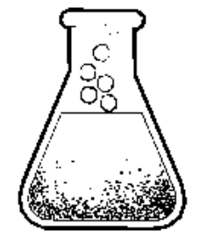
Enzymes are very important molecules found in every cell. Enzymes generally act as catalysts that increase the speed or rate at which substances in a cell get converted into other substances. Without enzymes, some reactions would take place too slowly – or might not take place at all.
Each enzyme has a different job and many enzymes must work together to keep an organism alive and healthy. In the liver, for example, there are several enzymes that act on certain toxic or poisonous compounds by removing hydrogen atoms from the poisons and transferring them to oxygen molecules. This detoxifies the poison but it creates a new compound, hydrogen peroxide (H2O2) that is very active and can be harmful to the organism. Fortunately there is another enzyme in the liver that helps break down the peroxide into water and oxygen.
This enzyme is known as catalase. The catalase enzyme reduces the substrate, peroxide, to water and oxygen by the following decomposition reaction.
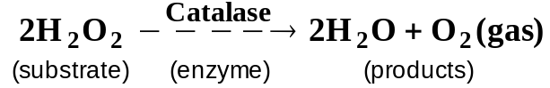
Like all enzymes, catalase helps the reaction but does not itself get used up in the reaction. Also like other enzymes, catalase must have a proper environment in which to work. Your body’s enzymes, for example, work best when your temperature is normal (around 37˚ C) and when the pH is between 7.3 to 7.4. If the environmental conditions are outside the normal range, the catalase will lose its ability to catalyze the peroxide reaction or may even be destroyed.
Since the breakdown of hydrogen peroxide produces oxygen gas, what is a way to measure the rate of the production of that gas?
Take time to write an answer to this question in the Lab Report section.

SAFETY REMINDERS  - Wear protective gear while handling chemicals.  - Follow directions for using the equipment.  - Dispose of all chemicals and solutions properly. | 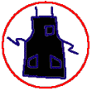 |  | 

For You To Do
Use the Pressure Sensor to measure the change in gas pressure inside a flask containing hydrogen peroxide and a source of catalase enzyme. After you measure the rate of activity for catalase and hydrogen peroxide, compare the rate of activity for the mixture under three different conditions: change in pH, change in temperature, and in the presence of an inhibitor (sodium fluoride). Use DataStudio or ScienceWorkshop to record and analyze the data.

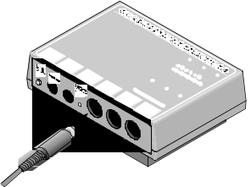
PART I: Computer Setup
1. Connect the ScienceWorkshop interface to the computer, turn on the interface, and turn on the computer.
2. Connect the Pressure Sensor DIN plug into Analog Channel A on the interface.
3. Open the file titled as shown;

DataStudio | ScienceWorkshop (Mac) | ScienceWorkshop (Win)
B04 Catalase.DS | B05 Catalase Activity | B05_CATA.SWS
• The DataStudio file has a Workbook display. Read the instructions in the Workbook. The file has a Graph of Pressure versus Time and a Digits display of Pressure.
• The ScienceWorkshop document opens with a Graph display of Pressure (kPa) versus Time (s).
• Data recording is set for 1 measurement per second with a ‘Stop’ condition at 150 s.

PART II: Sensor Calibration and Equipment Setup

Sensor Calibration
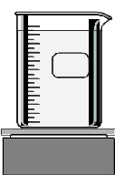
- You do not need to calibrate the Pressure Sensor for this activity since you will measure the change in pressure.

Boil Water
1. Put about 500 mL of water into a beaker and put the beaker on a hot plate. Start heating the water to a boil.

Set Up the Equipment
2. Put a drop of glycerin on the barb end of the quick-release connector and insert the barb into one end of the plastic tubing.
3. Put a drop of glycerin on the smaller diameter end of the connector that will go into the stopper. Insert the small diameter end into the plastic tubing.
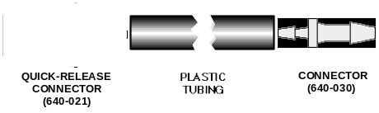
4. Put a drop of glycerin on the larger diameter end of the connector that will go into the stopper, and insert the end into the stopper.
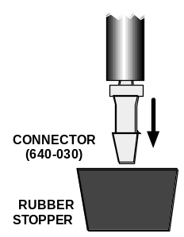
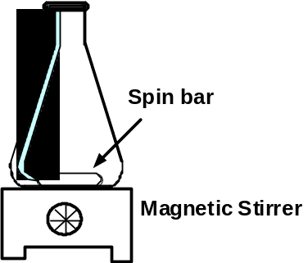
5. Carefully put a spin bar into the flask and place the flask on the magnetic stirrer.

PART III: Data Recording
- There are six parts to the data recording.

Part | Description | Part | Description
A | Catalase + Hydrogen Peroxide | D | Catalase + Hydrogen Peroxide + Acid
B | Catalase + Hydrogen Peroxide + Inhibitor | E | Chilled Catalase + Hydrogen Peroxide
C | Catalase + Hydrogen Peroxide + Base | F | Heated Catalase + Hydrogen Peroxide

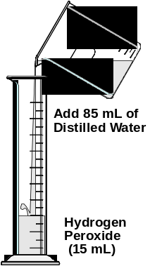
PART IIIA: Catalase + Hydrogen Peroxide

Prepare the Mixture
1. Pour 15 mL of 3% hydrogen peroxide in a 100 mL graduated cylinder. Fill the cylinder to the 100-mL mark with 85 mL of distilled water.
2. Transfer the diluted peroxide solution to the flask.
3. Turn on the stirrer.
4. Add 2 mL of catalase extract to the dilute peroxide solution in the flask.
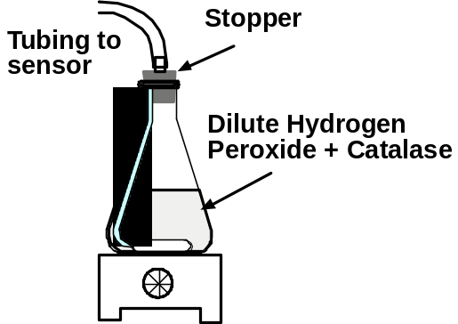
5. Put the one-hole stopper into the flask.
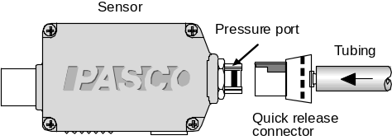
6. Align the quick-release connector on the end of the plastic tubing with the connector on the pressure port of the Pressure Sensor. Push the connector onto the port, and then turn the connector clockwise until it clicks (about one-eighth turn).

Record the Data
7. Start recording data. (Hint: Click ‘Start’ in DataStudio or click ‘REC’ in ScienceWorkshop.)
• Data recording will stop automatically at 150 seconds.

Clean Up
8. Disconnect the tubing from the Pressure Sensor. Remove the stopper from the flask.
9. Dispose of the peroxide mixture as directed and clean the flask thoroughly.

Part IIIB: Catalase + Hydrogen Peroxide + Inhibitor

Make a prediction:

What effect do you think adding an inhibitor to the hydrogen peroxide will have on the enzymes’s ability to catalyze the breakdown of the peroxide? Put your prediction and a brief explanation in the Lab Report.

Prepare the mixture
1. Repeat the data recording procedure. Put 100 mL of dilute peroxide solution in the flask. Add the spin bar.
2. Add 2.0 g of sodium fluoride to the peroxide solution. Add 2 mL of catalase extract to the flask and stopper the flask.
3. Re-connect the tubing to the Pressure Sensor.

Record the data
4. Start recording data.
• Data recording will stop automatically at 150 seconds.

Clean Up
5. Disconnect the tubing from the Pressure Sensor. Remove the stopper from the flask.
6. Dispose of the peroxide mixture as directed and clean the flask thoroughly.

Part IIIC: Catalase + Hydrogen Peroxide + Base

Make a prediction:
What effect do you think adding a base to the hydrogen peroxide will have on the enzymes’s ability to catalyze the breakdown of the peroxide? Put your prediction and a brief explanation in the Lab Report.

Prepare the mixture
1. Repeat the data recording procedure. Put 100 mL of dilute peroxide solution in the flask. Add the spin bar.
2. Add 10 mL of 1 Molar sodium hydroxide (NaOH) to the peroxide to raise the pH before you add the catalase. Add 2 mL of catalase extract to the flask and stopper the flask.
3. Re-connect the tubing to the Pressure Sensor.

Record the data
4. Start recording data.
• Data recording will stop automatically at 150 seconds.

Clean Up
5. Disconnect the tubing from the Pressure Sensor. Remove the stopper from the flask.
6. Dispose of the peroxide mixture as directed and clean the flask thoroughly.

Part IIID: Catalase + Hydrogen Peroxide + Acid

Make a prediction:
What effect do you think adding acid to the hydrogen peroxide will have on the enzymes’s ability to catalyze the breakdown of the peroxide? Put your prediction and a brief explanation in the Lab Report.

Prepare the mixture
1. Repeat the data recording procedure. Put 100 mL of dilute peroxide solution in the flask. Add the spin bar.
2. Add 10 mL of 1 Molar hydrochloric acid (HCl) to the peroxide to lower the pH before you add the catalase. Add 2 mL of catalase extract to the flask and stopper the flask.
3. Re-connect the tubing to the Pressure Sensor.

Record the data
4. Start recording data.
• Data recording will stop automatically at 150 seconds.

Clean Up
5. Disconnect the tubing from the Pressure Sensor. Remove the stopper from the flask.
6. Dispose of the peroxide mixture as directed and clean the flask thoroughly.

PART IIIE: Chilled Catalase + Hydrogen Peroxide

Make a prediction:
What effect do you think decreasing the temperature of the catalase will have on the enzymes’s ability to catalyze the breakdown of the peroxide? Put your prediction and a brief explanation in the Lab Report.

Prepare the mixture
1. Repeat the data recording procedure. Put 100 mL of dilute peroxide solution in the flask. Add the spin bar.
2. Put 2 mL of catalase extract into a test tube. Put the test tube into a beaker and pack crushed ice around the test tube. Cool the test tube in the ice for 5 minutes.
3. Add the chilled catalase extract to the flask and stopper the flask.
4. Re-connect the tubing to the Pressure Sensor.

Record the data
5. Start recording data.
• Data recording will stop automatically at 150 seconds.

Clean Up
6. Disconnect the tubing from the Pressure Sensor. Remove the stopper from the flask.
7. Dispose of the peroxide mixture as directed and clean the flask thoroughly.

PART IIIF: Heated Catalase + Hydrogen Peroxide

Make a prediction:
What effect do you think boiling the catalase will have on the enzymes’s ability to catalyze the breakdown of the peroxide? Put your prediction and a brief explanation in the Lab Report.

Prepare the mixture
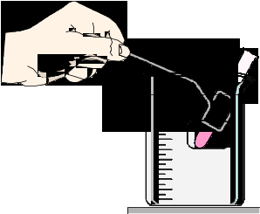
1. Repeat the data recording procedure. Put 100 mL of dilute peroxide solution in the flask. Add the spin bar.
2. Put 2 mL of catalase extract into a test tube. Use tongs to hold the test tube in a beaker of boiling water. Heat the test tube in boiling water for 5 minutes.
3. Add the heated catalase extract to the flask and stopper the flask.
4. Re-connect the tubing to the Pressure Sensor.

Record the data
5. Start recording data.
• Data recording will stop automatically at 150 seconds.

Clean Up
6. Disconnect the tubing from the Pressure Sensor. Remove the stopper from the flask.
7. Dispose of the peroxide mixture as directed and clean the flask thoroughly.

Analyzing the Data
1. Set up the Graph display to show all your data
• Hint: DataStudio automatically shows all six runs of data. In ScienceWorkshop, do the following to put two runs of data in a top plot, two runs in a middle plot, and two runs of data in a bottom plot.
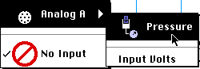
• Click the ‘Add Plot Menu’ button () to add a second plot to the Graph window. Select Analog Channel A, Pressure from the Add Plot Menu.
• Click the ‘Add Plot Menu’ button again to add a third plot to the Graph window. Select Analog Channel A, Pressure from the Add Plot Menu.
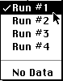
• Click the ‘DATA Menu’ button () in the top plot. Select Run #1 from the DATA Menu. Repeat to select Run #2 from the DATA menu.
• Click the ‘DATA Menu’ button in the middle plot. Select No Data first.
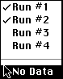
• Use the Data Menu in the second plot to select Run #3 and then Run #4.
• Click the ‘DATA Menu’ button in the bottom plot. Use the Data Menu to add Run #5 to the plot.
2. Use the built-in statistics for the Graph display to find the minimum pressure and the maximum pressure for each run of data.
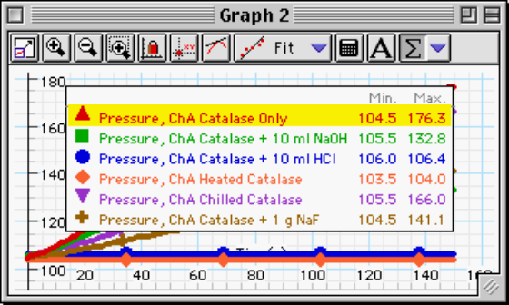
• Hint: In DataStudio, click the ‘Statistics Menu’ button (). The default statistics are ‘Minimum’ and ‘Maximum’. The values appear in the legend in the display area.
In ScienceWorkshop, click the ‘Statistics’ button () to open the statistics area. Click the ‘Statistics Menu’ button (). Select ‘Maximum’ from the menu. Repeat and select ‘Minimum’ from the menu.
3. Record the minimum pressure as the starting pressure. Record the maximum pressure as the ending pressure.
4. Calculate the difference in pressure.
5. Calculate the enzyme activity. Divide the difference in pressure by the amount of time (in minutes).

Record your results in the Lab Report section.

Lab Report - Activity B04: Catalase Enzyme Activity

What Do You Think
What are some factors that can influence the rate of enzyme activity in an organism?

Since the breakdown of hydrogen peroxide produces oxygen gas, what is a way to measure the rate of the production of that gas?

Predictions

Part IIIB: Catalase + Hydrogen Peroxide + Inhibitor
What effect do you think adding an inhibitor to the hydrogen peroxide will have on the enzymes’s ability to catalyze the breakdown of the peroxide?

Part IIIC: Catalase + Hydrogen Peroxide + Base
What effect do you think adding a base to the hydrogen peroxide will have on the enzymes’s ability to catalyze the breakdown of the peroxide?

Part IIID: Catalase + Hydrogen Peroxide + Acid
What effect do you think adding acid to the hydrogen peroxide will have on the enzymes’s ability to catalyze the breakdown of the peroxide?

PART IIIE: Chilled Catalase + Hydrogen Peroxide
What effect do you think decreasing the temperature of the catalase will have on the enzymes’s ability to catalyze the breakdown of the peroxide?

PART IIIF: Heated Catalase + Hydrogen Peroxide
What effect do you think boiling the catalase will have on the enzymes’s ability to catalyze the breakdown of the peroxide?

Data Table

Item | Part IIIA | Part IIIB  NaF | Part IIIC  NaOH | Part IIID  HCl | Part IIIE  Chilled | Part IIIF  Heated
Starting Pressure | kPa | kPa | kPa | kPa | kPa | kPa
Ending Pressure | kPa | kPa | kPa | kPa | kPa | kPa
Pressure Difference | kPa | kPa | kPa | kPa | kPa | kPa
Activity (kPa/min)

Questions
1. What does the graph of the reaction between hydrogen peroxide and catalase tell you about enzyme activity?

2. Describe the effect of adding the inhibitor (sodium fluoride) to the peroxide before you add the catalase to the solution of peroxide? What explanation can you give for the results?

3. Describe the effect of adding the base (sodium hydroxide) to the solution of peroxide? What did the sodium hydroxide do to the pH of the solution in the flask? What does this tell you about the range of conditions in which catalase may be effective?

4. Describe the effect of adding the acid (hydrochloric acid) to the solution of peroxide? What did the hydrochloric acid do to the pH of the solution in the flask? What does this tell you about the range of conditions in which catalase may be effective?

5. Describe the effect of cooling the catalase before adding it to the solution of peroxide?

6. Describe the effect of heating the catalase to boiling before adding it to the solution of peroxide? How did the effect of cooling compare to the effect of boiling the catalase? How can you explain the difference between these two trials?

