Activity B07: Membrane Permeability

(pH sensor)

Concept | DataStudio | ScienceWorkshop (Mac) | ScienceWorkshop (Win)
Cell biology | B07 Membrane.DS | B07 Membrane | B07_MEMB.SWS

Equipment | Qty | Chemicals and Consumables | Qty
pH Sensor (CI-6507) | 1 | Buffer solution: high pH | 100 mL
Base and support rod (ME-9355) | 1 | Buffer solution: low pH | 100 mL
Beaker, 250 mL | 4 | Dialysis tubing, 15 cm length | 2
Binder clip | 2 | Hydrochloric acid, 1.0 M | 15 mL
Clamp, buret (SE-9446) | 2 | Sodium hydroxide, 1.0 M | 15 mL
Graduated cylinder | 1 | String, 10 cm length | 2
Magnetic stirrer & spin bar | 1 | Water, distilled | 1 L
Wash bottle | 1
Protective gear | PS

What Do You Think?

The purpose of this laboratory activity is to test the permeability of a membrane to hydrogen and hydroxide ions. Which do you think will move through the membrane more quickly: the hydrogen ion or the hydroxide ion?
Take time to answer this question in the Lab Report section.
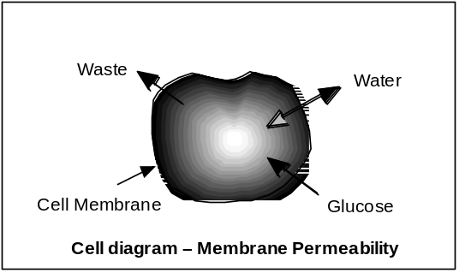

Background
The contents of a cell are separated from the outside environment by a membrane. A biological membrane is the cellular organelle which isolates biochemical reactions, enzymes and genetic material essential to the vitality of the individual cell from the outside world. In some cases, the cell membrane acts as a passive barrier. When the membrane acts passively, the materials migrate in or out due to a difference in concentration (or osmotic gradient) between the inside and outside of the membrane.
In other cases, the membrane can be very selective to what passes from one side to the other. It is through the membrane that essential nutrients pass into and waste products pass out of the cell. An active membrane is also the anchorage site for many enzymes and coenzymes. The cell membrane is NOT a simple bag holding cell parts . The active nature of a biological membrane makes it a living part of the cell.
While membranes are selectively permeable, this experiment investigates the role of the cell as a passive mediator of diffusion of materials from one side of the membrane to the other.
SAFETY REMINDERS  - Wear protective gear while handling chemicals.  - Follow directions for using the equipment.  - Dispose of all chemicals and solutions properly. | 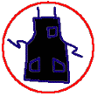 |  | 
• CAUTION: Hydrochloric acid (HCl) and sodium hydroxide (NaOH) are irritants and can ruin clothing. Avoid contact to eyes and skin. DO NOT INGEST. Immediately flush spills with water for 15 minutes. Notify your teacher of any contact with HCl or NaOH.

Procedure
Use piece of dialysis tubing as a model of the cell membrane. Tie the tubing at one end, fill it with a chemical solution, and place it in distilled water. Use the pH Sensor to measure the change in pH of the distilled water around the dialysis tubing. Use DataStudio or ScienceWorkshop to record and display the data.
Compare the rate of change of pH around the dialysis tubing when the tubing contains an acid to the rate of change of pH around the dialysis tubing when the tubing contains a base.

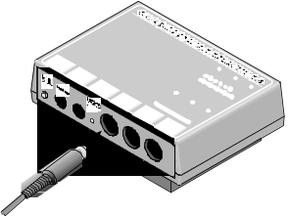
PART I: Computer Setup
1. Connect the ScienceWorkshop interface to the computer, turn on the interface, and turn on the computer.
2. Connect the DIN plug of the pH Sensor into Analog Channel A of the interface.
3. Open the file titled as shown:
DataStudio | ScienceWorkshop (Mac) | ScienceWorkshop (Win)
B07 Membrane.DS | B07 Membrane | B07_MEMB.SWS
• The DataStudio file has a Workbook display. Read the instructions in the Workbook.
• The ScienceWorkshop file has a Digits display of pH and a Graph display of pH versus time.
• Data recording is set for ten measurements per second (10 Hz) and a ‘Stop’ condition at 200 seconds

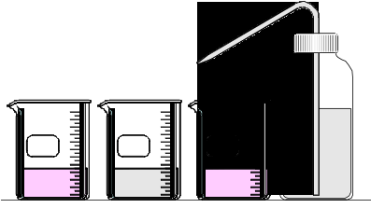
PART II: Sensor Calibration and Equipment Setup

Calibrate the Sensor
• To calibrate the pH Sensor you will need a wash bottle, distilled water, three beakers, and buffer solutions of high pH (e.g. pH 10) and low pH (e.g. pH 4). Put distilled water into the wash bottle and into one of the beakers. Put buffer solutions in the other two beakers.
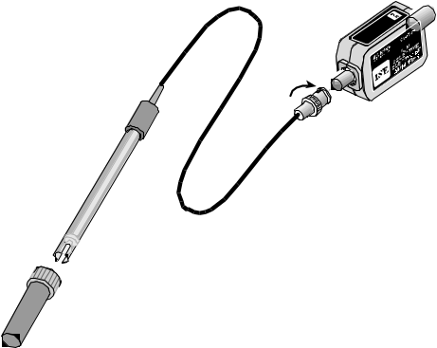
1. Remove the pH electrode from its bottle of buffer solution. Connect the electrode to the pH Sensor amplifier. To connect the electrode, push the BNC plug onto the receptacle on the Sensor amplifier and turn the BNC plug clockwise until it ‘clicks’ into place.
Connect to the sensor.
Remove the bottle of buffer solution.
2. Use the wash bottle to rinse the end of the electrode. Soak the pH electrode in the beaker of distilled water for 10 minutes.
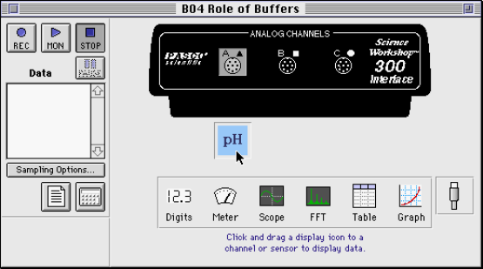
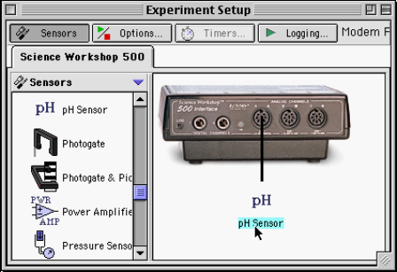
3. In the Experiment Setup window, double-click the pH Sensor icon.
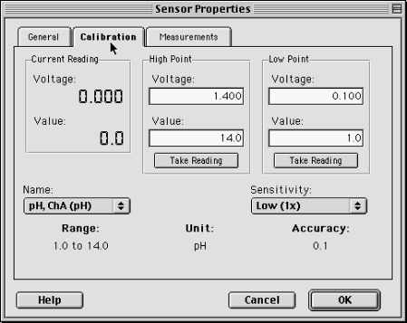
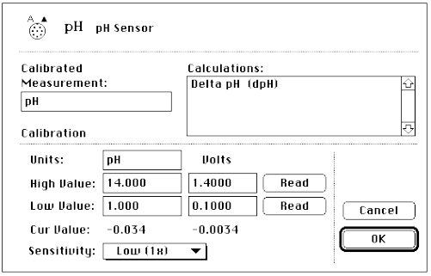
• In DataStudio, the Sensor Properties window will open. Click the ‘Calibration’ tab. In ScienceWorkshop, the Sensor Setup window will open.
4. Calibrate with the high pH buffer solution.
- Put the end of the pH electrode into the high pH buffer solution.
- Check the voltage under ‘Current Reading’ in DataStudio or next to ‘Cur Value:’ in ScienceWorkshop.
- When the voltage stabilizes, click the ‘Take Reading’ button under ‘High Point’ in DataStudio or the ‘Read’ button in the row for ‘High Value:’ in ScienceWorkshop.
- Enter the pH value of the buffer solution.
5. Thoroughly rinse the pH electrode with distilled water and dry it with a tissue.
6. Calibrate with the low pH buffer solution.
- Put the end of the H electrode in the low pH buffer solution.
- Check the voltage under ‘Current Reading’ in DataStudio or next to ‘Cur Value:’ in ScienceWorkshop.
- When the voltage stabilizes, click the ‘Take Reading’ button under ‘Low Point’ in DataStudio or the ‘Read’ button in the row for ‘Low Value:’ in ScienceWorkshop.
- Enter the pH value of the buffer solution. Click OK to return to the Experiment Setup window.
7. Thoroughly rinse the pH electrode with distilled water and dry gently.

Dialysis Bag Preparation
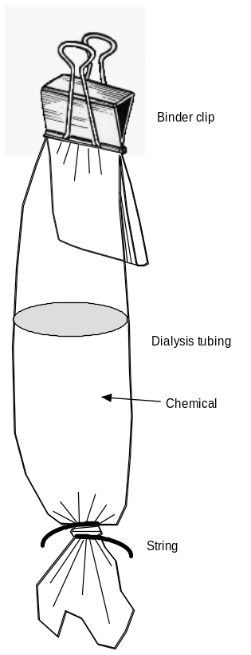
1. Cut two pieces of dialysis tubing about 15 centimeters (6 inches) long. Tie one end of one piece of dialysis tubing with string to form the tubing into a bag.
2. Add 15 mL of 1.0 Molar hydrochloric acid to one of the dialysis tubing bags. Place the exterior of the bag under a gentle stream of running water to wash off any acid that may have fallen on the exterior of the bag.
3. Fold over the open end of the bag. Place a binder clip over the folded end.
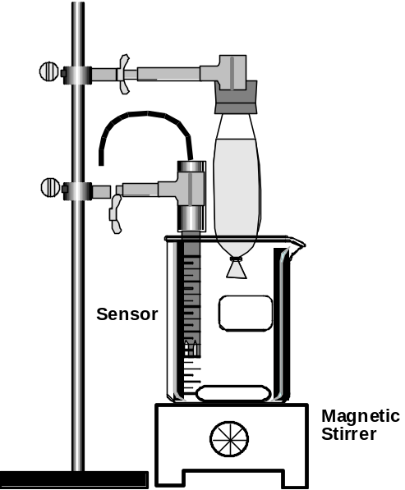
4. Prepare the second piece of dialysis tubing. Add 15 mL of 1.0 M sodium hydroxide instead of the hydrochloric acid. Rinse the outside of the second bag.
Do not allow the exteriors of the bags to come in contact with each other.
Set your bags aside on a labeled paper towel.

Equipment Setup
1. Put a spin bar in a 250-mL beaker and place the beaker on a magnetic stirrer.
2. Use a base and support rod and a clamp to mount the pH electrode so the end of the sensor is in the beaker
3. Position the sensor so the electrode cannot hit the spin bar.
4. Use a clamp to suspend the dialysis tubing bag containing hydrochloric acid above the beaker.

PART III: Data Recording
There are two parts to data recording. In the first part, use the dialysis tubing that contains hydrochloric acid. In the second part, use the dialysis tubing that contains sodium hydroxide.
Follow the same basic procedure for both parts:
- Put distilled water into the beaker and turn on the magnetic stirrer.
- Start recording data.
- Lower the dialysis tubing into the water.

PART IIIA: Migration of Hydrogen Ions Through the Membrane
1. Put 100 mL of distilled water into the beaker. Turn on the magnetic stirrer. Get ready to lower the dialysis tubing into the water.
2. When you are ready, start recording data. (Hint: In DataStudio, click ‘Start’. In Scienceworkshop, click ‘REC’.) Allow the interface to record for about 5 seconds.
3. After about 5 seconds, lower the dialysis tubing bag containing the hydrochloric acid into the water.
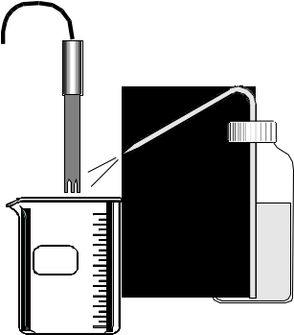
- The pH Sensor will measure the pH of the water bath for 200 seconds and then data recording will stop automatically.
4. Dispose of the dialysis tubing bag and hydrochloric acid as directed.
5. Turn off the magnetic stirrer. Raise the pH electrode out of the water. Use the wash bottle to thoroughly rinse the pH electrode. Catch the rinse water in the beaker.
6. Remove the spin bar and dispose of the rinse water in the beaker as directed. Clean and dry the beaker.

Part IIIB: Migration of Hydroxide Ions Across a Membrane
1. Put 100 mL of distilled water in the beaker. Add the spin bar and place the beaker on the magnetic stirrer. Turn on the stirrer.
2 Position the pH electrode so it is in the water in the beaker, but does not hit the spin bar in the beaker.
3. Suspend the second dialysis tubing bag (with sodium hydroxide) above the water in the beaker.
4. Start recording data.
5. After about 5 seconds, lower the dialysis tubing bag containing the sodium hydroxide into the water.
6. After data recording stops automatically, dispose of the dialysis tubing bag and sodium hydroxide as directed.
7. Turn off the magnetic stirrer. Raise the pH electrode out of the water. Use the wash bottle to thoroughly rinse the pH electrode. Catch the rinse water in the beaker.
8. Remove the spin bar and dispose of the rinse water in the beaker as directed.

Analyzing the Data
1. Use the Graph’s built-in analysis tools to find the rate of change of pH for each run of data.
• Hint: In DataStudio, click ‘Run #1’ in the Graph legend (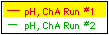) to make it the active run. Click the ‘Smart Tool’ button () in the Graph. The ‘Smart Tool’ displays the coordinates of its position as you move it to any position in the Graph display. When the ‘Smart Tool’ is on a data point, the ‘x’ coordinate is the time and the ‘y’ coordinate is the pH value at that point.
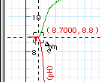
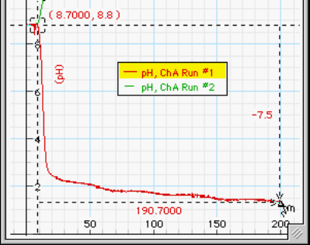
• Move the ‘Smart Tool’ to the point on Run #1 where the pH begins to change. Move the cursor to a corner of the ‘Smart Tool’. Notice that the cursor changes to a delta shape (). Click-and-drag the delta cursor to the end of Run #1. The ‘Smart Tool’ shows the change in time and the change in pH between the starting and ending points.
The ‘Smart Tool’ shows the change.
• In ScienceWorkshop, click the ‘Smart Cursor’ button () and move the cursor into the display area. The coordinates of the cursor are displayed in the label area of the Y-axis and the X-axis.
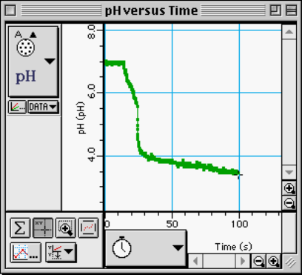
• Move the ‘Smart Cursor’ to the point on the first run where the pH begins to change. Click-and-drag the ‘Smart Cursor’ to the end of the run. The change in pH appears along the Y-axis and the change in time appears along the X-axis.
2. Record the change of pH and the change of time between the beginning and end points for the first run of data.
3. Repeat the process to find the change of pH and time for the second run of data.

Record your results in the Lab Report section.

Lab Report - Activity B07: Membrane Permeability

What Do You Think?
The purpose of this laboratory activity is to test the permeability of a membrane to hydrogen and hydroxide ions. Which do you think will move through the membrane more quickly: the hydrogen ion or the hydroxide ion?

Data Table
Convert the amount of time to minutes. Calculate the ‘Rate of change of pH’ by dividing the change in pH by the amount of time. Record the ‘Rate of change of pH’

Trial | Run | ∆pH | ∆Time | Rate of change of pH
HCl |  |  | min | pH/min
NaOH |  |  | min | pH/min

Questions
1. Which ion appears to have migrated across the membrane the fastest?

2. How could the migration rate of the ions be increased?

3. How could you use a series of ions to determine the size of the pores in the membrane?

