Activity B11: Exercise and Pulse Rate

(Heart Rate Sensor)

Concept | DataStudio | ScienceWorkshop (Mac) | ScienceWorkshop (Win)
Physiology | B11 Pulse Rate.DS | B10 Exercise & Pulse Rate | B10_EPR.SWS

Equipment Needed | Qty
Heart Rate Sensor (CI-6543A) | 1
Chair or couch | 1

NOTE: This activity requires the person whose heart rate is being measured to perform exercise (e.g., jogging in place) for several minutes. Do NOT perform this activity if vigorous activity will cause discomfort or be hazardous to the health of the person.

What Do You Think?

The purpose of this laboratory exercise is to determine how mild exercise affects heart rate and recovery time. What do you predict will happen to the heart rate after mild exercise?
Take time to write an answer to this question in the Lab Report section.
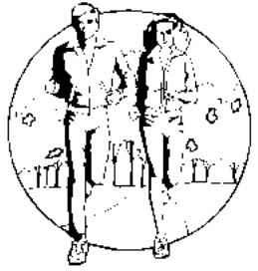

Background
You probably have experienced the sensation of your heart beating strongly when you participated in physical activity. Your nervous system monitors your entire body and signals your heart to beat faster in response to increased activity. Pulse rate measures how fast your heart is beating. Recovery time is how long it takes for the heart to return to its normal resting rate.

SAFETY REMINDER  - Follow all safety instructions. | 

For You To Do
Use the Heart Rate Sensor to measure pulse rate before mild exercise and after mild exercise. Use DataStudio or ScienceWorkshop to record and display the pulse rate versus time.
Compare pulse rate at rest to pulse rate after mild exercise. Estimate the approximate amount of recovery time needed for the pulse rate to return to its normal resting rate.

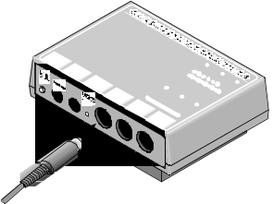
PART I: Computer Setup
1. Connect the ScienceWorkshop interface to the computer, turn on the interface, and turn on the computer.
2. Connect the Heart Rate Sensor DIN plug into Analog Channel A on the interface.
3. Open the ScienceWorkshop file titled as shown:

DataStudio | ScienceWorkshop (Mac) | ScienceWorkshop (Win)
B11 Pulse Rate.DS | B10 Exercise & Pulse Rate | B10_EPR.SWS
- The DataStudio file has a Workbook display. Read the instructions in the Workbook.
• The ScienceWorkshop document opens with a Digits display and a Table display for Heart Rate and a Graph display for Heart Rate versus Time.
• Data recording is set at 50 measurements per second (50 Hz) with a Stop condition at 60 seconds.

PART II: Sensor Calibration and Equipment Setup

Sensor Calibration
• You do not need to calibrate the Heart Rate Sensor.
• The Heart Rate Sensor is a small photogate-type device that sends light through your ear lobe. As your heart beats, the amount of blood in the capillaries near the surface of the skin will vary. The amount of light that passes through your ear lobe varies as the amount of blood in the capillaries varies. The sensor measures changes in light transmittance of your ear lobe. The change in transmittance corresponds to beats of the heart. The DataStudio or ScienceWorkshop program automatically calculates the heart beat rate.

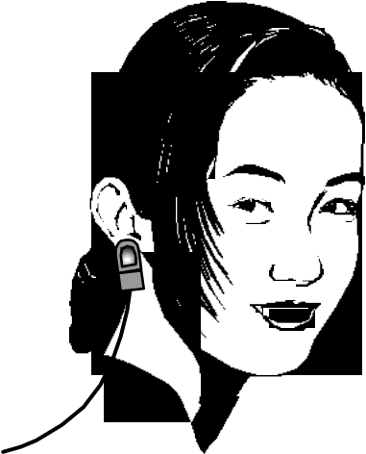
Check the Heart Rate Sensor:
1. Attach the clip to your ear lobe. There is a small light bulb in the clip, so you may feel warmth on your ear lobe.
2. Monitor the heart rate.
• Hint: In DataStudio, select ‘Monitor Data’ from the Experiment menu. In ScienceWorkshop, click the ‘MON’ button.
3. Watch the plot of voltage versus time in the Graph display, and the value of heart rate in the Digits display. It may take a few seconds for the readings to stabilize. If the voltage versus time plot is “flat”, try adjusting the clip on your ear lobe.
4. When you are sure that the Heart Rate Sensor is working properly, click the STOP button.
• NOTE: This activity requires the person whose heart rate is being measured to perform exercise (e.g., jogging in place) for several minutes. Do NOT perform this activity if vigorous activity will cause discomfort or be hazardous to the health of the person.

PART III: Data Recording
There are three parts to data recording.
- Measure your resting heart rate.
- Exercise.
- Measure your heart rate after exercise.

PART IIIA: Resting Heart Rate
1. Relax in a chair for about a minute. When you are ready, start recording data.
• Hint: In DataStudio, click ‘Start’. In ScienceWorkshop, click ‘REC’.
• Data collection begins immediately, but the value of heart rate in the Digits display may not change for a few seconds. Data recording will end automatically after 60 seconds.

PART III: Heart Rate After Exercise
In this trial you will measure heart rate after exercise.
1. Before you begin recording, remove the ear clip from your ear. Stand up and begin to “jog in place”. Continue to jog vigorously for at least two minutes.
2. At the end of two minutes, sit down. Re-attach the ear clip to your ear.
3. Start recording data. Click REC to record data during the recovery period after exercise.
• Data recording ends automatically after 60 seconds.
4. Remove the ear clip from your ear.

Analyzing the Data

View the Graph of Heart Rate
1. Set up your Graph display to view the data from the Heart Rate Sensor.
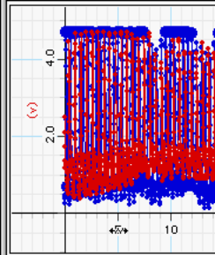
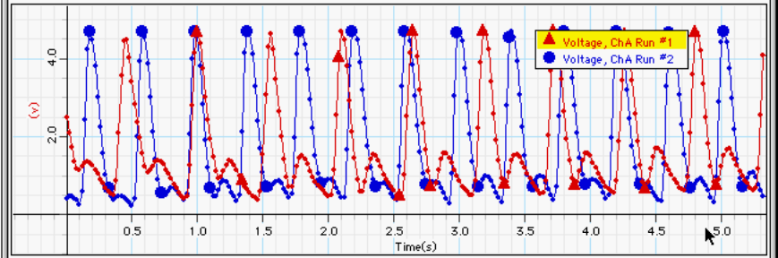
• Hint: In DataStudio, rescale the horizontal axis so the range is from 0 to about 5 seconds. Place the cursor over a number on the horizontal axis. Notice that the cursor changes to a spring shape (). Click-and-drag the cursor to the right or left to change the horizontal axis scale.
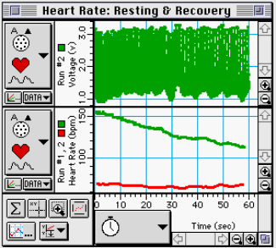
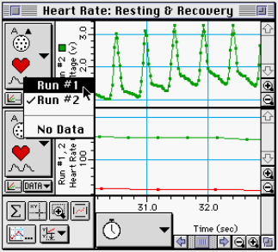
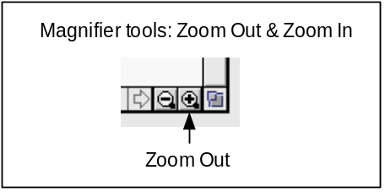
• Hint: In ScienceWorkshop, click the ‘Zoom Out Magnifier’ tool in the lower right corner of the Graph several times to rescale the X-axis.

Determine the Heart Rate Before and After Exercise
2. Use the built-in statistics in the Table display to determine the heart rate before exercise.
• Hint: In DataStudio, click the ‘Statistics’ menu button (). Minimum and Maximum are selected by default. Click ‘Mean’ to add it to the statistics displayed at the bottom of the Table display.
• Hint: In ScienceWorkshop, click the ‘Statistics’ button (). The Statistics area at the bottom of the Table will display Min (minimum), Max (maximum), Mean, and Std. Dev (standard deviation)
3. Record you minimum, maximum, and mean heart rate for Run #1 (before exercise) in the Lab Report section.
4. Use the built-in statistics to determine the heart rate after exercise.
• Hint: Use the ‘Data’ menu button to select Run #2. (In DataStudio, click (). In ScienceWorkshop, click ().
5. Record you minimum, maximum, and mean heart rate for Run #2 (after exercise) in the Lab Report section.
6. Calculate your recovery rate after exercise. Determine the change in heart rate (subtract the minimum heart rate from the maximum heart rate). You recorded data for 60 seconds (one minute) so the change in heart rate is your Recovery Rate per minute. Record your recovery rate in the Lab Report section.

Record your results in the Lab Report Section

Lab Report - Activity B11: Exercise & Pulse Rate

What Do You Think?
The purpose of this laboratory exercise is to determine how mild exercise affects heart rate and recovery time. What do you predict will happen to the heart rate after mild exercise?

Data Table

Heart Rate | Resting | After Exercise
Minimum | bpm | bpm
Maximum | bpm | bpm
Mean | bpm | bpm
Recovery Rate = ________ bpm/min

Questions
1. What was the control in your experiment?

2. What is the influence of exercise on your heart rate?

3. How do different types of exercise affect heart rates and recovery rates among the students in your class? Explain.

4. Are there any differences between male and female heartbeat rates and recovery rates among the students of your class?

Optional — Calculating Pulse Rate Using the Wrist Method
1. Calculate your pulse using the wrist method. Place the index and middle fingers of your left hand on your right wrist. Find your pulse.
2. Count the number of heart beats for a specified time interval.
Number of Beats = _________
Time Interval = _________ sec
3. Determine your pulse rate.
Pulse Rate = _________ beats/sec
4. Repeat steps 2-3 twice and determine an average pulse rate. Compare to the value determined using the interface and the Heart Rate Sensor.

