Activity B13: EKG – Demonstration
(EKG Sensor)

Concept | DataStudio | ScienceWorkshop (Mac) | ScienceWorkshop (Win)
Physiology | B13 EKG Demo.DS | B13 EKG Demonstration | B13_EKGD.SWS

Equipment Needed | Qty | Chemicals and Consumables | Qty
EKG Sensor (CI-6539) | 1 | electrode patches (inc. with sensor) | 3
chair or couch | 1 | paper towel | 1

What Do You Think?

How does the electrical activity of the heart muscle look?
Take time to write an answer to this question in the Lab Report section.

Background
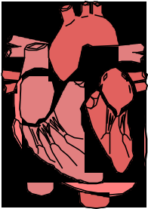
The EKG (electrocardiogram) sensor measures cardiac electrical potential waveforms (voltages) produced by the heart as its chambers contract. Heart muscle cells are polarized at rest. This means the cells have a very small potential difference (voltage) from one side to the other of their cell membranes.
The cells of the heart can depolarize without an outside stimulus; that is, they will depolarize spontaneously. The group of cells that depolarize the fastest is called the pacemaker (also known as the sinoatrial or SA node). These cells are located in the right atrium. All the cells of both atria depolarize and contract almost simultaneously.
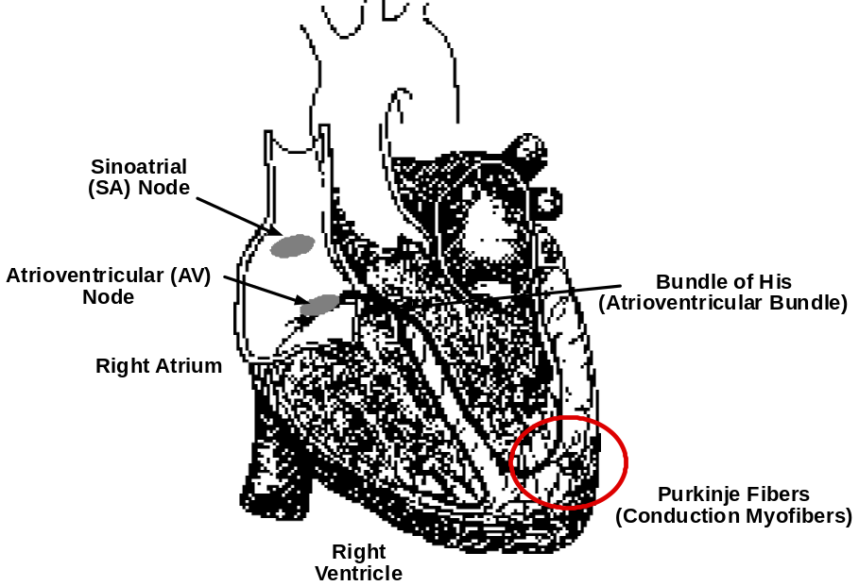
The atria and the ventricles are isolated from each other electrically. Therefore, the depolarization of the atria does not directly affect the ventricles. Another group of cells in the right atria called the atrioventricular or AV node sends electrical signals from the atria down a special bundle of conducting fibers (called the Bundle of His) to the ventricles. In the muscle wall of the ventricles are the Purkinje fibers, which are a special system of muscle fibers that bring depolarization to all parts of the ventricles almost simultaneously. This process causes a small time delay and so there is a short pause after the atria contract before the ventricles contract. Because the cells of the heart muscle are interconnected, this wave of depolarization, contraction and repolarization spreads across all the connected muscle of the heart.
When a portion of the heart is polarized and the adjacent portion is depolarized this creates an electrical current that moves through the body. The changes in these currents can be measured, amplified, and plotted over time. The EKG is the graphical representation of the measured electrical currents.
Note: An excellent text about the electrocardiogram and other phenomena of bioelectricity is Physics with Health Science Applications by Paul Peter Urone, ©1986, John Wiley & Sons, Inc., New York.

The Electrocardiogram
One part of a typical EKG (electrocardiogram) is a ‘flat line’ or trace indicating no detectable electrical activity. This line is called the Isoelectric line. Deviation from this line indicates electrical activity of the heart muscles.
The first deviation from the Isoelectric line in a typical EKG is an upward pulse following by a return to the Isoelectric line. This is called the P wave and it lasts about 0.04 seconds. This wave is caused by the depolarization of the atria and is associated with the contraction of the atria.
After a return to the Isoelectric line there is a short delay while the heart’s AV node depolarizes and sends a signal along the atrioventricular bundle of conducting fibers (Bundle of His) to the Purkinje fibers, which bring depolarization to all parts of the ventricles almost simultaneously.
After the AV node depolarizes there is a downward pulse called the Q wave. Shortly after the Q wave there is a rapid upswing of the line called the R wave followed by a strong downswing of the line called the S wave and then a return to the Isoelectric line. These three waves together are called the QRS complex. This complex is caused by the depolarization of the ventricles and is associated with the contraction of the ventricles.
After a short period of time the chemical ions that have been involved in the contraction migrate back to their original locations. The movement of these ions generates an upward wave that then returns to the Isoelectric line. This upward pulse is called the T wave and indicates repolarization of the ventricles.
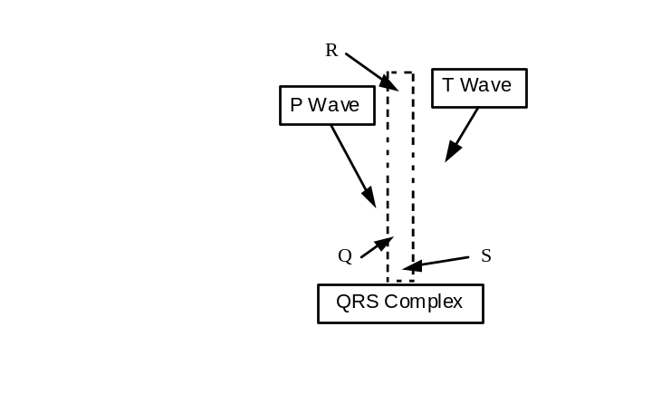
The sequence from P wave to T wave represents one heart cycle. The number of such cycles in a minute is called the heart rate and is typically 70-80 cycles (beats) per minute at rest.
Some typical times for portions of the EKG are given below.
If your EKG does not correspond to the above numbers, DO NOT BE ALARMED! These numbers represent typical averages and many healthy hearts have data that fall outside of these parameters. To read an EKG effectively takes considerable training and skill. This sensor is NOT intended for medical diagnoses.
P-R interval... 120-200 milliseconds (0.120 to 0.200 seconds)
QRS interval... under 100 milliseconds (0.100 seconds)
Q-T interval... under 380 milliseconds (0.380 seconds)
SAFETY REMINDER  - Follow all safety instructions. | 

For You To Do
Use the EKG sensor to measure the electric potential associated with the polarization and depolarization of heart muscle tissue during the heart’s contractions. Use DataStudio or ScienceWorkshop to record and display the heart voltage signal (electrocardiogram) and to calculate heart rate based on the peaks and valleys in the EKG trace.

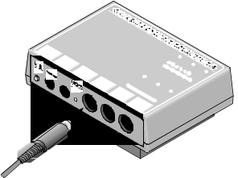
PART I: Computer Setup
1. Connect the ScienceWorkshop interface to the computer, turn on the interface, and turn on the computer.
2. Connect the EKG sensor’s DIN plug into Analog Channel A on the interface.
3. Open the file titled as shown:

DataStudio | ScienceWorkshop (Mac) | ScienceWorkshop (Win)
B13 EKG Demo.DS | B13 EKG Demonstration | B13_EKGD.SWS
• The DataStudio file has a Workbook display. Read the instructions in the Workbook.
• The ScienceWorkshop file opens with a Graph display of “EKG Voltage (mV) ” versus “Time (s)” on one plot, and “Heart Rate (bpm)” versus “Time (s)” on the second plot.
• Data recording is set for 100 samples per second (100 Hz). Data recording stops automatically at 15 seconds.

PART II: Sensor Calibration and Equipment Setup

About the EKG Sensor
The sensor consists of the EKG amplifier case and a cable for connecting to the interface. Three electrode leads are attached to the amplifier case. The circuitry isolates the user from the possibility of electrical shock in two ways. The sensor signal is transmitted through an opto-isolation circuit. Power for the sensor is transferred through a transformer. The circuitry protects against accidental over-voltages of up to 4,000 volts.
The sensor is designed to produce a signal between 0 and five volts with 1 volt being the Isoelectric line. Deviation from the Isoelectric line indicates electrical activity. The shape and periodicity of the signal is of primary importance, so the sensor does not need to be calibrated.
Use three electrode patches. The electrodes can be reused but they tend to absorb moisture (they are very hygroscopic), and therefore, reuse is not recommended. The electrodes should be kept in an airtight, clean, dry container for storage. Because the electrical signal produced by the heart and detected at the body’s surface is so small, it is very important that the electrode patch makes good contact with the skin. Scrub the areas of skin where the patches will be attached with a paper towel to remove dead skin and oil.
1. Peel three electrode patches from the backing paper. Firmly place the first electrode on the right wrist. Place a second electrode on the right elbow pit. Place the third electrode on the left elbow pit.
• Place each electrode so it is on the inside part of the arm (closer to the body) and the tab on the edge of the electrode patch points down, so the wire of the sensor can hang freely without twisting the edge of the electrode patch.
2. Connect the micro alligator clips from the sensor to the tabs on the edges of the electrode patches.
• Connect the black (or “reference”) alligator clip to the wrist electrode patch. This is the reference point for the “Isoelectric” line (baseline).
• Connect the green (or negative) alligator clip to the right elbow electrode patch.
• Connect the red (or positive) alligator clip to the left elbow electrode patch.
There are several different ways to connect the EKG sensor. This simple arrangement is appropriate for the classroom.

PART III: Data Recording - Resting EKG
• The person whose EKG is being measured should remain calm and relaxed. Encourage the person to breathe normally.
1. When everything is ready, start recording data. The values of data will be recorded in the Graph display. Data recording stops automatically at 15 seconds.
Muscle activity in the arms causes electrical signals that may overwhelm the cardiac signals. Remind the person whose EKG is being measured to relax and remain as still as possible. If the EKG trace is very irregular, remove the electrode patches. Use rubbing alcohol to more thoroughly clean the areas of skin where the electrodes will be placed. After the alcohol evaporates, put new electrode patches on the cleaned areas of skin.

Analyzing the Data
1. Zoom in on a region of the Graph display that includes three or four complete heart cycles.
2. Use the built-in analysis tools to measure the peaks of the P, Q, and R waves. Record the times in the Lab Report section.
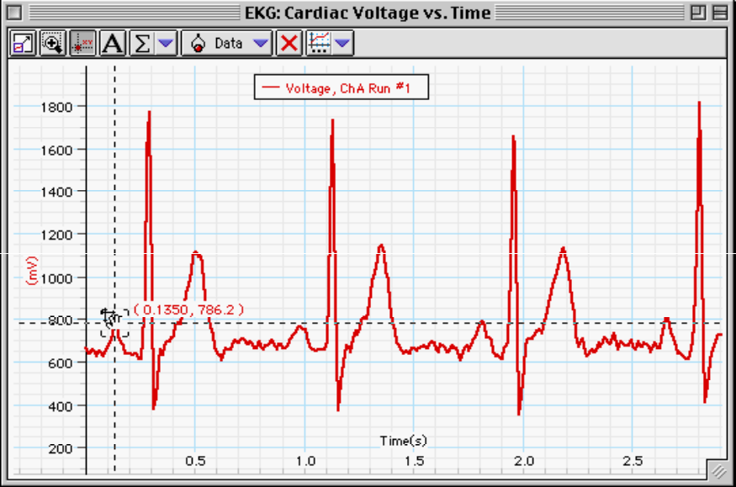
• Hint: In DataStudio, click the ‘Smart Tool’ button ().The ‘Smart Tool’ displays the coordinates of its position as you move it to any position in the Graph display. When the ‘Smart Tool’ is on a data point, the ‘x’ coordinate is the time and the ‘y’ coordinate is the voltage value at that point.
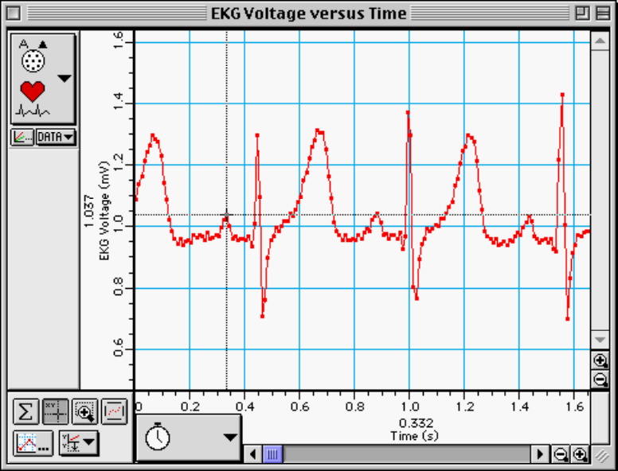
• In ScienceWorkshop, click the ‘Smart Cursor’ button () and move the cursor into the display area. The coordinates of the cursor are displayed in the label area of the Y-axis and the X-axis.
3. Calculate the P-R interval and record the time.
4. Measure the peak of the S wave. Record the time.
5. Calculate the Q-R-S interval and record the time.
6. Measure the peak of the T wave. Record the time.
7. Calculate the overall Q-T interval and record the time.
8. Using the graph’s built-in statistics tools, find the minimum, maximum, and mean for the Heart Rate.

Record your results in the Lab Report Section

Lab Report - Activity B14: EKG – Demonstration

What Do You Think?
How does the electrical activity of the heart muscle look?

Data Table: Interval Analysis
Item | Time
P wave begins | sec
Q wave begins | sec
R wave begins | sec
S wave begins | sec
T wave begins | sec

Item | Time | Typical Time
P-R interval | sec | sec
QRS interval | sec | sec
Q-T interval | sec | sec

Data Table: Heart Rate Analysis
Item | Rate (bpm)
Minimum
Maximum
Mean

Questions
1. Compare your values for the P-R, Q-R-S, and Q-T intervals to the ones given earlier. What could explain the differences?

2. How does the heart rate measured by the EKG compare to your heart rate measured with the Heart Rate sensor or by the direct measurement of the pulse at the wrist or neck? What could explain the differences?

