How Loud Is That Bubble?

Equipment Needed | Consumables
• ScienceWorkshop® Interface | • bubble gum (several kinds)
• Sound Sensor

Purpose
The purpose of this activity is to use the Sound Sensor to record the sound intensity of one bubble gum bubble compared to another.
Procedure

  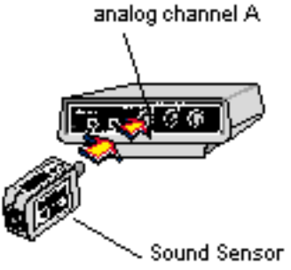 | Turn on the interface box and the computer. Plug a Sound Sensor into analog channel A of the interface box.
 | Open the Experiment Library template file:
 |  | ScienceWorkshop |  |  | DataStudio™
 |  | MSS17 |  |  | MSS17 Bubble.ds
 | Chew a piece of gum to get it perfectly prepared to blow and pop LOUD bubbles.
  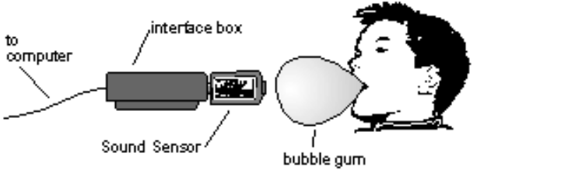 | When you are ready to record the popping of a bubble, point the Sound Sensor directly at the bubble while a partner uses the mouse. Signal for your “mouse driver” to begin recording data.
 | Stop recording once you have popped your bubble. Record several bubble pops.
 |  | 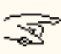 | For each bubble pop, keep the distance between the bubble and the Sound Sensor as constant as possible, and keep the Sound Sensor pointed directly at the bubble.
 |  |  |  | Write down in your notebook your predictions about which pops seem the loudest.
 | When you have collected enough data, you are ready to analyze it. Your data about the sound intensity is recorded as numbers in a table. The numbers can be compared to each other by their place value. For example, a number of 30.43 represents a greater intensity than does a number of 30.29.
 |  |  |  | Does the bubble with the highest number agree with the bubble that seemed loudest to you?  How do your predictions about each bubble compare to the data you recorded?  Which bubble pop was the most surprising?  Does the pitch (how low or high) of the sound seem to have any effect on the intensity?
 | 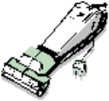 |  |  | Be sure to follow your teacher’s instructions for disposing of the gum, putting away your equipment, and shutting down the computer. If you are saving your data on a disk, remember to give it a new file name.

