Follow the Leader Graphing I
Equipment Needed | Consumables
• ScienceWorkshop® Interface | • masking tape (optional)
• Motion Sensor
• meter stick
• support stand (optional)

Purpose
The purpose of this activity is to use the Motion Sensor to see how closely you can follow a path that has been “drawn” for you by the computer.
Procedure

  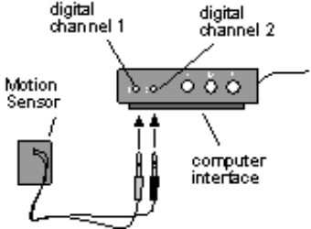 | Turn on the ScienceWorkshop 500 Interface box and the computer.
 | Insert the yellow plug of the Motion Sensor into digital channel 1 of the interface box and the black plug into digital channel 2.
  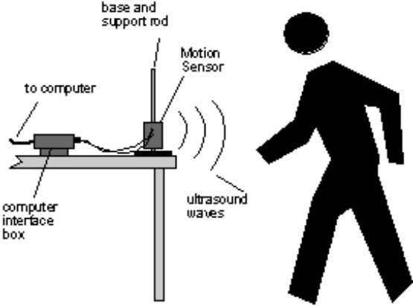 | Mount the Motion Sensor on its stand —or set it on a table so it is stable and facing you — and adjust its height so that the metal screen is aimed right at the middle of your shirt.

 | Set up your area so that you can back away from the Motion Sensor’s metal screen, without running into anything for 2 meters. Ask your teacher’s permission before putting any tape on the floor.
 | Open the Experiment Library template file:
 |  | ScienceWorkshop |  |  | DataStudio™
 |  | MSS01 |  |  | MSS01 Follow the Leader.ds
 |  | 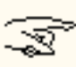 | In ScienceWorkshop, you can close or minimize the Experiment Notes window that is on the screen when you first open the file. To open this window again, select Notes Window from the list at the end of the Experiment menu.
 |  |  | You will need to be able to look at your computer’s monitor while you are backing away from the Motion Sensor.
 | Notice the Graph display on the computer, titled Position versus Time – Match Graph. The black, zigzag line has been drawn for you by the computer. The y-axis shows how far away you need to be from the Motion Sensor. The x-axis shows how many seconds each part of your travel should last.
 | 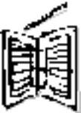 |  |  | Can you predict how close to the Motion Sensor you should be before you begin to record? Can you predict how far to back away from the Motion Sensor before stopping? Write down your predictions in your notebook.

 | When you are ready to begin, have a partner start recording data. (Hint: Click REC (ScienceWorkshop) or Start (DataStudio). Another way to begin recording data is to select Record (DataStudio) or Start Data (ScienceWorkshop) on the Experiment menu.) The Motion Sensor will make a faint clicking sound while it is recording. (Note: There is a 5-second “countdown” in DataStudio.) Watch the monitor, and try to match your motion to the line on the monitor.
 | The computer will automatically stop recording after 10 seconds. You may now look at your graph and analyze your data and compare yourself to the “leader.” To do this, re-scale your graph so the data fills the whole window. [(Hint: Click the Autoscale button (ScienceWorkshop) or the Scale to Fit button (DataStudio)].
 | In ScienceWorkshop, click the Statistics button and examine the total abs. difference (total absolute difference) number. For DataStudio, check the “Match Score.” The closer this number is to zero, the more closely you have followed the leader and matched your motion to the computer’s graph.
 | Repeat the data recording process several more times. Each time, try to improve how closely your motion matches the computer.
 | To choose runs of data, click the Data menu. To clear all runs of data from the graph, click the Data menu button and select No Data.
 |  | Write a description of your motion in your notebook, using terms such as constant speed and no motion.

 | How was your first attempt at matching the graph different from your last attempt? Are there some students in your class who are especially good at matching the computer?
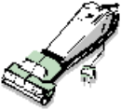 | Be sure to follow your teacher’s instructions for putting away your equipment and shutting down the computer. If you are saving your data on a disk, remember to give it a new file name.

