Investigating Temperature Data
Equipment Needed | Consumables
• ScienceWorkshop® Interface | • ice
• Temperature Sensor | • hot water
• glass container, 250 ml (two)
• graduated cylinder or measuring cup

Purpose
The purpose of this activity is to use the Temperature Sensor to record the temperature of cold and hot liquids before and after they are mixed.
Procedure
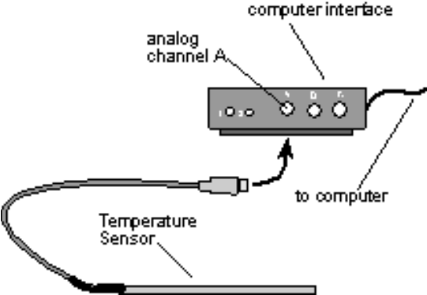
 | Turn on the ScienceWorkshop 500 Interface box and the computer.
 | Plug a Temperature Sensor into analog channel A of the interface box.
 | Open the Experiment Library template file:
 |  | ScienceWorkshop | DataStudio™
 |  | MSS03 | MSS03 Investigating Temp.ds

  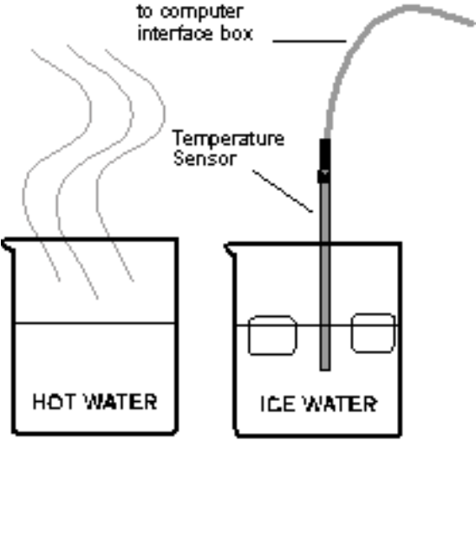 |  | Use the graduated cylinder to measure 100 ml of ice water. Pour the 100 ml of ice water into one of the glass containers. Use the graduated cylinder to measure 100 ml of hot water. Pour the hot water into the other glass container.
 |  | Place the Temperature Sensor into one of the containers of water. Start recording data. To do this, click REC (ScienceWorkshop) or Start (DataStudio). Watch the graph for about 10 seconds.
 |  | Move the Temperature Sensor to the other container and watch the graph for another 10 seconds or so. Stop recording data. (To do this, click the STOP button).
 | Try different ways of changing the temperature, such as putting the tip of the sensor directly on an ice cube, mixing the hot and cold water in several different ways, or taking the sensor out of the water and blowing on the tip of it.
 |  | 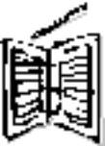 | In your notes, keep a list of the things you try. For each thing you try, write down your predictions about what will happen to the temperature before you do the experiment.
 | When you have finished collecting your temperature data, you are ready to analyze it. To do this, click the graph to make it active.

 | Re-scale the graph so the data fills the whole window. (Hint: Click the Autoscale button (ScienceWorkshop) or the Scale to Fit button (DataStudio).
 | Pinpoint the exact values for your temperature data. (Hint: Click the Smart Cursor button (ScienceWorkshop) or the Smart Tool (DataStudio) and move the cross hairs in the graph. Notice how the coordinates of the cursor are shown near the origin of the axes.)
Find the lowest temperature you recorded (this is the y-coordinate of the lowest point on your graph). Write down this temperature in your notes.
Find the highest temperature you recorded (this is the y-coordinate of the highest point on your graph). Write down this temperature in your notes.
 |  | What was the most amount of change you were able to produce in the temperature?  Which temperature change took the least amount of time? Which took the longest?  Which of your predictions turned out as you expected? Which predictions did not agree with the results?
 | 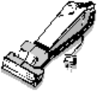 | Be sure to follow your teacher’s instructions for putting away your equipment and shutting down the computer. If you are saving your data on a disk, remember to give it a new file name.

