How Well Insulated is Your Room (House)?
Equipment Needed | Consumables
• ScienceWorkshop® 500 Interface  with fresh batteries and power adapter | • None required
• Temperature Sensor

Purpose
The purpose of this activity is to use the Temperature Sensor to record the temperature inside a room or house.
Procedure
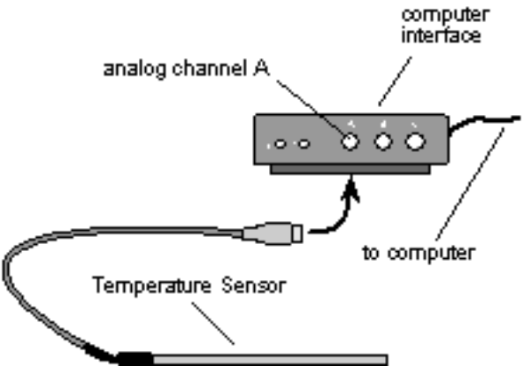

 |  | Turn on the interface box and the computer. Plug a Temperature Sensor into analog channel A of the interface box.
 |  | Open the Experiment Library template file:
 |  |  |  | ScienceWorkshop |  |  | DataStudio™
 |  |  |  | MSS23 |  |  | MSS23 How Well Insulated.ds
 |  |  |  |  |  | ScienceWorkshop has been preset to record data once every 10 seconds, so data can be collected over a long period of time.
 |  | When you are ready to take the interface box and sensor home to begin logging remote data, select Disconnect for Logging (ScienceWorkshop) or click the Logging button on the Setup Toolbar (DataStudio).
 |  |  |  |  |  | Printing the checklist is an option. Follow your teacher’s instructions about whether or not to print the checklist.
 |  | Disconnect the computer cable and the power cord from the back of the ScienceWorkshop 500 Interface. Leave the interface box turned on and the Temperature Sensor plugged in. Be certain to take the AC power adaptor home with you also, since batteries only last for about 3 ½ hours.
 |  | Once at home, position the interface and sensor near a wall that faces the outside. Do not place the sensor near a heat or air conditioning vent. Do place the equipment where you can plug in the power adaptor. Keep the doors and windows the way they normally are in your house at this time of year. Be sure you plug the AC power adaptor into the wall outlet first before connecting it to the interface box.
 |  | To begin recording the temperature, “wake up” the Science Workshop 500 Interface by pushing — and holding down for a second — the LOG button on the front of the box. The green light will flash 10 times, and will then begin to flash rapidly. It is now recording.
 |  | Record the temperature from the moment you arrive home until you are ready to leave for school the next morning.
 | Press LOG button to end recording just before you leave for school.
 | When you arrive at school, plug the AC power adaptor into an electrical outlet, return the 500 Interface box to the computer, and reconnect the computer and power cables. Be sure you plug the AC power adaptor into the wall outlet first before connecting it to the interface box. Start the Science Workshop program, and select Connect to Interface on the Experiment menu (ScienceWorkshop) or click the Connect button on the Setup toolbar (DataStudio).

 |  |  | Your data will appear on the screen on a Time vs. Temperature graph. If you are not able to analyze the data at this time, save it (according to your teacher’s instructions) for later analysis.
 | When you are ready to analyze your home temperature data, re- scale the data. Use the Smart Cursor or Smart Tool and Magnifier tools to examine areas of interest. Activate the Statistics menu to see the Mean (or “average”) temperature for the entire time.
 |  |  | By how many degrees did the temperature vary in your room (or house) from the highest to the lowest temperature?  What was the average temperature for the whole time?  If heat or air conditioning was on, can you tell from your graph when it turned on and off?  By how many degrees can temperature vary and still remain comfortable to the people who live in the house?
 | 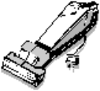 |  | Follow your teacher’s instructions for finishing up this activity and putting away the equipment.

