The Beam Team
Equipment Needed | Consumables
• ScienceWorkshop® 500 Interface | •None required
• Light Sensor
• MagLight® flashlight or laser pointer
• mirrors (two or more)

Purpose
The purpose of this activity is to use the Light Sensor to record the intensity of a beam of reflected light.
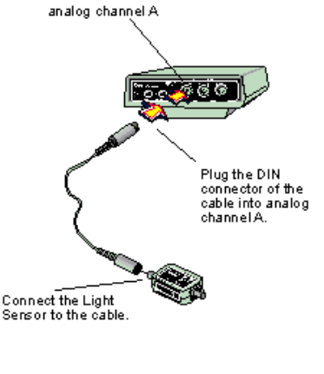
Procedure
 | Turn on the interface box and the computer. Plug a Voltage Sensor into analog channel A of the interface box.
 | Open the Experiment Library template file:
 |  | ScienceWorkshop | DataStudio™
 |  | MSS25 | MSS25 The Beam Team.ds
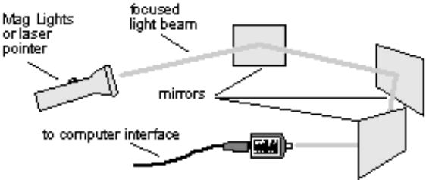
 | Arrange several students, holding mirrors, around the room. Turn on the flashlight and focus its beam as tightly as possible. One person shines the flashlight so its beam is reflected off a mirror. The person holding that mirror then bends the beam so it is reflected to the next mirror, and so on. Imagine that your are “playing catch” with a beam of light. Reflect the beam of light to the Light Sensor. This requires a great team effort!
 | Begin recording data on the intensity of this beam of light. After you have collected about 20 seconds of data from the beam of light, stop recording data.
 | Re-scale the graph. Pinpoint exact values for your light intensity data using the Smart Cursor or Smart Tool.
 | If possible, try other things, such as adding another mirror to reflect and bend the beam even more before it reaches the Light Sensor, or changing the distances between each mirror.
 |  | How does the distance between the mirrors affect the intensity of your beam of light?  How would you change the experiment so that you could increase the intensity of light?
 | 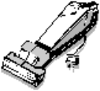 | Be sure to follow your teacher’s instructions for putting away your equipment and shutting down the computer. If you are saving your data on a disk, remember to give it a new file name.

