Activity P01: Position and Time – Understanding Motion 1
(Motion Sensor)

Concept | DataStudio | ScienceWorkshop (Mac) | ScienceWorkshop (Win)
Linear motion | P01 Position and Time.ds | P01 Understanding Motion 1 | P01_MOT1.SWS

Equipment Needed | Qty | Equipment Needed | Qty
Motion Sensor (CI-6742) | 1 | Base and Support Rod (ME-9355) | 1

What Do You Think?
What is the relationship between the motion of an object – YOU – and a graph of position and time for the moving object?
Take time to answer the ‘What Do You Think?’ question(s) in the Lab Report section.

Background
When describing the motion of an object, knowing where it is relative to a reference point, how fast and in what direction it is moving, and how it is accelerating (changing its rate of motion) is essential. A sonar ranging device such as the PASCO Motion Sensor uses pulses of ultrasound that reflect from an object to determine the position of the object. As the object moves, the change in its position is measured many times each second. The change in position from moment to moment is expressed as a velocity (meters per second). The change in velocity from moment to moment is expressed as an acceleration (meters per second per second). The position of an object at a particular time can be plotted on a graph. You can also graph the velocity and acceleration of the object versus time. A graph is a mathematical picture of the motion of an object. For this reason, it is important to understand how to interpret a graph of position, velocity, or acceleration versus time. In this activity you will plot a graph of position in real-time, that is, as the motion is happening.

SAFETY REMINDER
- Follow all safety instructions.
- Keep the area clear where you will be walking.

For You To Do
- This activity is easier to do if you have a partner to run the computer while you move.
For this activity, you will be the object in motion. Use the Motion Sensor to measure your position as you move in a straight line at different speeds. Use DataStudio or ScienceWorkshop to plot your motion on a graph of position and time.
The challenge in this activity is to move in such a way that a plot of your motion on the same graph will “match” the line that is already there.

PART I: Computer Setup
1. Connect the ScienceWorkshop interface to the computer, turn on the interface, and turn on the computer.
2. Connect the stereo phone plugs of the Motion Sensor to Digital Channels 1 and 2 on the interface. Connect the yellow plug to Digital Channel 1 and the other plug to Digital Channel 2.
3. Open the file titled as shown:

DataStudio | ScienceWorkshop (Mac) | ScienceWorkshop (Win)
P01 Position and Time.ds | P01 Understanding Motion 1 | P01_MOT1.SWS
• The DataStudio file has a Workbook display. Read the instructions in the Workbook.
• The ScienceWorkshop document has a Graph display of Position versus Time.
• The Graph shows Position and Time values that were entered into the Graph.
• Data recording is set to stop automatically at 10 seconds. In the DataStudio file there is a three-second ‘countdown’ before data recording begins.

PART II: Sensor Calibration and Equipment Setup
- You do not need to calibrate the Motion Sensor.
1. Mount the Motion Sensor on a support rod so that it is aimed at your midsection when you are standing in front of the sensor. Make sure that you can move at least 2 meters away from the Motion Sensor.  2. Position the computer monitor so you can see the screen while you move away from the Motion Sensor. | 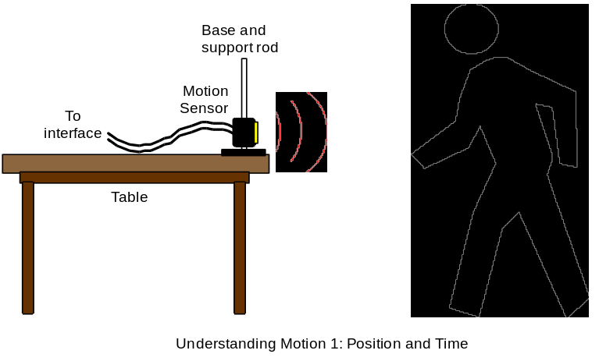
- You will be moving backwards for part of this activity. Clear the area behind you for at least 2 meters (about 6 feet).

PART III: Data Recording
1. Enlarge the Graph display until it fills the monitor screen.
2. Study the plot of Position versus Time in order to determine the following:
• How close should you be to the Motion Sensor at the beginning? _______ (m)
• How far away should you move? _______ (m)
• How long should your motion last? _______ (s)
3. When you are ready, stand in front of the Motion Sensor.
- WARNING: You will be moving backward, so be certain that the area behind you is free of obstacles.
4. When everything is ready, start recording data.
• In DataStudio, click ‘Start’. There is a three-second countdown before data recording begins. The ‘cursor’ on the vertical axis of the Graph will move up and down as you move forward and backward relative to the sensor. Use the feedback from ‘cursor’ to find your best starting position.
• In ScienceWorkshop, click ‘REC’. Data recording will begin almost immediately.
• The Motion Sensor will make a faint clicking noise.
5. Watch the plot of your motion on the Graph and try to move so the plot of your motion matches the Position versus Time plot already there.
If the Motion Sensor is having difficulty picking up the echo, use a notebook as a reflector. Hold the notebook at the same height as the sensor.
6. Repeat the data recording process a second and a third time. Try to improve the match between the plot of your motion and the plot already on the Graph.
- The Graph can show more than one run of data at the same time.

Analyzing the Data
1. Determine the slope of the best-fit line for the middle section of your best position versus time plot. You may want to resize the graph to fit the data.
• The slope of this part of the position versus time plot is the velocity during the selected region of motion.
2. Determine how well your plot of motion fits the plot that was already in the Graph. (Hint: In DataStudio, examine the ‘Match Data’ calculation. In ScienceWorskhop, examine the ‘total abs. diff.’ (total absolute difference) and the chi^2 (goodness of fit) terms from the Statistics area.)
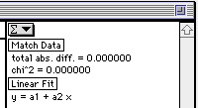

Lab Report - Activity P01: Position & Time – Understanding Motion 1

What Do You Think?
What is the relationship between the motion of an object – YOU – and a graph of position and time for the moving object?

Questions
1. In the Graph, what is the slope of the line of best fit for the middle section of your plot?

2. What is the description of your motion? (Example: “Constant speed for 2 seconds followed by no motion for 3 seconds, etc.”)

3. What would be the physical meaning of a steeper slope on the graph?

4. What would be different about the motion if the slope were negative?

