P02: Velocity and Time – Understanding Motion 2
(Motion Sensor)

Concept | DataStudio | ScienceWorkshop (Mac) | ScienceWorkshop (Win)
Linear motion | P02 Velocity and Time.ds | P02 Understanding Motion 2 | P02_MOT2.SWS

Equipment Needed | Qty | Equipment Needed | Qty
Motion Sensor (CI-6742) | 1 | Base and Support Rod (ME-9355) | 1

What Do You Think?
What is the relationship between the motion of an object – YOU – and a graph of velocity and time for the moving object?
Take time to answer the ‘What Do You Think?’ question(s) in the Lab Report section.

Background
When describing the motion of an object, knowing where it is relative to a reference point, how fast and in what direction it is moving, and how it is accelerating (changing its rate of motion) is essential. A sonar ranging device such as the PASCO Motion Sensor uses pulses of ultrasound that reflect from an object to determine the position of the object. As the object moves, the change in its position is measured many times each second. The change in position from moment to moment is expressed as a velocity (meters per second). The change in velocity from moment to moment is expressed as an acceleration (meters per second per second). The position of an object at a particular time can be plotted on a graph. You can also graph the velocity and acceleration of the object versus time. A graph is a mathematical picture of the motion of an object. For this reason, it is important to understand how to interpret a graph of position, velocity, or acceleration versus time. In this activity you will plot a graph of velocity in real-time, that is, as the motion is happening.

SAFETY REMINDERS
- Follow all safety instructions.
- Keep the area clear where you will be walking.

For You To Do
- This activity is easier to do if you have a partner to run the computer while you move.
For this activity, you will be the object in motion. Use the Motion Sensor to measure your position as you move in a straight line at different speeds. Use DataStudio or ScienceWorkshop to plot your motion on a graph of position and time.
The challenge in this activity is to move in such a way that a plot of your motion on the same graph will “match” the line that is already there.

PART I: Computer Setup
1. Connect the ScienceWorkshop interface to the computer, turn on the interface, and turn on the computer.
2. Connect the stereo phone plugs of the Motion Sensor to Digital Channels 1 and 2 on the interface. Connect the yellow plug to Digital Channel 1 and the other plug to Digital Channel 2.
3. Open the file titled as shown:

DataStudio | ScienceWorkshop (Mac) | ScienceWorkshop (Win)
P02 Velocity and Time.ds | P02 Understanding Motion 2 | P01_MOT2.SWS
• The DataStudio file has a Workbook display. Read the instructions in the Workbook.
• The ScienceWorkshop document has a Graph display of Velocity versus Time.
• The Graph shows Velocity and Time values that were entered into the Graph.
• Data recording is set to stop automatically at 10 seconds.

PART II: Sensor Calibration and Equipment Setup
- You do not need to calibrate the motion sensor for this activity. Moving away from the motion sensor is considered a positive velocity. Moving toward the motion sensor is considered a negative velocity.
1. Mount the motion sensor on a support rod so that it is aimed at your midsection when you are standing in front of the sensor. Make sure that you can move at least 2 meters away from the motion sensor.
2. Position the computer monitor so you can see the screen while you move away from the motion sensor.  - You will be moving backwards for part of this activity. Clear the area behind you for at least 2 meters (about 6 feet). | 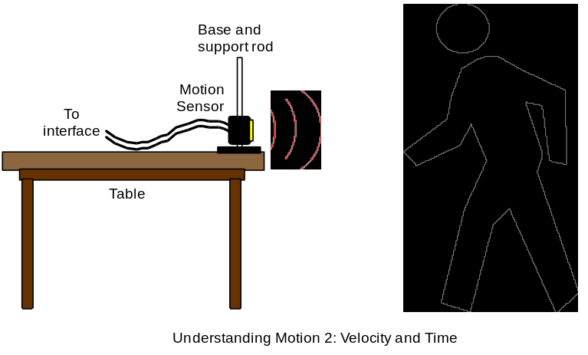

PART III: Data Recording
1. Enlarge the Graph until it fills the monitor screen.
2. Study the Velocity versus Time plot in order to determine the following:
- Which direction (positive or negative) should you go at the beginning? _______
- What is the maximum speed (positive or negative) you must achieve? _______ (m/s)
• How long should your motion last? _______ (s)
- When you are ready, stand in front of the motion sensor.
- WARNING: You will be moving backward, so be certain that the area behind you is free of obstacles.
4. When everything is ready, start recording data. Data recording will begin almost immediately. The motion sensor will make a faint clicking noise.
5. Watch the plot of your motion on the Graph, and try to move so that the plot of your motion matches the Velocity versus Time plot that is already there.
6. Repeat the data recording process a second and a third time. Try to improve the match between the plot of your motion and the plot that is already on the Graph.
- The Graph can show more than one run of data at the same time.

Analyzing the Data
- Determine how well your best plot of velocity versus time matches the velocity versus time plot that was already on the Graph. You may want to resize the graph to fit the data.
• In DataStudio, check the ‘Match Score’ calculation in a Digits display. In ScienceWorkshop, examine the ‘total abs. diff.’ (total absolute difference) and the ‘chi^2’ (goodness of fit) terms from the Statistics area.
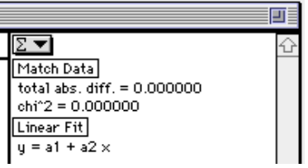

Lab Report - Activity P02: Velocity & Time – Understanding Motion 2

What Do You Think?
What is the relationship between the motion of an object – YOU – and a graph of velocity and time for the moving object?

Question
1. For your best attempt, how well did your plot of motion fit the plot that was already in the Graph?

