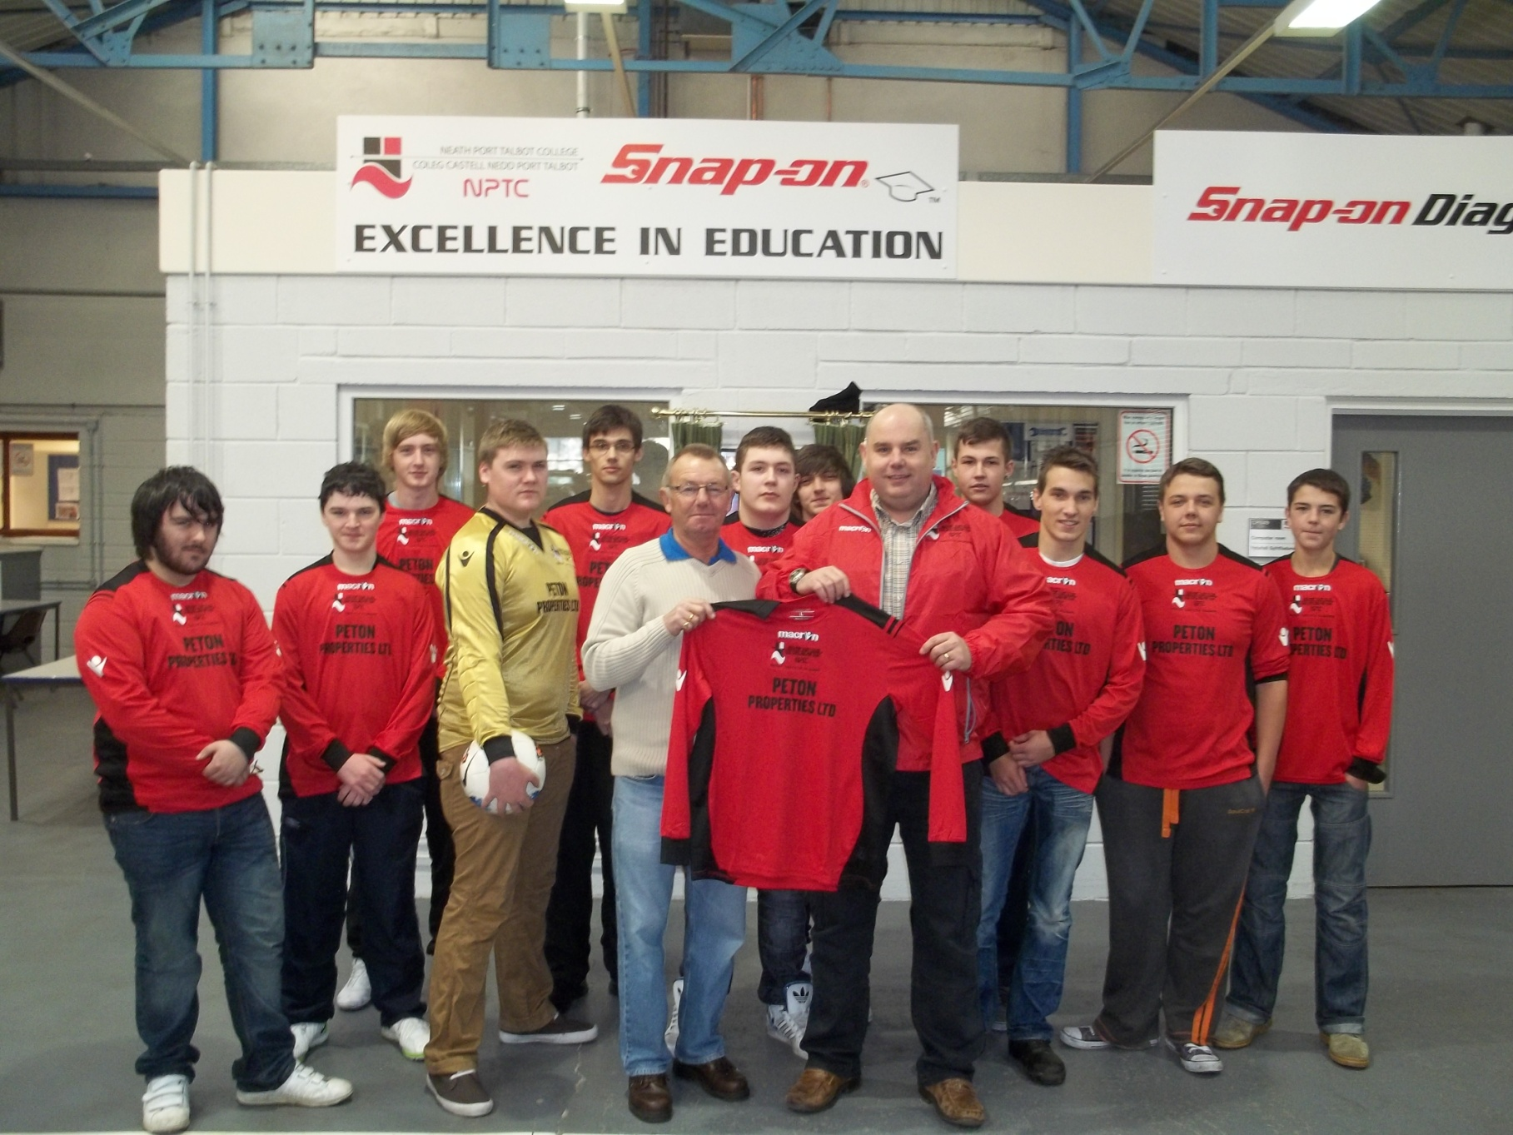

Neath Port Talbot College Motor Vehicle Academy are seen receiving a new football kit from Mr Peter Burns of PETON Properties Ltd. Lecturer Tony Davison said “ It is great to see the vocational students embrace taking part in physical activities such as football along with their college studies.
Our hope now is that a Motor Vehicle & Engineering team can play friendly matches and the kind donation of a kit from Mr Burns has helped this “goal” become a reality.

