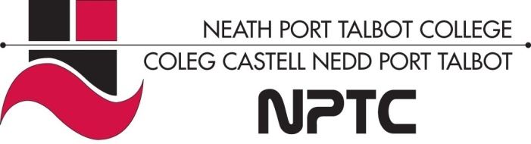

School of Horticulture, Hairdressing and Applied Therapies

Level 1 Certificate in Retail Knowledge

Question | √ or X | Comments
Retail size and type

Range of retail occupations
Retail supply chain

Contribution of the retail sector to the economy
Customer concerns influence the products and services

Unit UV10347-Understanding the business of retail

Workbook
Name:

Group:

Date of completion:

Tutor signature:

Literacy Alert:

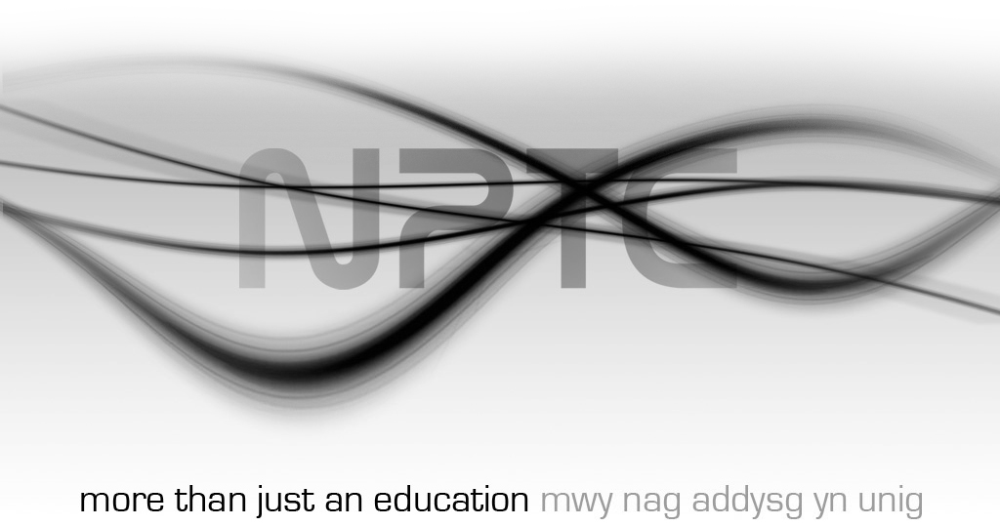

The purpose of this unit is to provide you with knowledge and understanding of the retail sector. It will introduce you to the supply chain and the different types of retail outlets and occupations found within the sector.
Understand how retail outlets differ in size and type
- List the different retail channels and state the main features of each one

- Identify the sizes and types of retail outlets typically found in a variety of retail locations such as high streets or retail business parks

Understand the range of retail occupations

- State how retail occupations differ between small, medium and large retail businesses

- Identify the usual entry points and progression opportunities for a variety of retail occupations

- Outline the skills, personal attributes and behaviours required for a range of retail occupations

Understand the retail supply chain
- List the sources from which retailers obtain products

- Outline the key stages of a product’s journey through the supply chain

Understand the contribution which the retail sector makes to the economy of the United Kingdom
- Outline the size of the retail sector using information such as:
- the number of people employed
- the number of retail businesses
- the amount of money spent by customers every year

Understand how customer concerns influence the products and services offered by retailers

- Outline environmental issues of concern to retail customers

- Outline ethical issues of concern to retail customers

- List the main advantages to retailers of being responsive to customer environmental and ethical concerns

