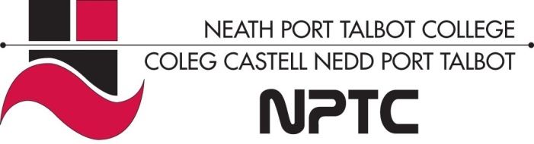

School of Horticulture, Hairdressing and Applied Therapies

Level 1 Certificate in Retail Knowledge

Question | √ or X | Comments
Rights and responsibilities
Effective team work
Skills and performance

Literacy Alert:

Unit UV10352-Understanding how individuals and teams contribute to the effectiveness of a retail business

Workbook
Name:

Group:

Date of completion:

Tutor signature:

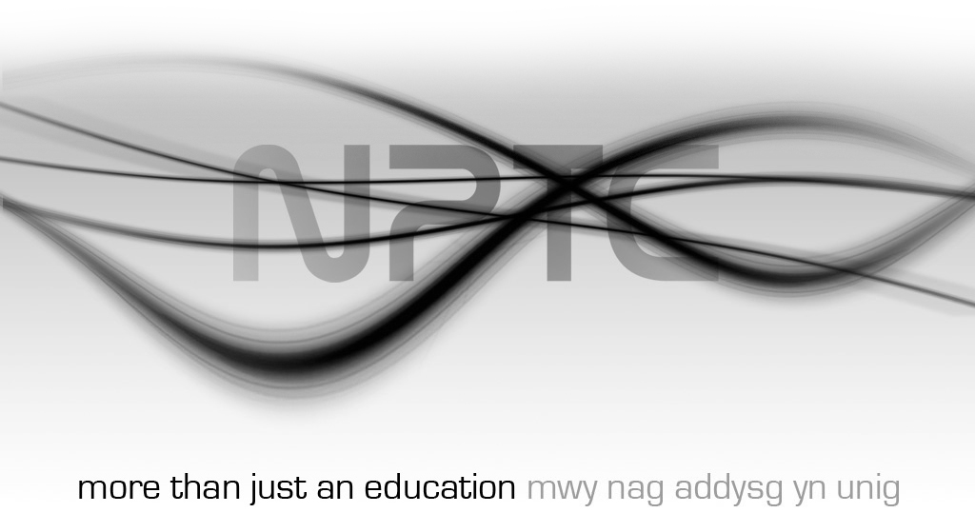

The purpose of this unit is to provide you with knowledge and understanding of how individuals and teams contribute to the effectiveness of retail businesses. The unit covers the effective characteristics of team building and the activities which can be used for improving the skills and performance of individuals.

Employment rights and responsibilities of employees and the employer
- State the purpose of a contract of employment

- List the main content typically included in a contract of employment

- Outline the actions which can be taken by the individual and the employer if either party fails to keep to the terms of the contract of employment

- Identify the legislation which protects individuals from harassment and discrimination

Characteristics of effective team working in retail business

- State the benefits to individual employees and to the retail business as whole of working in teams

- Identify the different roles and levels of responsibilities within retail teams

- List the typical characteristics of effective and ineffective teams

- List different techniques for communicating effectively within a team

Range of activities for improving own skills and performance

- State the benefits to the retail business of improving employees’ skills and performance

- State why it is important for employees to identify own strengths and development needs

- List the different methods for reviewing and improving the performance and skills of individual employees

