1. During the consultation what are you assessing using questioning, observation and manual examination skills?

|  |
| --- |
|  |

1. Explain the importance of and reasons for disinfecting feet and how to do it effectively

|  |
| --- |
|  |

1. How can the therapist minimise the risk of injury to them self and the client whilst carrying out the pedicure?

|  |
| --- |
|  |

1. How should you cut and file the toenails, and why?

|  |
| --- |
|  |

1. Draw below how the toenail would appear if cut correctly, too short and ingrowing

Correctly shaped Too short Ingrowing



1. Explain the condition Hyperanhidrosis and how can the client deal with it?

|  |
| --- |
|  |

1. Label the diagram of the bones of the foot

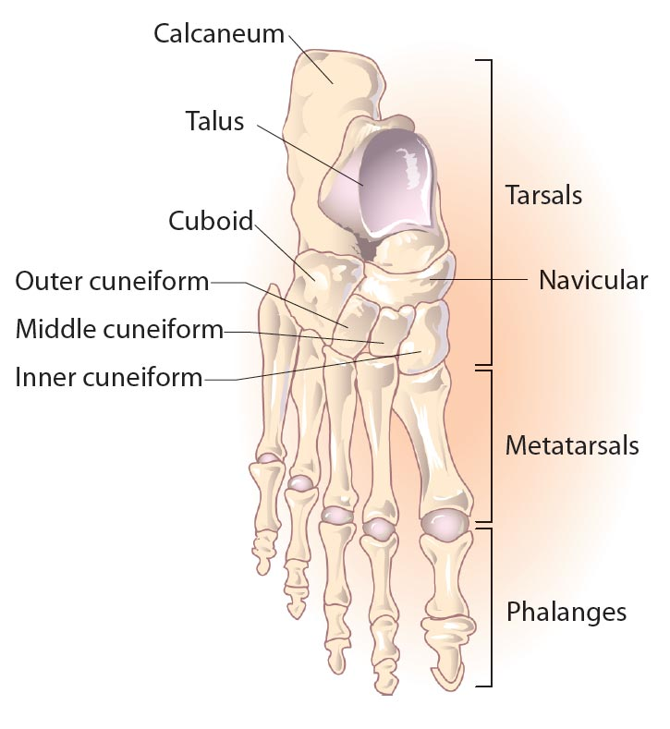

Name the bones that make up the lower leg

1. b.

What is the correct name for the knee cap?

6. What are the benefits of buffing the toenail?

|  |
| --- |
|  |

State the homecare/aftercare advice you would offer the client.

|  |
| --- |
|  |