IF YOU NEED ME…..I’M IN THE OFFICE – JUST SHOUT!!
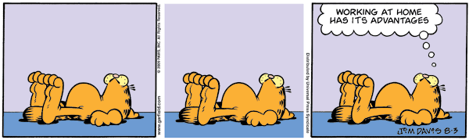
Send me your Drafts
Hope you’re all safe, well & sane…..

