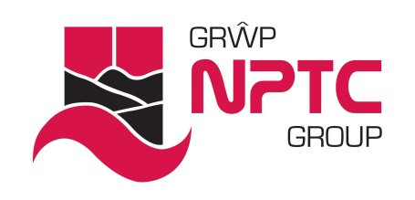 | Marking for literacy  (Two ticks and a wish)

Learners need information to improve their levels of literacy. They need to know:

- What they are aiming for
- What they have got right or have improved
- What they need to do to improve further.

Please follow these marking guidelines when you mark any piece of writing.

- Proof reading - expect learners to check and proof read their writing before they hand it in.
- Feedback should be given as soon as is possible after the task is completed.
- Give written feedback; ‘Two ticks and a wish’. Find two things to say to praise and encourage learners in their writing skills.
- The Wish - Be constructive and specific in your written feedback; explain exactly what the learner needs to do to improve.
- Feedback can be written using pen or pencil. Use a different colour to the learner but avoid using a red pen.

Mark | Meaning
Circle the word and write ‘Sp’ in the margin or above the word | Try this spelling again and learn it  Spelling correction written in the margin for new/unfamiliar vocabulary which needs to be learnt. Look for improvement in next piece of written work.  Spelling mistakes should be corrected, however if there are a large number of errors then focus on the words that are most important e.g. spellings of words relevant to the learner or the course.
Circle the letter and write ‘C’ | Use capital letter (upper case)
Circle the letter and write ‘lc’ | Use lower case
// | Start a new paragraph
Circle space or incorrect punctuation mark and write ‘P’ | Indicates where to remove/add punctuation marks e.g. full stops, exclamation marks, question marks, commas, speech marks and apostrophes
^ | Missing word or phrase
T | Error of tense
SS | Sentence structure
Circle the word and write ‘G’ | Grammar error e.g. ‘There was three cars in the car park’
WW | Wrong word used e.g. ‘here’ when the learner meant ‘hear’. Use this also when the wrong technical term is used.

