Level 1 Essential Skills Wales in

Application of Number (3768)

Candidate logbook
500/7619/X
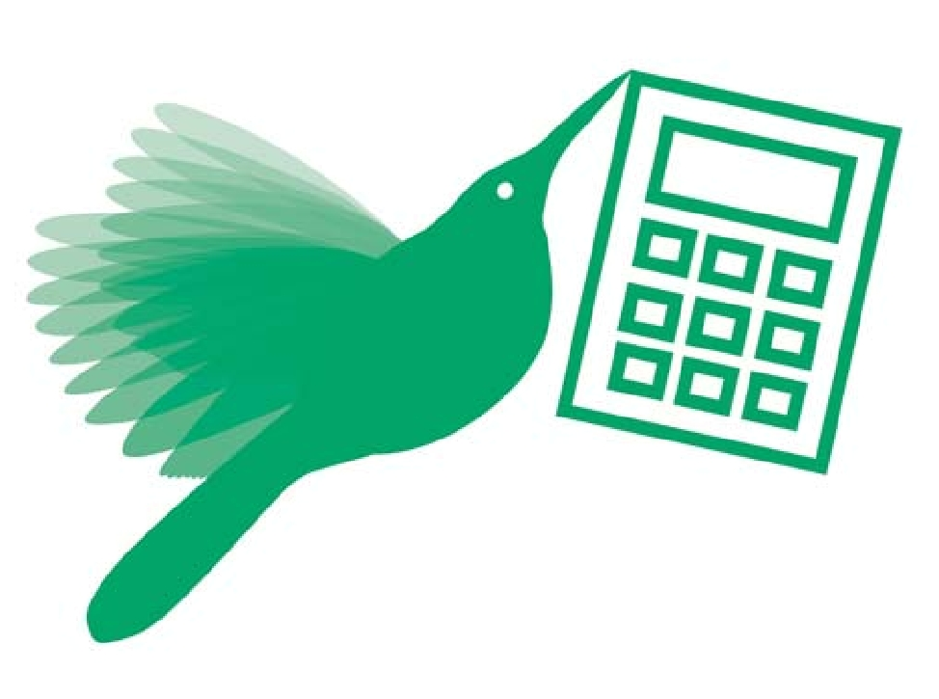

www.cityandguilds.com September 2010 Version 1.1

Your name:

City & Guilds enrolment number:

Unique Learner Number (ULN):

Date of registration for 3768:

Date portfolio started:

Date portfolio completed:

Assessor’s name: Internal verifier’s name:

1 How do I use this logbook?

This logbook will help you work towards Level 1 Essential Skills Wales in Application of Number. It contains:

- an evidence record form detailing the evidence you must provide to complete this qualification. You should use this to record and organise your evidence.

- a skills checklist containing all of the skills you need to have in order to show that you are competent. You can use this to help show how you have learnt and gained confidence in these skills.

The evidence and skills requirements for ESW are set out in full in the DCELLS document ‘Essential Skills Wales’. This can be downloaded from www.cityandguilds.com/esw. Your assessor/tutor will also be able to explain to you in more detail what you need to do.

About ESW

The Essential Skills Wales (ESW) qualifications are designed to help you develop and demonstrate the skills needed to make the most of your learning, work and life.

This qualification will help you improve your number skills. You will be required to demonstrate your skills in:

- understanding numerical data

- carrying out calculations

- interpreting results and presenting findings

in order to tackle problems or tasks that you meet in education, training, work and social roles.

About City & Guilds

City & Guilds is your awarding organisation for Essential Skills Wales. City & Guilds is the UK’s leading awarding body for vocational qualifications. You may also be working towards other City & Guilds qualifications at the same time as completing ESW and in some cases you may be able to use work completed for those qualifications towards your ESW portfolio.

Information about City & Guilds and our qualifications is available on our website www.cityandguilds.com.

2 Level 1 Essential Skills Wales in Application of Number (3768)

2 Level 1 Essential Skills Wales in Application of Number

2.1 Evidence record

Your portfolio must include all of the following. Please use this sheet to record what your evidence is and where it can be found. The Declarations on the following page must be completed.

Standard |  | Description of | Location/ | Confirmed met and date
 |  | evidence presented | reference | (assessor use only)
N1.1.1 |  |  |  | >=1 problem described
Understand and describe at least |  |  |  | ________________________
one given practical problem or task
that involves a range of numerical |  |  |  | ________________________
data and information.
N1.1.2 |  |  |  | contributed to deciding
Agree with an appropriate person |  |  |  | how to tackle
how you will tackle it. |  |  |  | ________________________
 |  |  |  | ________________________
N1.1.3 |  |  |  | relevant data/info
Obtain relevant numerical data and |  |  |  | obtained from >1
information from at least two |  |  |  | source
sources to meet the purpose of |  |  |  | includes >=1 of table/
your task. |  |  |  | chart/graph/diagram
Your sources must include at least
 |  |  |  | ________________________
one of a table, a chart, a graph, or
a diagram. |  |  |  | ________________________
N1.2.1 |  |  |  | >1 method used to get
Use appropriate methods to get |  |  |  | results needed
the results you need and describe |  |  |  | methods and purpose
the methods you have used.
 |  |  |  | described
 |  |  |  | ________________________
 |  |  |  | ________________________
N1.2.2 |  |  |  | relevant data/info from
Use the data and information you |  |  |  | N1.1 used
have obtained to carry out |  |  |  | amounts or sizes
calculations relevant to your task
 |  |  |  | scales or proportions
to do with:
 |  |  |  | handling statistics
a) | amounts or sizes
 |  |  |  | checked methods/calcs
b) | scales or proportion
 |  |  |  | results chked for sense
c) | handling statistics.
 |  |  |  | ________________________
 |  |  |  | ________________________
N1.3.1 |  |  |  | findings presented
Present your findings using charts, |  |  |  | using choice of >1 of
graphs or diagrams. |  |  |  | chart/graph/diagram
 |  |  |  | includes >=1 diagram
 |  |  |  | accuracy checked
 |  |  |  | ________________________
 |  |  |  | ________________________
N1.3.2 |  |  |  | results described
Describe what your results tell you |  |  |  | purpose explained
and explain how they meet the
 |  |  |  | ________________________
purpose of your task.
 |  |  |  | ________________________

Level 1 Essential Skills Wales in Application of Number (3768) 3

2 Level 1 Essential Skills Wales in Application of Number

2.2 Declarations

The candidate and assessor declarations below must be completed in all cases.

Candidate name:

Candidate declaration:

I confirm that the evidence produced for this portfolio is entirely my own work.

Candidate signature: Date:

For centre staff and City & Guilds’ use only

Assessor declaration:

I confirm that the candidate has met / not met (as applicable) all of the evidence requirements for this Essential Skills Wales qualification. Assessment is valid, authentic, reliable, current and sufficient.

Assessor signature: Date:

Internal verifier declaration:

(if sampled)

I confirm that the candidate has met / not met (as applicable) all of the evidence requirements for this Essential Skills Wales qualification. I have internally verified this work.

Internal verifier signature: Date:

External verifier declaration:

(if sampled)

I confirm that the candidate has met / not met (as applicable) all of the evidence requirements for this Essential Skills Wales qualification. I have externally verified this work.

External verifier signature: Date:

4 Level 1 Essential Skills Wales in Application of Number (3768)

2 Level 1 Essential Skills Wales in Application of Number

2.3 Skills checklist

This checklist is designed to help you show you have learnt all of the skills needed for this qualification. Unlike the Evidence record, this list is not a formal part of your assessment although you and your assessor/tutor should be confident that you can do all of these things by the time you complete your portfolio.

In order to show you are competent, |  | Tick if | Further guidance
you need to know how to: |  | you
 |  | can
a) | check with an appropriate person |  | Check
 | that you understand the problem or |  | You must be able to show that you understand the
 | task… |  | problem or task that you have been given (eg by
a) | …and agree how you will tackle it |  | repeating it in your own words and/or asking for more
 |  |  | detail).
 |  |  | Agree
 |  |  | You must be able to discuss and agree with an
 |  |  | appropriate person how to tackle a problem or task, i.e.
 |  |  | you will make the decision jointly with a teacher, tutor or
 |  |  | supervisor.
a) | read, understand and extract |  | Read, understand, extract
 | information from tables, diagrams, |  | You must know how to obtain information from:
 | charts and simple graphs |  |  | tables, such as a timetable or pricelist
b) | read and understand numbers
 |  |  |  | charts, such as a pictogram, pie chart or bar chart
 | presented in different ways,
 |  |  |  | (eg to identify the number of items sold on a given
 | including large numbers in figures or
 |  |  |  | day, the sales for a week or the day with the most
 | words, simple fractions, decimals, |  |  | sales)
 | percentages, ratios and negative |  |  | single line graphs (eg to identify the temperature at
 | numbers
 |  |  |  | given times of day, or the time of day when the
c) | collect and record data from
 |  |  |  | temperature was highest or lowest) diagrams, such
 | accurate observations |  |  | as a simple map, workshop drawing or plan using a
d) | read scales on familiar measuring |  |  | scale such as 10mm = 1m.
 |  |  | Read and understand numbers
 | equipment using everyday units
e) | use scales on diagrams to find and |  | You must know how to deal with numbers presented in
 |  |  | different ways, eg write down spoken numbers such as
 | interpret information
 |  |  | ‘one thousand and fifty’, or ‘three-fifths’, recognise
f) | use shape and space to record
 |  |  | decimal fractions, know that one-third is a bit more than
 | measurements and make
 |  |  | 30% or 0.3.
 | observations.
 |  |  | Collect, record
 |  |  | You must know how to read numbers from scales on
 |  |  | familiar measuring equipment (eg from a thermometer,
 |  |  | tape measure, or measuring jug), and how to make
 |  |  | accurate observations (eg when carrying out stock
 |  |  | checks) using everyday units such as minutes,
 |  |  | millimetres, litres, grams, degrees.
 |  |  | You must record measurements and observations
 |  |  | accurately and in a way that is fit for the purpose of your
 |  |  | task.
a) | identify and use methods and |  | Identify methods and calculations
 | calculations that are suitable for your |  | You must know how to select the method and calculation
 | task |  | you need for a task, eg ‘I must multiply these numbers’ or
 |  |  | ‘I must divide by 100’.
 |  |  | Describe
 |  |  | You must be able to make notes of or talk through your
 |  |  | methods and what you did to achieve your purpose.
a) | work to the levels of accuracy you |  | Carry out calculations
 | have been given |  | Application of Number requires you to show that you can
b) | add and subtract, with whole |  | carry out a number of different types of calculations
 |  |  | (amounts or sizes; scales or proportion; handling
 | numbers and simple decimals with
 |  |  | statistics). ‘Amounts or sizes’ is a single category. ‘Scales
 | and without a calculator
 |  |  | or proportion’ is another single category. From each of
c) | multiply and divide a simple decimal
 |  |  | these categories, you must present at least one example
 | by a whole number, with and without
 |  |  | as evidence.
 | a calculator
 |  |  | You must be able to carry out calculations both with and

Level 1 Essential Skills Wales in Application of Number (3768) 5

In order to show you are competent, |  |  | Tick if | Further guidance
you need to know how to: |  |  | you
 |  |  | can
d) | recall multiplication facts to 10 x 10 |  |  | without a calculator.
 | and make connections with division |  |  | a) Amounts or sizes
 | facts |  |  | You must know how to:
e) | understand and find simple fractions |  |  |  | carry out calculations using:
 | and percentages |  |  |  | − simple decimals – in the context of everyday
f) | recognise equivalencies between
 |  |  |  |  |  | tasks such as dealing with money, or measuring
 | common fractions, percentages and |  |  |  |  | using metric units, eg how to multiply and divide
 | decimals, and use these to find |  |  |  |  | decimals by 10, 100 and 1000, with and without
 | proportions of whole numbers add, |  |  |  |  | a calculator
 | subtract, multiply, divide and record |  |  |  | − simple fractions and percentages – how to find
 | sums of money |  |  |  |  | parts, such as two-thirds or three-quarters, of
g) | read, measure and record time in |  |  |  |  | whole number amounts or` measurements, and
 |  |  |  |  |  | find percentages, including how to work out
 | common date and time formats
 |  |  |  |  |  | increases in amounts (eg a 10% rise in cost) and
h) | choose and use appropriate units
 |  |  |  |  |  | decreases in amounts (eg a 20% discount)
 | and instruments to estimate, read,
 |  |  |  |  | − | areas and volumes – eg how to find a
 | measure and compare length,
 |  |  |  |  |  | rectangular area in m² or the volume of a box in
 | weight, capacity, time and
 |  |  |  |  |  | cm³
 | temperature
 |  |  |  |  | convert within a system, eg convert 70 minutes to 1
i) | calculate within a system by:
 |  |  |  |  | hour 10 minutes, 0.36 metres to 360mm, 0.6 hours
 | − | adding and subtracting common
 |  |  |  |  | to 36 minutes.
 |  | units of measure
 | − |  |  | b) Scales or proportion
 |  | converting units of measure in
 |  |  |  |  | You must know how to use simple scales on
 |  | the system
 |  |  |  |  | diagrams to work out actual measurements.
j) | work out different properties of a
 |  |  |  |  | When working with proportions, you must know how
 | variety of shapes, including
 |  |  |  |  | to increase and reduce whole-number amounts
 | perimeters, areas and volumes
 |  |  |  |  | using ratio and direct proportion, eg scale up
k) | draw 2-D shapes in different
 |  |  |  |  | amounts of food for three times the number of
 | orientations using grids
 |  |  |  |  | people or put items in two piles, one with twice as
l) | use ratios and proportion
 |  |  |  |  | many items as the other.
m) | use probability to show (using
 |  |  |  | c) Handling statistics
 | fractions, decimals and percentages)
 |  |  |  | You must know how to calculate the range and the mean
 | that some events are more likely to
 |  |  |  | of a group of up to 10 numbers.
 | occur than others
 |  |  |  | Levels of accuracy
n) | find the average (mean) of up to 10
 |  |  |  | You must know how to work to levels of accuracy given
 | items
 |  |  |  | by a teacher, tutor or trainer, such as the nearest 10p or
o) | find the range for up to 10 items
 |  |  |  | nearest hundredth, and to round results.
p) | calculate efficiently using whole
 |  |  |  | Check calculations
 | numbers, fractions, and decimals
 |  |  |  | You must always check the accuracy of your calculations.
q) | use different ways of checking your |  |  | This is often a mental process and you do not have to
 | methods and calculations |  |  | produce evidence every time you do it. Where there is a
 |  |  |  | series of calculations of the same type, you must record
r) | identify and correct any errors
 |  |  |  | evidence of how you have checked at least the first few of
s) | check that your results make sense.
 |  |  |  | each type. For the remainder, accurate results must
 |  |  |  | confirm that you have checked effectively.
 |  |  |  | You must be aware of the importance of checking your
 |  |  |  | results and be familiar with different methods of carrying
 |  |  |  | out checks.
 |  |  |  | Check that results make sense
 |  |  |  | While a calculation may be accurate, it may not ‘make
 |  |  |  | sense’ or be fit for purpose in relation to the problem or
 |  |  |  | task that you have tackled. You must check this.
a) | interpret the results of your |  |  | Choose, use, present
 | calculations |  |  | You must be able to identify more than one way to
b) | show how your results relate to your |  |  | present your findings, and to choose for yourself which
 |  |  |  | is/are the most suitable for your purpose, eg as discrete
 | problem or task
 |  |  |  | data in a bar chart, or in a diagram such as a plan of a
c) | identify and describe more than one
 |  |  |  | room or piece of equipment. This does not mean that you
 | appropriate way to present your
 |  |  |  | have to present the same finding in two different ways,
 | findings to a familiar given audience,
 |  |  |  | but that, in your work as a whole, you must use two
 | including using charts or diagrams
 |  |  |  | different ways of presenting your findings.
d) | using the correct units, use
 | appropriate ways to present your
 | findings, including a chart or graph,
 | and a diagram
e) | label your work correctly

6 Level 1 Essential Skills Wales in Application of Number (3768)

In order to show you are competent, | Tick if | Further guidance
you need to know how to: | you
 | can
f) describe what your results tell you |  | Describe and explain
and explain how they meet the |  | You must know how to describe what the results of your
purpose of your task. |  | calculations show in relation to the problem you have
 |  | tackled, eg show that the results of your calculations
 |  | suggest that a proposed solution will not work.

Level 1 Essential Skills Wales in Application of Number (3768) 7

Published by City & Guilds 1 Giltspur Street

London EC1A 9DD
T +44 (0)844 543 0033 F +44 (0)20 7294 2413
www.cityandguilds.com

City & Guilds is a registered charity established to promote education and training

WW-11-3768

PDF to Word

