OGO

Diwylliant Cymru:

Traddodiadau ac Arferion Cymru

Lefel 1

1 Credyd

Welsh Culture:

The Traditions and Customs of Wales

Level 1

1 Credit

Enw/Name: …………………………………………………………………………………

Cwrs/Course: …………………………………………………………………………………

Tiwtor/ Tutor …………………………………………………………………………………

[](http://www.agored.org.uk/)

Diwylliant Cymru: Traddodiadau ac Arferion Cymru

Côd Uned: **FM31CY001**  
Lefel: **Un**  
Credydau: **1**  
  
[Ymwybyddiaeth Iaith Rhagarweiniol](http://www.agored.org.uk/default.aspx?id=238&group=135372)

[ESDGC Culture and Identity](http://www.agored.org.uk/default.aspx?id=238&group=147047)

[Cau](javascript:void(0))

|  |
| --- |
| **Pwrpas a Nod:** |

|  |  |  |
| --- | --- | --- |
| CANLYNIADAU DYSGU | MEINI PRAWF ASESU | **Wedi cwbwlhau** |
| Bydd y myfyriwr yn | Mae’r myfyriwr yn gallu |
| |  |  | | --- | --- | | **1.** | Deall traddodiadau Cymru. | | |  |  | | --- | --- | | **1.1** | Amlinellu nodweddion allweddol un digwyddiad diwylliannol Cymreig pwysig. | | **1.2** | Disgrifio un symbol a gysylltir â Chymru. | | **1.3** | Amlinellu nodweddion allweddol un o’r canlynol: • traddodiad chwaraeon a gysylltir â Chymru. • traddodiad cerddorol a gysylltir â Chymru. • traddodiad llenyddol a gysylltir â Chymru. | |  |
| |  |  | | --- | --- | | **2.** | Deall myth neu chwedl Gymreig. | | |  |  | | --- | --- | | **2.1** | Amlinellu un myth neu chwedl Gymreig. | |  |
| |  |  | | --- | --- | | **3.** | Deall pwysigrwydd dysgu’r Gymraeg. | | |  |  | | --- | --- | | **3.1** | Dweud beth yw’r tueddiadau yn y defnydd o’r iaith Gymraeg a dysgu’r Gymraeg. | | **3.2** | Rhestru tri mantais o ddysgu a defnyddio’r Gymraeg. | | **3.3** | Enwi un awdur sy’n ysgrifennu yn y Gymraeg. | | **3.4** | Enwi un actor/actores sy’n perfformio yn y Gymraeg. | | **3.5** | Adnabod un canwr neu ddiddanwr sy’n perfformio yn y Gymraeg | |  |

Llofnodion

|  |  |
| --- | --- |
| Dyddiad: | Tiwtor: |
| Myfyrwyr: | Gwiro mewnol: |

Welsh Culture: The Traditions and Customs of Wales

Unit Code: **FM31CY001**  
Level: **One**  
Credit Value: **1**

|  |  |  |
| --- | --- | --- |
| Learning Outcomes | Assessment Criteria | **Completed** |
| The learner will | The learner can |
| |  |  | | --- | --- | | **1.** | Understand Welsh traditions. | | |  |  | | --- | --- | | **1.1** | Outline the key characteristics of one important Welsh cultural event. | | **1.2** | Describe one symbol associated with Wales. | | **1.3** | Outline the key features of one of the following: • a sporting tradition associated with Wales • a musical tradition associated with Wales • a literary tradition associated with Wales | |  |
| |  |  | | --- | --- | | **2.** | Understand a Welsh myth or legend. | | |  |  | | --- | --- | | **2.1** | Outline one Welsh myth or legend. | |  |
| |  |  | | --- | --- | | **3.** | Understand the importance of Welsh language learning. | | |  |  | | --- | --- | | **3.1** | State the trends in the use of the Welsh language and Welsh language learning. | | **3.2** | List at least 3 of the benefits of learning and using Welsh. | | **3.3** | Name one author who writes in Welsh. | | **3.4** | Name one actor/actress who performs in Welsh. | | **3.5** | Identify one singer or entertainer who performs in Welsh. | |  |

Signatures

|  |  |
| --- | --- |
| Date: | Tutor: |
| Student: | I/V: |

* 1. Nodwch brif nodweddion un digwyddiad diwylliannol pwysig yng Nghymru.

Outline the key characteristics of one important Welsh

cultural event.

  

1.2 Disgrifiwch un symbol rydym yn ei gysylltu â Chymru

Describe one symbol associated with Wales







1.3 Nodwch brif nodweddion un o’r canlynol:

• traddodiad chwaraeon Cymru

• traddodiad cerddorol Cymru

• traddodiad llenyddol Cymru

Outline the key features of one of the following:

• sporting tradition associated with Wales

• musical tradition associated with Wales

• literary tradition associated with Wales



2.1 Rhowch ddisgrifiad bras o un chwedl Gymreig

Outline one Welsh myth or legend

[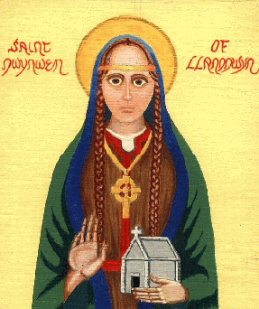](http://www.google.co.uk/url?sa=i&rct=j&q=santes+dwynwen&source=images&cd=&cad=rja&docid=7FizNO2-4lhRiM&tbnid=pBvH1r_ppvZ70M:&ved=0CAUQjRw&url=http://areluctantsinner.blogspot.com/2011/01/st-dwynwen-britains-patron-saint-of.html&ei=sCjIUbK9DvOc0wWQ6oGQCw&bvm=bv.48293060,d.d2k&psig=AFQjCNE0BqBnXgffN7J7SAOo2XH5az2Slg&ust=1372158498142619)[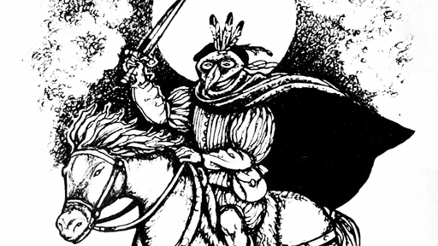](http://www.google.co.uk/url?sa=i&rct=j&q=twm+sion+cati&source=images&cd=&docid=OtAnejeLur-RnM&tbnid=IaJ4LtNgRnbNmM:&ved=&url=http://news.bbc.co.uk/welsh/hi/newsid_7900000/newsid_7909800/7909871.stm&ei=HinIUY_dHozu0gX9roHACw&bvm=bv.48293060,d.d2k&psig=AFQjCNGWKD8muVf0BRaYKiXMCqUSsybaVg&ust=1372158579280022)

3.1 Nodwch y tueddiadau yn y defnydd o’r iaith Gymraeg a

dysgu Cymraeg

State the trends in the use of the Welsh language and Welsh

language learning.

 

3.2 Rhestrwch 3 o fanteision dysgu a defnyddio’r Gymraeg

List 3 of the benefits of learning and using Welsh

|  |  |
| --- | --- |
| 1 |  |
| 2 |  |
| 3 |  |

[](http://www.google.co.uk/url?sa=i&rct=j&q=interview&source=images&cd=&cad=rja&docid=U21InMOZtfJsmM&tbnid=YIKrLavTuDjZRM:&ved=0CAUQjRw&url=http://www.smartrecruiters.com/blog/4-conversation-starters-for-the-interview-room/&ei=aDPIUZjEMOPR0QX35IGwDg&bvm=bv.48293060,d.d2k&psig=AFQjCNEIzcPg_uFwI84e4XU00ilJX_74gg&ust=1372161249183356) [](http://www.google.co.uk/url?sa=i&rct=j&q=money&source=images&cd=&cad=rja&docid=TiyF-NpnLas9GM&tbnid=iLW_tU7Jh_T_PM:&ved=0CAUQjRw&url=http://www.computeractive.co.uk/ca/news/2181453/hp-sony-dell-offering-jubilee-weekend-discounts&ei=vDXIUejXEo2d0wWT-4HgAQ&bvm=bv.48293060,d.d2k&psig=AFQjCNEruIhxqRQt26Iv-IItmEbbOcGJNQ&ust=1372161752125109) [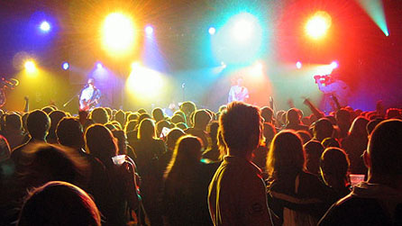](http://www.google.co.uk/url?sa=i&rct=j&q=maes+b&source=images&cd=&cad=rja&docid=EDaMJ218tvZGmM&tbnid=vVUgpAcnLIS3UM:&ved=0CAUQjRw&url=http://ucluwelshsociety.wordpress.com/&ei=RTTIUbO6PKSd0wX_0YCwAw&bvm=bv.48293060,d.d2k&psig=AFQjCNHWQEAB9Bim8z5pjRKjN0xOQqn-QA&ust=1372161404798079)

|  |
| --- |
|  |
|  |  |

3.3 Enwch un awdur neu awdures sy’n ysgrifennu yn Gymraeg.

Identify one author who writes in Welsh.

3.4 Enwch un actor neu actores sy’n perfformio yn Gymraeg

Identify one actor / actress who performs in Welsh

3.5 Enwch un canwr neu gantores neu ddiddanwr sy’n

perfformio yn Gymraeg

Identify one singer or entertainer who performs in Welsh

[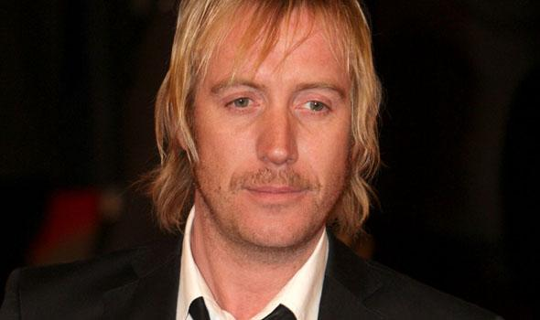](http://www.google.co.uk/url?sa=i&rct=j&q=rhys+ifans&source=images&cd=&cad=rja&docid=u2uD2UQjtALJkM&tbnid=fh5VmZE6IYqaNM:&ved=0CAUQjRw&url=http://www.virginmedia.com/movies/news/story/2011/07/21/rhys-ifans-reinvents-villain/&ei=JfXJUd2kGK-A0AWWn4HICg&bvm=bv.48293060,d.d2k&psig=AFQjCNFDlktkSO1X-F5KulfeCI8uNRrp-g&ust=1372276306363323) [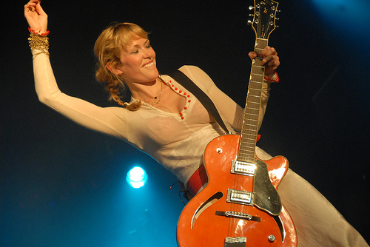](http://www.google.co.uk/url?sa=i&rct=j&q=cerys+matthews&source=images&cd=&cad=rja&docid=VxfCcOtlsSPOIM&tbnid=O-VeJmOSWB9fTM:&ved=0CAUQjRw&url=http://www.flickriver.com/groups/camfolkfest2006/pool/interesting/&ei=uPXJUc2EDuSr0AXGkYCIAw&bvm=bv.48293060,d.d2k&psig=AFQjCNFChXix5lkHm16tfCAL4nutro0q3g&ust=1372276456730645) [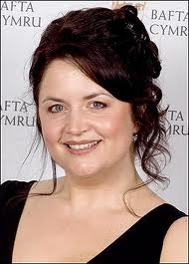](http://www.google.co.uk/url?sa=i&rct=j&q=ruth+jones&source=images&cd=&cad=rja&docid=QMN3im6sFndOkM&tbnid=gy8MQPVhsvrJ9M:&ved=0CAUQjRw&url=http://www.thesun.co.uk/sol/homepage/showbiz/tv/2025675/Jones-Jam-for-radio-Ruth.html&ei=l_bJUfrxNK2d0wWqloHQDQ&bvm=bv.48293060,d.d2k&psig=AFQjCNFc5tiQVPhh6a28A3URSe9zNeSQnA&ust=1372276608953994)