After School Report

We’ve been looking at what people in Meadowbank School do in their spare time. Here is a summary of what you like to do.

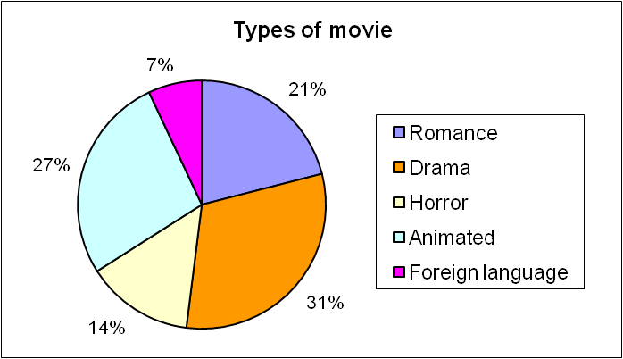

Cinema

We all love to go to the cinema, but what do most of you like to see?
Here are the results of a survey taken from students in year 9.

Venues

When we say venues, we include theatre, clubs, music gigs and comedy acts. We surveyed the students in year 7 and this is what they like to do best.

You can see that the most popular night out is a concert. These are very expensive though, and most of you expressed dismay at ticket prices, especially for weekend gigs and international artists.

Exercise

Exercise is free, but most of you do prefer organised sports.

Naturally, as the school provides some of these, the majority of those of you who do exercise, stay in the school grounds!!

Here is a list of available sports in Meadowbank.

At the end of it all…

The moral of the story is, that when it comes down to it, most of you would prefer to be out and about than stuck in front of the television!! We were really pleased with this result, and say to all of you to keep up the good work!

