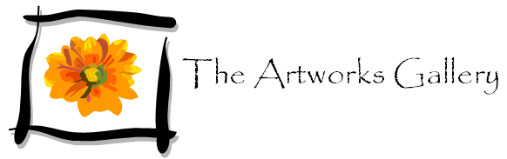

Exhibition of works by local artists

Mary McDermott
Rosalie Wesley
Brian Moore
Introducing Sharon Browne

July 19th in the Main Gallery
Opening night in aid of Boxton Hospital

Tickets £15 include:
Wine and buffet
Short lecture by Professor Michael Triton “Art today – is it all in the eye of the beholder?”
2 free tickets to the exhibition for family and friends

The exhibition will run from
Wednesday July 20th to Wednesday August 24th

