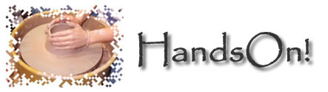

About Hands On!
Regular classes have been held at Hands On! since 1995. The professional workshops are fully equipped and spacious and can accommodate students with ease. We offer once off classes, evening courses, weekend workshops and a two week intensive summer school. The Kiln at Hands On! is always on and students can return during the Pottery Gallery hours to collect work created during class.

All classes are run by David Blackhouse, and the gallery in the front of the school showcases his award winning work.

Pottery Gallery Hours
Monday - Friday: 10 a.m. - 4 p.m.
Saturday: 12 noon - 4 p.m.
Closed Sunday

Once Off Classes
These are for students who have completed level 1 in pottery, either at Hands On! or somewhere else. The content of these are arranged in advance – call David on 662 5598

Evening courses
For 3 hours once a week you can work on improving your pottery throwing skills. These classes run in 6 week terms from 6.30pm until 9.30pm. Call David to find out what level you should take.
Monday – Beginners
Tuesday – Intermediate/Beginners
Wednesday – Intermediate/Advanced

Weekend Workshops
These are held 4 times a year, or more often depending on demand.
Typical produce from these classes include trays, dishes and boxes etc. Students are always encouraged to develop their own ideas. Attention to handles, surface decoration, faceting, incising and fluting are used over a wide range of forms including teapots.

The school begins early Saturday morning and ends on Sunday at 5pm. Work may be continued on the Saturday evening until 7pm.
Lunch is included for both days; tea, coffee and biscuits are also provided mid-morning and afternoon.

The course for this workshop varies depending on seasonality. Call Hands On! for an up to date schedule.

Two week intensive course
We take it further than the weekend workshop, these courses involve basics, surface decoration, attention to detail, glazing techniques, brushwork and pigmentation techniques. We have several Kilns and the students can be involved in the kiln packing and firing of their work.

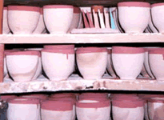
We emphasise wherever possible the basic understanding of raw materials, the use of workshop equipment, glaze technology and kiln firing. Discussion groups take place and influences and personal approaches are assessed. Hands On! take a total approach to encompass the potter’s art.

Contact us for a more detailed brochure.

Accommodation and Food

Daisy chain B&B is providing from 35% off accommodation for students in association with Hands On! If you book in advance for the full two week intensive course, they will provide evening meals if required. You can contact Margaret at Daisy chain on 663 8989

The list of other suggested accommodation includes some places offering beds only.

Brookwood Tavern serves snacks and evening meals at a reasonable price and is conveniently close to Hands On! There are several restaurants in the area including a Mexican, Chinese, Indian and a Bistro.

