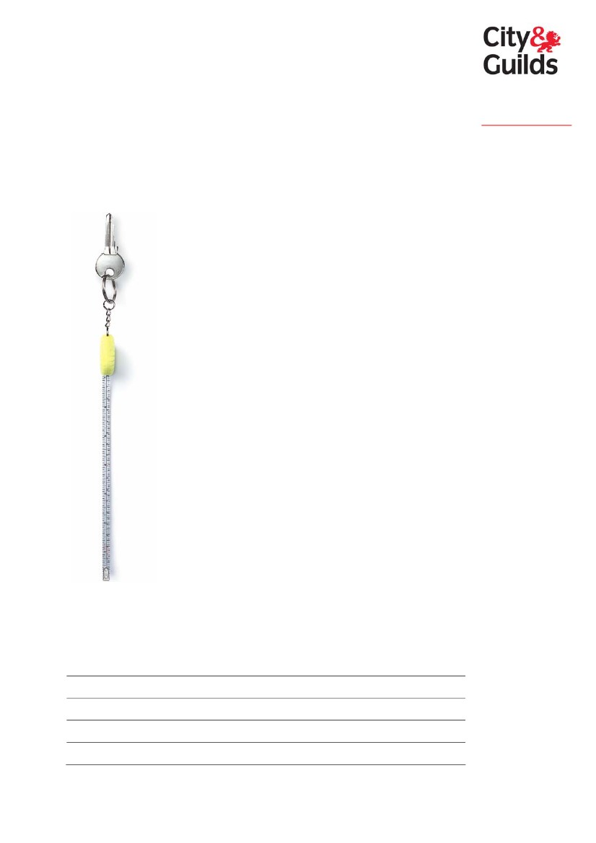
Level 3 Key Skills in Improving
Own Learning and Performance
2004 standard and logbook
www.cityandguilds.com
www.key-skills.org
September 2004
Please complete the following:
Your name
Programme start date
Date registered for key skills qualifications
City & Guilds enrolment number
Date of portfolio completion
City & Guilds is the UK’s leading provider of vocational qualifications, offering over 500
awards across a wide range of industries, and progressing from entry level to the highest
levels of professional achievement. With over 8500 centres in 100 countries, City & Guilds is
recognised by employers worldwide for providing qualifications that offer proof of the skills
they need to get the job done.
The City & Guilds Group includes City & Guilds Pitman Qualifications, specialising in IT, office-
based qualifications and English as a second language awards, and ILM (the Institute of
Leadership & Management) providing management qualifications, learning materials and
membership services. Land based qualifications are offered through NPTC, also part of the
City & Guilds Group. City & Guilds also manages the Engineering Council Examinations on
behalf of the Engineering Council.
General information about City & Guilds is available on our website
www.cityandguilds.com or from our Customer Relations team at the address below or by
phoning 020 7294 2800 or e-mailing centresupport@cityandguilds.com
City & Guilds fully supports the principle of equal opportunities and we are committed to
satisfying this principle in all our activities and published material. A copy of our equal
opportunities policy statement ‘Access to assessment’ is available on our website or from
the Customer Relations team.
City & Guilds publications are available from our Publication Sales department at the address
below or by phoning 020 7294 2850 or faxing 020 7294 3387
©2004 The City and Guilds of London Institute All rights reserved.
City & Guilds is a trademark of the City and Guilds of London Institute.
Every effort has been made to ensure that the information contained in this publication is
true and correct at the time of going to press. However, City & Guilds’ products and services
are subject to continuous development and improvement and the right is reserved to change
products and services from time to time. City & Guilds cannot accept liability for loss or
damage arising from the use of information in this publication.
City & Guilds
1 Giltspur Street
London, EC1A 9DD
T +44 (0)20 7294 2468
F +44 (0)20 7294 2400
www.cityandguilds.com
More information about key skills is available from the
City & Guilds key skills website – www.key-skills.org
Introduction
How do I use this logbook?
This logbook will help you work toward the key skill of Improving Own Learning and
Performance at level 3. It contains the following:
•
•
•
national standard (as published by QCA, ACCAC and CCEA, the qualification regulatory
authorities for England, Wales and Northern Ireland)
Part A coverage record sheets
Part B evidence record sheets.
The coverage and evidence record sheets are designed to help you to track your progress
and organise your portfolio so that your assessor/tutor can determine with you when you
have met the required standard.
Standards and guidance document
Further examples and guidance on the key skills standards can be found in ‘The Wider Key
Skills Standards and Guidance’ (QCA publication QCA/04/1294). Your assessor/tutor must
have a copy of this document.
Part A question
The 2004 standard wider key skills are available as pilot qualifications within the National
Qualifications Framework. As well as producing your portfolio (which must cover all the
requirements set out in Part B of the standard), you may also need to respond to a generic
question to confirm that you know how to use the knowledge and understanding listed in
Part A of the standard.
The Part A question is contained in a separate document that will be given to you once
your portfolio is complete; the questioning process only needs to cover the points within
Part A that have not been explicitly shown in your portfolio. The amount of detail you need
to give will therefore depend on how your portfolio has been put together; you should
discuss this with your assessor/tutor.
Your response to the Part A question will be assessed by your assessor/tutor. A record of
your response must be kept with this logbook so it can be checked by the internal verifier
and external verifier.
Key skills 2004 logbook – Improving Own Learning and Performance level 3
3
This page is intentionally blank
4
Key skills 2004 logbook – Improving Own Learning and Performance level 3

Improving Own Learning and Performance level 3
standard
The key skills are the skills which are most commonly needed to succeed in a range of
activities – at work, in education and training and in everyday life. In developing the key
skill of Improving Own Learning and Performance, you will learn to use and adapt your
skills confidently and effectively in a range of settings and contexts.
Progression
The key skills qualifications are designed to enable you to progress at your own pace.
Each level of the key skill above level 1 incorporates and builds on the previous ones. The
key skills qualifications not only recognise your current capabilities, they also require you
to identify how you can further improve your skills to meet new demands at higher levels.
Part A
You need to know how to
This section tells you about the
techniques and knowledge associated
with each key skill. It tells you what you
need to learn and practise to feel
confident about applying these skills in
your studies, work or other aspects of
your life.
Part B
You must
This section builds on Part A and
describes the application of skills. It
describes the skills you must show. All
of your work for this section will be
assessed. You must have evidence that
you can do all the things listed in the
bullet points.
To achieve Improving Own Learning and Performance at level 3, you must be able to
apply your skills to suit different purposes. You will show that you can:
•
•
•
plan how you will manage your time and review progress
seek and use feedback and support from relevant sources to help meet targets
agree ways to further improve your performance.
Key skills 2004 logbook – Improving Own Learning and Performance level 3
5
Part A – you need to know how to:
Set targets and plan how these will be met
•
make sure you understand:
– how planning and reviewing your learning, and effective time-management, can
help to improve your performance
– what is meant by constructive feedback and reflection
seek information from appropriate people on ways to achieve what you want to do
and identify factors (financial, legal, health and safety, available opportunities, your
motivation, other commitments) that might affect your plans
develop an individual learning plan that includes:
– targets that say exactly what you want to achieve, how you will prove you have
met them and clear action points, using the information you have obtained from
appropriate people
– how you will manage your time to meet deadlines, use support, review your
progress and overcome possible difficulties.
•
•
Take responsibility for your learning and using your
plan
•
•
•
•
manage your time effectively, by prioritising action, dealing with any difficulties to
meet your deadlines, and revising your plan to take into account any changed
circumstances
choose different ways of learning (learning styles) and decide on the methods that
best suit you (eg pictures/diagrams, reading/talking/writing, listening to others,
watching or doing something practical)
work independently at times, so you take responsibility for organising your learning,
choosing resources and adapting your approach to meet new demands
reflect on your own progress by taking time out to think about what is going well and
less well and how you might improve your performance, seeking constructive
feedback and relevant support to help you meet targets.
Review progress and establish evidence of
achievements
•
provide information on:
– how you have used your learning from one task to meet the demands of another
task
– how the quality of the outcome was affected by factors such as your motivation,
the learning situation, your choice of learning style(s) and methods, the quality of
feedback and support
identify targets you have met and gather evidence to support what you say about your
achievements
consult appropriate people to agree ways to further improve your performance.
•
•
6
Key skills 2004 logbook – Improving Own Learning and Performance level 3


Part B – you must:
Provide at least one example of meeting the standard for LP3.1, LP3.2 and LP3.3 (the
example should cover at least three targets). Overall, show you can use at least two
different ways of learning to improve your performance.
Evidence must show you
can:
LP3.1
Set targets using information from
appropriate people and plan how
these will be met.
3.1.1
3.1.2
3.1.3
seek information on ways to achieve
what you want to do, and identify
factors that might affect your plans
use this information to set realistic
targets and identify clear action points
plan how you will manage your time,
use support, review progress and
overcome possible difficulties.
LP3.2
Take responsibility for your
learning, using your plan to help
meet targets and improve your
performance.
3.2.1
3.2.2
manage your time effectively to meet
deadlines, revising your plan as
necessary
choose ways of learning to improve
your performance, working at times
independently and adapting
approaches to meet new demands
reflect on your progress, seeking
feedback and relevant support to help
you meet your targets.
3.2.3
LP3.3
Review progress and establish
evidence of your achievements.
3.3.1
provide information on the ways you
have used your learning to meet new
demands and on factors affecting the
quality of your outcome
identify targets you have met and
gather evidence of your achievements
consult appropriate people to agree
ways to further improve your
performance.
3.3.2
3.3.3
Key skills 2004 logbook – Improving Own Learning and Performance level 3
7

Examples and guidance
The following gives further guidance and examples
of the techniques and knowledge in Part A
Set targets and plan how these will be met
Seek information from others to achieve what you want to do (eg ask your trainer, tutor,
and others at work or in your personal life).
Develop a learning plan that includes targets, deadlines, support and work out how much
time you will need and what teaching, coaching or guidance you will need.
Take responsibility for your learning and using your plan
Choose different ways of learning and decide the methods that suit you best by doing
something practical (eg watching others, reading).
Reflect on your progress, seek feedback and support (eg from your tutor, colleagues,
mentor).
Review progress and establish evidence of achievements
Show how you have used your learning from one task to help with another (eg by
identifying what learning methods suited you).
Identify targets you have met, and gather evidence to support what you say to help you in
the future.
For further examples and guidance on the key skills standards please refer to ‘The Wider
Key Skills Standards and Guidance’ (QCA publication QCA/04/1294).
Help with producing evidence
If producing certain types of evidence is difficult for you because of a disability or for
another reason, please discuss this with your assessor/tutor. It may be possible for you to
produce evidence using alternative methods. Depending on the skill and level, these may
include the use of a scribe (amanuensis); Braille, voice activated software and British Sign
Language.
Detailed guidance is available in the document ‘Basic and Key Skills: Guidance for
Candidates with Particular Requirements’, published by the Joint Council for Qualifications.
A summary of this information can also be found in the City & Guilds key skills centre
guide, and both documents can be obtained from the City & Guilds key skills website –
www.key-skills.org
Please ask your assessor/tutor if you have any questions about this.
This standard is for use in programmes starting from September 2004.
8
Key skills 2004 logbook – Improving Own Learning and Performance level 3

Part A coverage record
These record sheets are designed to help you and your assessor/tutor compare your work
to what the Improving Own Learning and Performance level 3 standard says you need
know how to do.
Unlike the Part B evidence record and the Part A question you will answer once your
portfolio is complete, this coverage record for Part A is not a compulsory part of your
assessment. You may not be able find examples covering all the bullet points listed here,
although both you and your assessor/tutor should be happy that you are showing these
skills in your work by the time your portfolio is complete.
ü if you feel
you have
done it
Standard
Set targets and plan how these will be met
•
make sure you understand:
–
how planning and reviewing your
learning, and effective time-
management, can help to
improve your performance
what is meant by constructive
feedback and reflection
Notes/comments
or referred to Part A question
o
–
o
•
•
seek information from appropriate people
on ways to achieve what you want to do
identify factors that might effect your
plans, eg:
–
–
–
–
–
financial/legal
health and safety
available opportunities
your motivation
other commitments
o
o
o
o
o
o
See next page
Key skills 2004 logbook – Improving Own Learning and Performance level 3
9

Part A coverage record (continued)
Standard
Set targets and plan how these will be met
(continued)
•
develop an individual learning plan that
includes:
–
targets that say exactly what you
want to achieve, how you will
prove you have met them and
clear action points, using the
information you have obtained
from appropriate people
how you will manage your time to
meet deadlines, use support,
review your progress and
overcome possible difficulties.
ü if you feel
you have
done it
Notes/comments
or referred to Part A question
o
–
o
Take responsibility for your learning and
using your plan
•
manage your time effectively, by
prioritising action, dealing with any
difficulties to meet your deadlines, and
revising your plan to take into account
any changed circumstances
choose different ways of learning
(learning styles) and decide on the
methods that best suit you (eg
pictures/diagrams,
reading/talking/writing, listening to
others, watching or doing something
practical)
work independently at times, so you take
responsibility for organising your
learning, choosing resources and
adapting your approach to meet new
demands
reflect on your own progress by taking
time out to think about what is going well
and less well and how you might improve
your performance
o
•
o
•
o
•
o
See next page
10
Key skills 2004 logbook – Improving Own Learning and Performance level 3
Part A coverage record (continued)
Standard
Take responsibility for your learning and
using your plan (continued)
•
seek constructive feedback and relevant
support to help you meet targets.
ü if you feel
you have
done it
Notes/comments
or referred to Part A question
o
Review progress and establish evidence of
achievements
•
provide information on:
–
how you have used your learning
from one task to meet the demands
of another task
how the quality of the outcome was
affected by factors such as your
motivation, the learning situation,
your choice of learning style(s) and
methods, the quality of feedback and
support
o
–
o
•
identify targets you have met and gather
evidence to support what you say about
your achievements
consult appropriate people to agree ways
to further improve your performance.
o
•
o
Candidate’s signature
Date completed
The Part B evidence record on the following pages must be completed, as well as the
Part A question as necessary.
Key skills 2004 logbook – Improving Own Learning and Performance level 3
11
This page is intentionally blank
12
Key skills 2004 logbook – Improving Own Learning and Performance level 3


Key skills 2004 logbook – Improving Own Learning and Performance level 3
Part B evidence record
Standard
Overall
•
•
•
Provided at least one example of meeting
standard for LP3.1, LP3.2 and LP3.3
example covers at least three targets
showed use of at least two different ways of
learning to improve own learning and
performance
-
method 1 involved
(please state)
method 2 involved
(please state).
o
o
o
ü if
met
Purpose of task and details of evidence presented to
meet criteria
Evidence
location/reference
Date of
completion
o
o
-
See next page
13

Key skills 2004 logbook – Improving Own Learning and Performance level 3
Part B evidence record (continued)
ü if
met
LP3.1
•
•
•
•
•
Set at least three targets using information from
appropriate people
sought information on ways to achieve what
was wanted
identified factors that might affect plans
used information to set realistic targets and
clear action points
planned how time managed, support used,
progress reviewed and possible difficulties
overcome.
o
o
o
o
o
Purpose of task and details of evidence presented to
meet criteria
Evidence
location/reference
Date of
completion
See next page
14

Key skills 2004 logbook – Improving Own Learning and Performance level 3
Part B evidence record (continued)
Standard
LP3.2
•
•
•
•
•
•
Taken responsibility for own learning using plan
to help meet targets and improve performance
managed time effectively to meet deadlines,
revising plan as necessary
chose ways of learning to improve performance
worked independently at times
adapted approaches to meet new demands
reflected on progress, seeking feedback and
relevant support to help meet targets.
o
o
o
o
o
o
ü if
met
Purpose of task and details of evidence presented to
meet criteria
Evidence
location/reference
Date of
completion
See next page
15
Key skills 2004 logbook – Improving Own Learning and Performance level 3
Part B evidence record (continued)
Standard
LP3.3
•
•
Reviewed progress and established evidence of
achievements
provided information on ways learning has been
used to meet new demands and on factors
affecting quality of outcome
identified targets met and gathered evidence of
achievements
consulted appropriate people to agree ways to
further improve performance.
o
ü if
met
Purpose of task and details of evidence presented to
meet criteria
Evidence
location/reference
Date of
completion
o
o
o
•
•
Assessor declaration: I declare that the details above are correct, that the evidence submitted is the candidate’s own work and that the
candidate meets all of the requirements for this key skill.
Assessor’s name
Candidate’s name
Internal Verifier’s name
Assessor’s signature
Candidate’s signature
Internal Verifier’s signature
Date
Date
Date
Note Part A coverage must also be confirmed (using the Part A question as necessary) before a qualification certificate can be
claimed.
16
Key skills 2004 logbook – Improving Own Learning and Performance level 3
This page is intentionally blank
17

Published by City & Guilds
1 Giltspur Street
London
EC1A 9DD
T +44 (0)20 7294 2468
F +44 (0)20 7294 2400
www.cityandguilds.com
City & Guilds is a registered charity
established to promote education
and training

