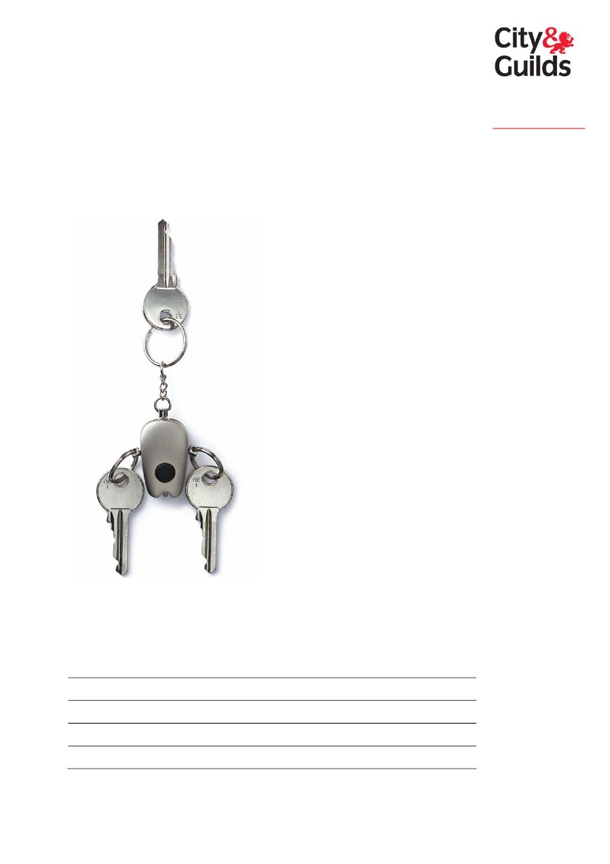Level 1 Key Skills in
Working With Others
2004 standard and logbook
www.cityandguilds.com
www.key-skills.org
September 2004
Please complete the following:
Your name
Programme start date
Date registered for key skills qualifications
City & Guilds enrolment number
Date of portfolio completion

City & Guilds is the UK’s leading provider of vocational qualifications, offering over 500
awards across a wide range of industries, and progressing from entry level to the highest
levels of professional achievement. With over 8500 centres in 100 countries, City & Guilds is
recognised by employers worldwide for providing qualifications that offer proof of the skills
they need to get the job done.
The City & Guilds Group includes City & Guilds Pitman Qualifications, specialising in IT, office-
based qualifications and English as a second language awards, and ILM (the Institute of
Leadership & Management) providing management qualifications, learning materials and
membership services. Land based qualifications are offered through NPTC, also part of the
City & Guilds Group. City & Guilds also manages the Engineering Council Examinations on
behalf of the Engineering Council.
General information about City & Guilds is available on our website
www.cityandguilds.com or from our Customer Relations team at the address below or by
phoning 020 7294 2800 or e-mailing centresupport@cityandguilds.com
City & Guilds fully supports the principle of equal opportunities and we are committed to
satisfying this principle in all our activities and published material. A copy of our equal
opportunities policy statement ‘Access to assessment’ is available on our website or from
the Customer Relations team.
City & Guilds publications are available from our Publication Sales department at the address
below or by phoning 020 7294 2850 or faxing 020 7294 3387
©2004 The City and Guilds of London Institute All rights reserved.
City & Guilds is a trademark of the City and Guilds of London Institute.
Every effort has been made to ensure that the information contained in this publication is
true and correct at the time of going to press. However, City & Guilds’ products and services
are subject to continuous development and improvement and the right is reserved to change
products and services from time to time. City & Guilds cannot accept liability for loss or
damage arising from the use of information in this publication.
City & Guilds
1 Giltspur Street
London, EC1A 9DD
T +44 (0)20 7294 2468
F +44 (0)20 7294 2400
www.cityandguilds.com
More information about key skills is available from the
City & Guilds key skills website – www.key-skills.org

Introduction
How do I use this logbook?
This logbook will help you work toward the key skill of Working With Others at level 1. It
contains the following:

national standard (as published by QCA, ACCAC and CCEA, the qualification regulatory
authorities for England, Wales and Northern Ireland)
Part A coverage record sheets
Part B evidence record sheets.
The coverage and evidence record sheets are designed to help you to track your progress
and organise your portfolio so that your assessor/tutor can determine with you when you
have met the required standard.
Standards and guidance document
Further examples and guidance on the key skills standards can be found in ‘The Wider Key
Skills Standards and Guidance’ (QCA publication QCA/04/1294). Your assessor/tutor must
have a copy of this document.
Part A questions
The 2004 standard wider key skills are available as pilot qualifications within the National
Qualifications Framework. As well as producing your portfolio (which must cover all the
requirements set out in Part B of the standard), you may also need to answer some broad
generic questions to confirm that you know how to use the knowledge and understanding
listed in Part A of the standard.
The Part A questions are contained in a separate document that will be given to you once
your portfolio is complete; the questioning process only needs to cover the points within
Part A that have not been explicitly shown in your portfolio. The number of questions you
need to answer, and the amount of detail you need to give, will therefore depend on how
your portfolio has been put together; you should discuss this with your assessor/tutor.
Your responses to any Part A questions you attempt will be assessed by your
assessor/tutor. A record of your responses must be kept with this logbook so they can be
checked by the internal verifier and external verifier.
Key skills 2004 logbook – Working With Others level 1
3

This page is intentionally blank
4
Key skills 2004 logbook – Working With Others level 1

Working With Others level 1 standard
The key skills are the skills which are most commonly needed to succeed in a range of
activities – at work, in education and training and in everyday life. In developing the key
skill of Working With Others, you will learn to use and adapt your skills confidently and
effectively in a range of settings and contexts.
Progression
The key skills qualifications are designed to enable you to progress at your own pace.
Each level of the key skill above level 1 incorporates and builds on the previous ones. The
key skills qualifications not only recognise your current capabilities, they also require you
to identify how you can further improve your skills to meet new demands at higher levels.
Part A
You need to know how to
This section tells you about the
techniques and knowledge associated
with each key skill. It tells you what you
need to learn and practise to feel
confident about applying these skills in
your studies, work or other aspects of
your life.
Part B
You must
This section builds on Part A and
describes the application of skills. It
describes the skills you must show. All
of your work for this section will be
assessed. You must have evidence that
you can do all the things listed in the
bullet points.
To achieve Working With Others at level 1, you must be able to apply your skills to
suit different purposes. You will show that you can:

identify what needs to be done, and your individual responsibilities
carry out tasks to meet your responsibilities
identify how you helped achieve things together.
Key skills 2004 logbook – Working With Others level 1
5

Part A – you need to know how to:
Confirm you understand the given objectives and
plan for working together

check you understand what you have to achieve (the objectives your supervisor or
tutor has given you for working together)
make sure you understand what is meant by one-to-one, group or team situations and
how this might affect the way you work
identify the tasks that need to be done and deadlines
identify the help, materials, equipment and/or tools needed
identify your individual responsibilities for:
– tasks to be done
– health and safety
– behaving in ways that show respect for each other’s rights, feelings, ideas and
contributions, what you should and should not do (the ground rules for working
together)
check you understand the arrangements for working together:
– who you will be working with, where and when
– who to ask for help if things go wrong.

Work with others towards achieving the given
objectives

get what you need to carry out tasks and meet your responsibilities
work safely to avoid accidents, health risks, offending others or disrupting their work
follow the working methods you have been given for using materials, equipment, tools
or providing a service
communicate with others, when appropriate, to:
– check progress towards your objectives
– ask for help from a suitable person
– offer support to others, provide information, assist with a task or help overcome a
disagreement or other problem.
Identify ways you helped and how to improve your
work with others

identify what has gone well and less well in working with others, including tasks and
working relationships
identify how you helped to achieve things together in carrying out tasks and offering
support to others
suggest ways of improving your work with others.
6
Key skills 2004 logbook – Working With Others level 1

Part B – you must:
Provide at least two examples of meeting the standard for WO1.1, WO1.2 and WO1.3. One
example must show you can work in a one-to-one situation and one example must show
you can work in a group or team situation.
Evidence must show
you can:
WO1.1
Confirm you understand the given
objectives, and plan for working together.
1.1.1
1.1.2
1.1.3
check that you clearly
understand what you have to
achieve together
identify what needs to be done
and your individual
responsibilities
make sure you understand the
arrangements for working
together.
WO1.2
Work with others towards achieving the
given objectives.
1.2.1
1.2.2
1.2.3
carry out tasks to meet your
responsibilities
work safely, following the
working methods you have
been given
check progress, asking for help
and offering support to others,
when appropriate.
WO1.3
Identify ways you helped to achieve things
and how to improve your work with
others.
1.3.1
1.3.2
1.3.3
identify what went well and less
well in working with others
identify how you helped to
achieve things together
suggest ways of improving your
work with others for next time.
Key skills 2004 logbook – Working With Others level 1
7

Examples and guidance
The following gives further guidance and examples
of the techniques and knowledge in Part A
Confirm you understand the given objective and plan for working together
Find out the tasks that need to be done and the deadlines for making something, for
carrying out a service.
Find out who you will be working with and who to ask if things go wrong by
checking with your supervisor or tutor.
Work with others towards achieving the given objectives
Know where to get what you need to carry out the tasks, for instance materials, tools
equipment, help from others.
Check your progress, ask for help from your supervisor, a member of your group, a work
colleague.
Identify ways you helped and how to improve your work with others
Know what has gone well by checking with your supervisor, your colleagues.
Identify ways of improving your work with others by completing tasks in a different way,
taking note of the ideas of others.
For further examples and guidance on the key skills standards please refer to ‘The Wider
Key Skills Standards and Guidance’ (QCA publication QCA/04/1294).
Help with producing evidence
If producing certain types of evidence is difficult for you because of a disability or for
another reason, please discuss this with your assessor/tutor. It may be possible for you to
produce evidence using alternative methods. Depending on the skill and level, these may
include the use of a scribe (amanuensis); Braille, voice activated software and British Sign
Language.
Detailed guidance is available in the document ‘Basic and Key Skills: Guidance for
Candidates with Particular Requirements’, published by the Joint Council for Qualifications.
A summary of this information can also be found in the City & Guilds key skills centre
guide, and both documents can be obtained from the City & Guilds key skills website –
www.key-skills.org
Please ask your assessor/tutor if you have any questions about this.
This standard is for use in programmes starting from September 2004.
8
Key skills 2004 logbook – Working With Others level 1

Part A coverage record
These record sheets are designed to help you and your assessor/tutor compare your work
to what the Working With Others level 1 standard says you need know how to do.
Unlike the Part B evidence record and the Part A questions you will answer once your
portfolio is complete, this coverage record for Part A is not a compulsory part of your
assessment. You may not be able find examples covering all the bullet points listed here,
although both you and your assessor/tutor should be happy that you are showing these
skills in your work by the time your portfolio is complete.
✓ if you feel
you have
done it
Standard
Confirm you understand the given
objectives and plan for working together

check you understand what you have to
achieve (the objectives your supervisor or
tutor has given you for working together)
make sure you understand what is meant
by one-to-one, group or team situations
and how this might affect the way you
work
identify the tasks that need to be done
identify deadlines for completing tasks
identify the help, materials, equipment
and/or tools needed
identify your individual responsibilities
for:
–
–
–
tasks to be done
health and safety
behaving in ways that show respect
for each other’s rights, feelings, ideas
and contributions, what you should
and should not do (the ground rules
for working together)
Notes/comments
or referred to Part A questions
□

□

□
□
□
□
□
□
See next page
Key skills 2004 logbook – Working With Others level 1
9

Part A coverage record (continued)
Standard
Confirm you understand the given
objectives and plan for working together
(continued)

check you understand the arrangements
for working together:
–
–
who you will be working with, where
and when
who to ask for help if things go
wrong.
✓ if you feel
you have
done it
Notes/comments
or referred to Part A questions
□
□
□
Work with others towards achieving the
given objectives

get what you need to carry out tasks and
meet your responsibilities
work safely to avoid accidents, health
risks, offending others or disrupting their
work
follow the working methods you have
been given for using materials,
equipment, tools or providing a service
communicate with others, when
appropriate, to:
–
–
–
check progress towards your
objectives
ask for help from a suitable person
offer support to others, provide
information, assist with a task or help
overcome a disagreement or other
problem.
□
□

□

□
□
□
□
See next page
10
Key skills 2004 logbook – Working With Others level 1

Part A coverage record (continued)
Standard
Identify ways you helped and how to
improve your work with others

identify what has gone well and less well
in working with others, including tasks
and working relationships
identify how you helped to achieve things
together in carrying out tasks and
offering support to others
suggest ways of improving your work
with others.
✓ if you feel
you have
done it
Notes/comments
or referred to Part A questions
□

□

□
Candidate’s signature
Date completed
The Part B evidence record on the following pages must be completed, as well as the
Part A questions as necessary.
Key skills 2004 logbook – Working With Others level 1
11

This page is intentionally blank
12
Key skills 2004 logbook – Working With Others level 1

Key skills 2004 logbook – Working With Others level 1
Part B evidence record
Standard
Overall

Provided at least two examples of meeting the
standard for WO1.1, WO1.2 and WO1.3
one example showed work in a one-to-one
situation
one example showed work in a group or team
situation.
□
□
□
✓ if
met
Purpose of task and details of evidence presented to
meet criteria
Evidence
location/reference
Date of
completion
See next page
13

Key skills 2004 logbook – Working With Others level 1
Part B evidence record (continued)
Standard
WO1.1

For one-to-one situation
-
checked for clear understanding of what
had to be achieved together
identified what needed to be done and own
individual responsibilities
made sure arrangements for working
together understood
□
□
□
✓ if
met
Purpose of task and details of evidence presented to
meet criteria
Evidence
location/reference
Date of
completion
-
-

for group or team situation
-
checked for clear understanding of what
had to be achieved together
identified what needed to be done and own
individual responsibilities
made sure arrangements for working
together understood.
□
□
□
-
-
See next page
14

Key skills 2004 logbook – Working With Others level 1
Part B evidence record (continued)
Standard
WO1.2

For one-to-one situation
-
carried out tasks to meet own
responsibilities
worked safely following given methods
checked progress, asking for help and
offering support to others when appropriate
□
□
□
✓ if
met
Purpose of task and details of evidence presented to
meet criteria
Evidence
location/reference
Date of
completion
-
-

for group or team situation
-
carried out tasks to meet own
responsibilities
worked safely following given methods
checked progress, asking for help and
offering support to others when
appropriate.
□
□
□
-
-
See next page
15

Key skills 2004 logbook – Working With Others level 1
Part B evidence record (continued)
Standard
WO1.3

For one-to-one situation
-
identified what worked well and less well in
working with others
identified how helped to achieve things
together
suggested ways of improving work with
others for next time
□
□
□
✓ if
met
Purpose of task and details of evidence presented to
meet criteria
Evidence
location/reference
Date of
completion
-
-

for group or team situation
-
identified what worked well and less well in
working with others
identified how helped to achieve things
together
suggested ways of improving work with
others for next time.
□
□
□
-
-
The declaration on the following page must be completed
See next page
16

Key skills 2004 logbook – Working With Others level 1
Assessor declaration: I declare that the details above are correct, that the evidence submitted is the candidate’s own work and that the
candidate meets all of the requirements for this key skill.
Assessor’s name
Candidate’s name
Internal Verifier’s name
Assessor’s signature
Candidate’s signature
Internal Verifier’s signature
Date
Date
Date
Note Part A coverage must also be confirmed (using Part A questions as necessary) before a qualification certificate can be claimed.
17

Published by City & Guilds
1 Giltspur Street
London
EC1A 9DD
T +44 (0)20 7294 2468
F +44 (0)20 7294 2400
www.cityandguilds.com
City & Guilds is a registered charity
established to promote education
and training

